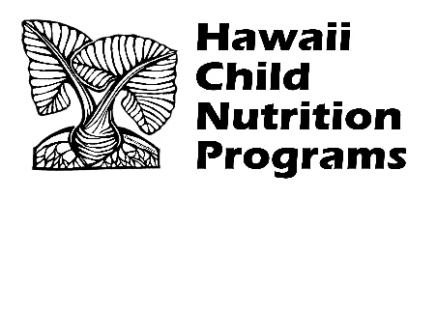

**Child and Adult Care Food Program**

**Family Day Care Homes Reimbursement Rates**

**Effective July 1, 2025 – June 30, 2026**

|  |  |
| --- | --- |
| **Tier I Day Care Homes** |  |
| Breakfast | $2.19 |
| Lunch and Supper | $4.18 |
| Snack | $1.24 |

|  |  |
| --- | --- |
| **Tier II Day Care Homes** |  |
| Breakfast | $0.77 |
| Lunch and Supper | $2.52 |
| Snack | $0.34 |

|  |  |
| --- | --- |
| **Administrative Reimbursement Rates** |  |
| Initial 50 Homes | $195.00 |
| Next 150 Homes | $149.00 |
| Next 800 Homes | $116.00 |

Hawai’i Child Nutrition Programs

650 Iwilei Road, Suite 270

Honolulu, Hawaii 96817

(808) 587-3600 office

(808)587-3606 fax