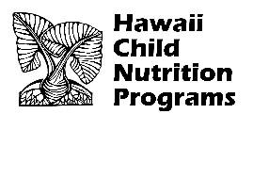  State of Hawaii  Department of Education  Hawaii Child Nutrition Programs  650 Iwilei Road Suite 270  Honolulu, Hawaii 96817 |  |  | ATTENDANCE AND ELIGIBILITY ROSTER  CHILD AND ADULT CARE FOOD PROGRAM  FEDERAL FISCAL YEAR 2026 (RETAIN THIS FORM FOR REVIEW BY HCNP)
NAME OF FACILITY: |  |  | AGREEMENT NUMBER:
NAME OF CHILD/PARTICIPANT | DATE ENTERED INTO PROGRAM  FFY 2026 | DATE EXITED FROM PROGRAM | CATEGORY OF ELIGIBILITY |  |  | DATE MBF SIGNED BY HOUSEHOLDMEMBER | DATE AND INITIALS OF  DETERMINING OFFICIAL
 |  |  | F | RP | AS

This institution is equal opportunity provider.

