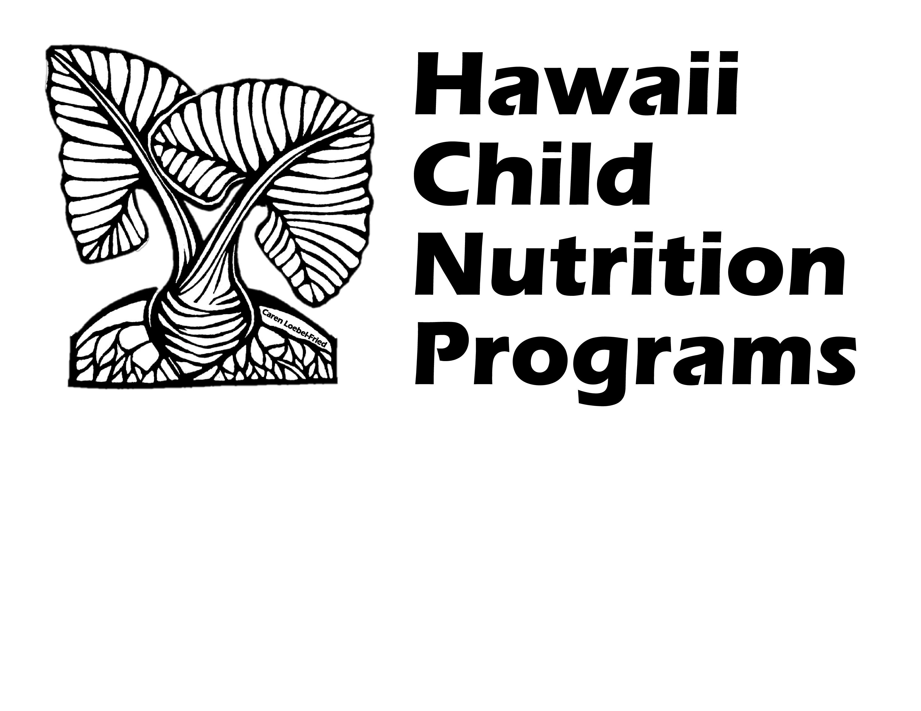
Child and Adult Care Food Program
Center Reimbursement
Effective July 1, 2025 – June 30, 2026

Breakfast
Free | $3.18
Reduced Price | $2.88
Above Scale | $0.51
Lunch**
Free | $5.98
Reduced Price | $5.58
Above Scale | $0.57

Snack
Free | $1.64
Reduced Price | $0.82
Above Scale | $0.15

**Cash In Lieu of Commodities $0.305

Hawaii Child Nutrition Programs
650 Iwilei Road Suite 270
Honolulu, Hawaii 96817
(808)587-3600 office
(808)587-3606 fax

