Enrollment Statement

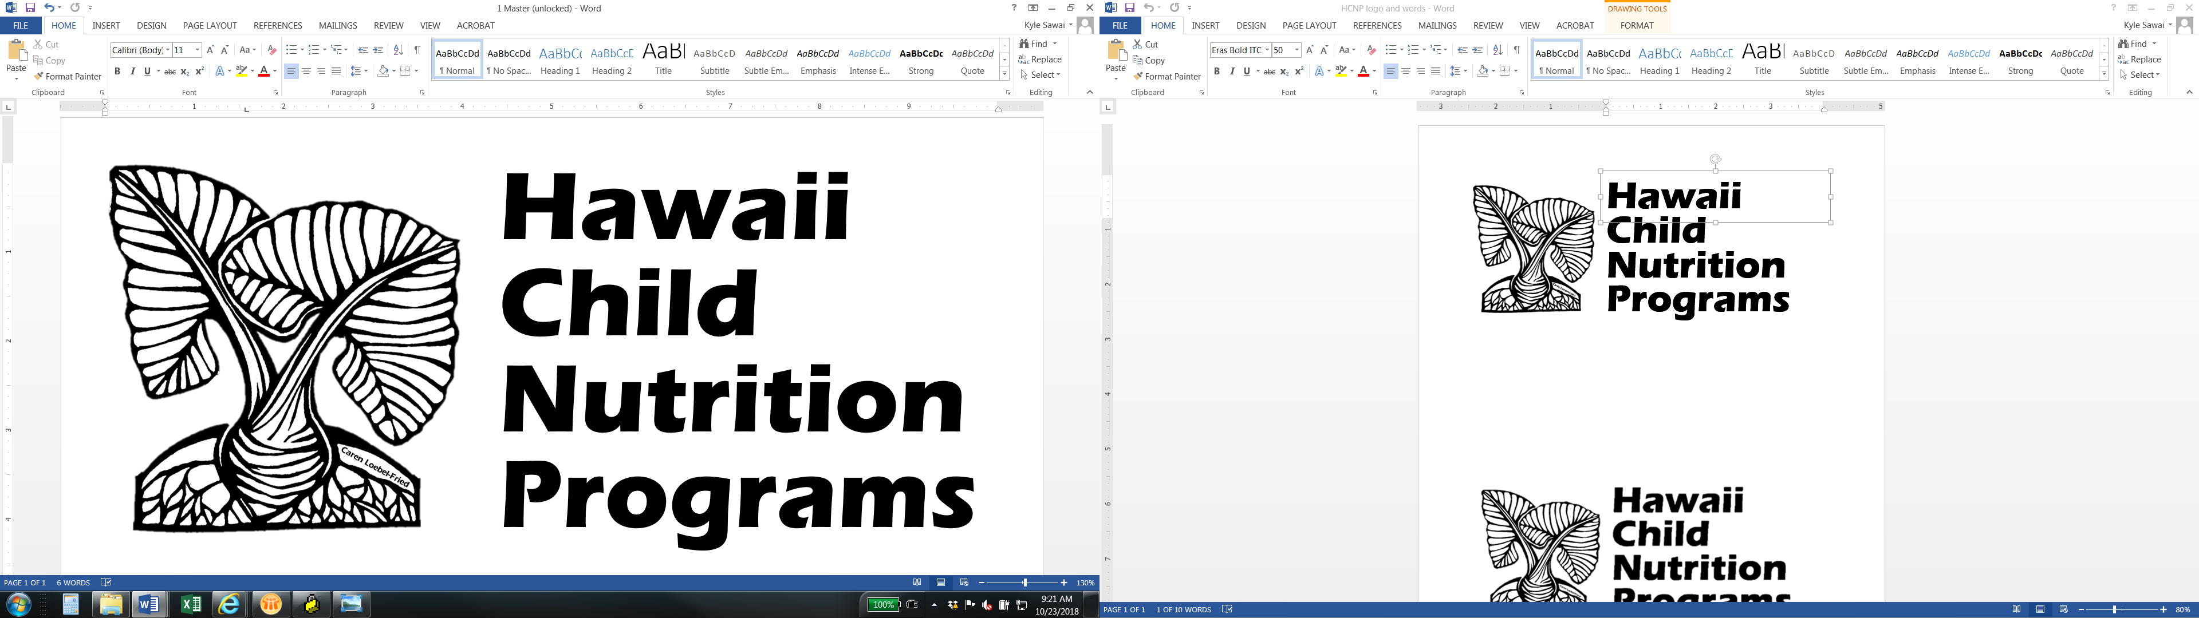

CACFP Family Day Care Home

_____________________________________________ ___________________________

Name of Child Birthdate and Age

is enrolled at:

Name of Provider:______________________________________________________________

Address:______________________________________________________________________

Beginning on:_____________________________________

Month/Day/Year

|  |  |  |  |  |  |  |  |  |
| --- | --- | --- | --- | --- | --- | --- | --- | --- |
| Child’s Normal days & hours of care | | **If attendance time and meals are the same Monday to Friday, Fill in Monday and initial ____________ | | Circle meals child will participate in |  |  |  | |
| **Monday \*\*** | | **_____ a.m. to _____ p.m. \*\*** | | **Breakfast \*\*** | **AM Snack\*\*** | **Lunch\*\*** | **PM Snack\*\*** | |
| Tuesday | | _____ a.m. to _____ p.m. | | Breakfast | AM Snack | Lunch | PM Snack | |
| Wednesday | | _____ a.m. to _____ p.m. | | Breakfast | AM Snack | Lunch | PM Snack | |
| Thursday | | _____ a.m. to _____ p.m. | | Breakfast | AM Snack | Lunch | PM Snack | |
| Friday | | _____ a.m. to _____ p.m. | | Breakfast | AM Snack | Lunch | PM Snack | |
| Saturday | | _____ a.m. to _____ p.m. | | Breakfast | AM Snack | Lunch | PM Snack | |
| Sunday | | _____ a.m. to _____ p.m. | | Breakfast | AM Snack | Lunch | PM Snack | |
| **Mark one ETHNIC identity:** | | **Mark one or more RACIAL identities:** | | | | |
| ** Hispanic or Latino**  ** Not Hispanic or Latino** | | * **Asian  American Indian or Alaska Native** * **White  Native Hawaiian or Other Pacific Islander** * **Black or African American** | | | | |

Signature____________________________________________ Date_________________

Parent/Guardian

Signature_____________________________________ Date_________________

Name of Provider

In accordance with federal civil rights law and USDA civil rights regulations and policies, the USDA, its agencies, offices, employees, and institutions participating in or administering USDA programs are prohibited from discriminating based on race, color, national origin, religion, sex, disability, age, marital status, family/parental status, income derived from a public assistance program, political beliefs, or reprisal or retaliation for prior civil rights activity, in any program or activity conducted or funded by USDA (not all bases apply to all programs). Remedies and complaint filing deadlines vary by program or incident.

Persons with disabilities who require alternative means of communication for program information (e.g., Braille, large print, audiotape, American Sign Language, etc.) should contact the state or local agency that administers the program or contact USDA through the Telecommunications Relay Service at 711 (voice and TTY). Additionally, program information may be made available in languages other than English.

To file a program discrimination complaint, complete the USDA Program Discrimination Complaint Form, [AD-3027](https://www.usda.gov/sites/default/files/documents/ad-3027.pdf), found online at How to File a Program Discrimination Complaint and at any USDA office or write a letter addressed to USDA and provide in the letter all of the information requested in the form. To request a copy of the complaint form, call (866) 632-9992. Submit your completed form or letter to USDA by:

1. **Mail**: U.S. Department of Agriculture, Office of the Assistant Secretary for Civil Rights, 1400 Independence Avenue, SW, Mail Stop 9410, Washington, D.C. 20250-9410;
2. **Fax**: (202) 690-7442; or
3. **Email**: [program.intake@usda.gov](mailto:program.intake@usda.gov).

This institution is an equal opportunity provider.

Provider Use Only

Child withdrew on: __________________________________________________________________