Okinawan Sweet Potato Filling

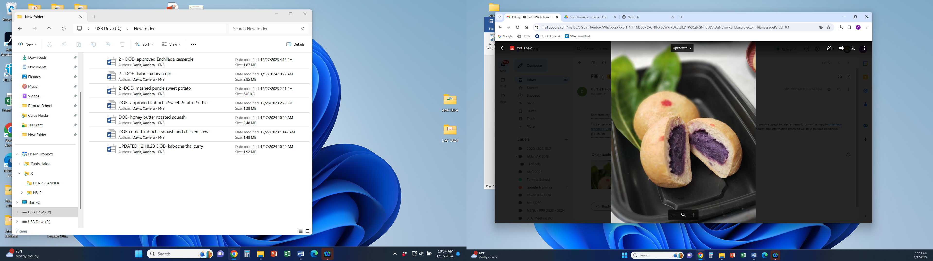

Our Okinawan Sweet Potato Filling is prepared from local grown produce. It features garden fresh sweet potatoes from the fields with flavorful ingredients.

# Recipe Project Name: Fiscal Year 2021 Cohort B Team Nutrition Training Grant for School Meal Recipe Development

# *State Agency*

# Preparation Time: About 35 minutes

# Cook Time: 30 minutes

**NSLP/SBP crediting information:**

One 1.5 oz weight serving provides 1/8 cup starchy vegetables

| **INGREDIENTS** | | **50 SERVINGS** | | | **100 SERVINGS** | | | | **DIRECTIONS** |
| --- | --- | --- | --- | --- | --- | --- | --- | --- | --- |
| **Weight** | | **Measure** | **Weight** | | **Measure** | |
| **Okinawan sweet potato**- wash, peel, large dice | | 4lbs. | | 3 qts.  3/4 c. | 8 lbs. | | 1 gal.  2 qts.  1 1/2 c. | | 1. (CCP) Place potatoes in full size perforated 2” hotel pans and steam uncovered or simmer in water until fork tender with internal temperature of 135 F/57 C or higher for 15 seconds. |
| **Sugar**- ready to use, granulated | | 6.90 oz. | | 1 c. | 13.80 oz. | | 1 pt. | | 1. In a separate mixing bowl combine together the white and brown sugars, salt, nonfat instant milk powder, and milk. Place mixture in a pot. Warm mixture stirring with a wire whisk until sugars are dissolved then remove from heat and place aside. |
| **Light brown sugar**- ready to use | | 3.45 oz. | | 1/2 c. | 6.90 oz. | | 1 c. | | 1. Remove fork tender potatoes from steamer or water and place in mixing machine bowl with paddle attachment and mash at low speed then add the warm milk mixture and stir together until incorporated. |
| **Salt, table iodized**- ready to use | 0.04 oz. | | 1/16 t. | 0.08 oz. | | 1/8 t. | | 1. (CCP) Remove potato mixture from mixing bowl and properly cool to 41 F/5 C or lower within 4 hours. |
| **Nonfat instant milk powder**- ready to use | 2.73 oz. | 1/2 c. | | | 5.46 oz. | | 1 c. | 1. (CP) Properly cool mixture down to 41 F/5 C. Place into full size hotel pans covered with plastic wrap and place in refrigerator at 41 F/5 C or lower. |
| **Milk, whole**- ready to use | 2.96 oz. | 6 T. | | | 5.92 oz. | | 3/4 c. | 1. Place 1.50 ounces of filling in a roll.   Portion: 50 one and a half ounce. Use 2- ounce  (#16) disher..  100 one and a half ounce. Use 2- ounce  (#16) disher. |
|  |  |  | | |  | |  | Note: Use 2 ounce grain equivalent of dough when preparing stuffed buns. |

**NUTRITION INFORMATION**

Amount Per Serving 1.5 oz wt

**NUTRIENTS**

**Calories**

**AMOUNT**

**55**

**Total Fat**

Saturated Fat Cholesterol **Sodium**

**Total Carbohydrate** Dietary Fiber Total Sugars

Added Sugars included

**Protein**

**1 g**

0 g

1 mg

**7 mg**

**13 g**

1 g

7 g

N/A

**1 g**

Vitamin C Calcium Iron

5 mg

22 mg

1 mg

|  |  |  |
| --- | --- | --- |
| **MARKETING GUIDE** | | |
| **Food as Purchased for** | **50 Servings** | **100 Servings** |
| Okinawan sweet potato | 5.00 lbs. | 10.00 lbs. |

|  |
| --- |
| **NOTES** |
| *See Marketing Guide for purchasing information on foods that will change during preparation or when a variation of the ingredients is available.  Cooking Process: Same Day Service |

|  |  |
| --- | --- |
| **YIELD/VOLUME** | |
| **50 Servings** | **100 Servings** |
| About 5 lbs. 0.08 oz. | About 10 lbs. 0.16 oz. |

**SOURCE:**

FY 2021 Cohort B Team Nutrition Training Grant