Mashed Purple Sweet Potato

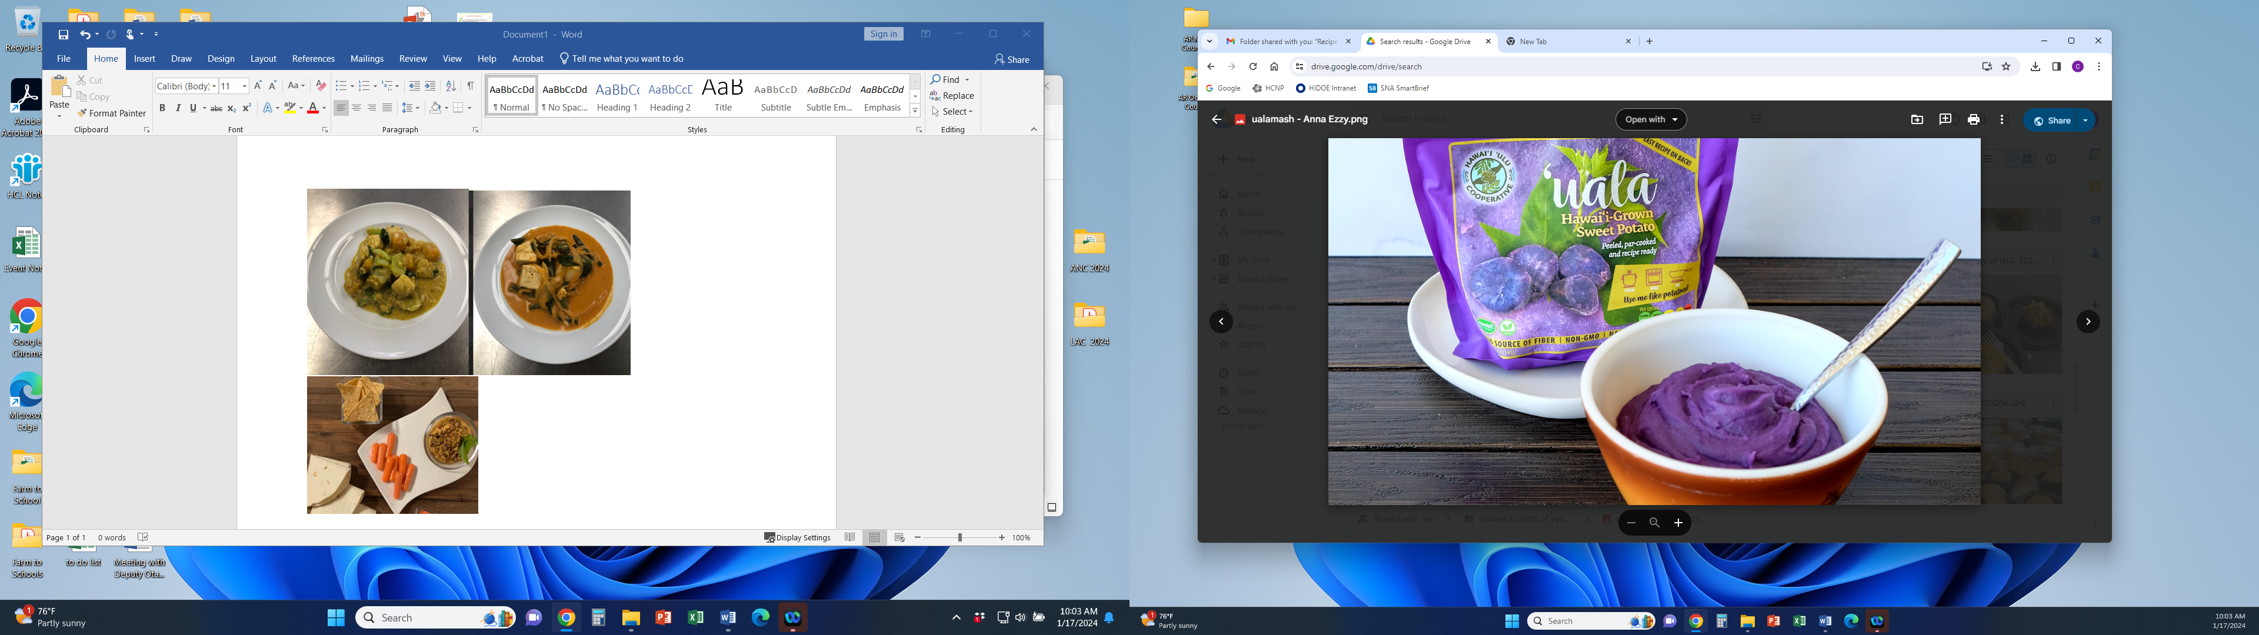

Our Mashed Purple Sweet Potato is prepared from local grown produce. It features garden fresh sweet potatoes from the fields with flavorful ingredients.

# Recipe Project Name: Fiscal Year 2021 Cohort B Team Nutrition Training Grant for School Meal Recipe Development

# *State Agency*

# Preparation Time: About 40 minutes

# Cook Time: 30 minutes

**NSLP/SBP crediting information:**

One ½ cup (4 oz disher) serving provides ¼ cup of starchy vegetables

| **INGREDIENTS** | | **50 SERVINGS** | | | **100 SERVINGS** | | | | **DIRECTIONS** |
| --- | --- | --- | --- | --- | --- | --- | --- | --- | --- |
| **Weight** | | **Measure** | **Weight** | | **Measure** | |
| **Purple sweet potato**- wash, peel, large dice, mash | | 7 lbs. 14.00 oz. | | 6 qts.  1 c. | 15 lbs. 12.00 oz. | | 3 gal. 1 pt. | | 1. (CCP) Place in full size perforated 2” hotel pans and steam uncovered or simmer in water until fork tender with internal temperature of 135 F/57 C or higher for 15 seconds. Remove from steamer or water and place in mixing machine bowl with paddle attachment then mash at low speed. |
| **Garlic clove**- ready to use, mince | | 4.20 oz. | | 3/4 c.  1/8 c. | 8.40 oz. | | 1 3/4 c. | | 1. (CP) Heat steam kettle/tilt skillet at low heat with oil. Add minced garlic and cook with metal stirring paddle until garlic fragrance appears. |
| **Light coconut milk**- ready to use, low sodium | | 3 lbs. 15.52 oz. | | 2 qts. | 7 lbs. 15.04 oz. | | 1 gal. | | 1. Add coconut milk and simmer until slightly thicker consistency then swirl in the butter. |
| **Margarine**- ready to use, low sodium | 10.50 oz. | | 1 1/4 c. | 1 lb. 5.00 oz. | | 2 1/2 c. | | 1. Pour infused coconut milk in mixing bowl with mashed potatoes and stir together until incorporated. Season with salt and pepper. |
| **Salt and black pepper seasoning mixture**- ready to use, table-iodized salt, ground pepper | 0.21 oz. | 1 t. | | | 0.42 oz. | | 2 t. | 1. Remove potato mixture from mixing bowl and place into hotel pans covered with plastic wrap.   (12” x 20” x 2 ½”)  For 50 servings, use 2 pans  For 100 servings, use 4 pans  Portion: 25 half cup servings per pan. Use 4 ounce,  (# 8) disher |
| **Canola oil**- ready to use, to cook ingredients | 0.50 oz. | 1 T. | | | 1.00 oz. | | 2 T. | 1. (CCP) Heat in the steamer covered with plastic wrap until internal temperature is 135 F/57 C or higher for service. |

**NUTRITION INFORMATION**

Amount Per Serving ½ cup (4 fl oz scoop)

**NUTRIENTS**

**Calories**

**AMOUNT**

**141**

**Total Fat**

Saturated Fat Cholesterol **Sodium**

**Total Carbohydrate** Dietary Fiber Total Sugars

Added Sugars included

**Protein**

**7 g**

3 g

0 mg

**39 mg**

**18 g**

1 g

7 g

0 g

**1 g**

Vitamin C Calcium Iron

1 mg

30 mg

1 mg

|  |  |  |
| --- | --- | --- |
| **MARKETING GUIDE** | | |
| **Food as Purchased for** | **50 Servings** | **100 Servings** |
| Purple sweet potato | 9 lbs. 13.50 oz. | 19 lbs. 11.00 oz. |

|  |
| --- |
| **NOTES** |
| *See Marketing Guide for purchasing information on foods that will change during preparation or when a variation of the ingredients is available.  Cooking Process: Same Day Service |

|  |  |
| --- | --- |
| **YIELD/VOLUME** | |
| **50 Servings** | **100 Servings** |
| About 12 lbs. 12.93 oz. | About 25 lbs. 9.87 oz. |

**SOURCE:**

FY 2021 Cohort B Team Nutrition Training Grant