Kabocha Thai Curry

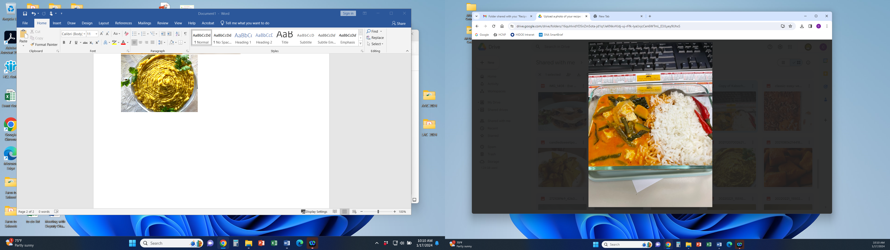

Our Kabocha Thai Curry is prepared from local grown produce. It features garden fresh vegetables from the fields with tender beans, tofu, coconut milk and aromatic flavorful ingredients.

# Recipe Project Name: Fiscal Year 2021 Cohort B Team Nutrition Training Grant for School Meal Recipe Development

# *State Agency*

# Preparation Time: About 50 minutes

# Cook Time: 40 minutes

**NSLP/SBP crediting information:**

One 1 cup (8 oz scoop) serving provides 1 oz eq meat/meat alternate, ¼ cup red/orange vegetables, and ¼ cup other vegetables

| **INGREDIENTS** | | **50 SERVINGS** | | | **100 SERVINGS** | | | | **DIRECTIONS** |
| --- | --- | --- | --- | --- | --- | --- | --- | --- | --- |
| **Weight** | | **Measure** | **Weight** | | **Measure** | |
| **Canola oil**- to cook ingredients | | 2.00 oz. | | 1/4 c. | 4.00 oz. | | 3/8 c. | |  |
| **White onion**- wash, peel, remove root end, thin slice/small dice | | 2 lb. 8.00 oz. | | 7 c. | 5 lbs. | | 1 qt.  1 pt.  1 c. | | 1. (CCP) Place cut squash in full size perforated 2” hotel pans and steam uncovered or simmer in water until fork tender with internal temperature of 135 F/57 C for 15 seconds. Remove from steamer/water and properly cool to 41 F/5 C or lower. |
| **Ginger root**- wash, peel, thin slice (matchstick) | | 6.15 oz. | | 1 1/2 c. | 12.30 oz. | | 1 pt.  1 c. | | 1. (CP) Blanch beans in boiling water until partially cooked then cool in ice water bath. Strain the beans in a colander to remove the water. Reserve on the side. |
| **Long beans/green beans (fresh)**- wash, trim stem end off, cut 2” length, par cook | 3 lbs. 8.00 oz. | | 1 qt.  1 pt.  1 c. | 7 lbs. | | 3 qt.  1 pt. | | 1. Heat steam kettle/tilt skillet at medium heat with oil and cook the onion until translucent then add ginger and continue the cooking process until a ginger fragrance appears. |
| **Vegetable broth**- low sodium | 8 lbs. 3.20 oz. | 1 gal.  1/3 c. | | | 16 lbs. 6.40 oz. | | 2 gal.  2/3 c. | 1. Add vegetable broth and red curry paste and mix ingredients together with the metal stirring paddle until incorporated then add beans and simmer mixture until beans are tender. |
| **Red curry paste**- mild | 0.5 lbs | 1 c. | | | 1 lb. | | 2 c. | 1. (CCP) Turn steam kettle/tilt skillet heat down to low and add in coconut milk and squash then carefully stir mixture until incorporated. Continue the cooking process for another 5 minutes then add the tofu and carefully stir in. Cook the mixture until internal temperature is 135 F/57 C or higher for 15 seconds. |
| **Light coconut milk**- low sodium | 7 lbs. 11.00 oz. | 3 qts.  1 pt.  1 c. | | | 15 lbs. 6.00 oz. | | 1 gal.  3 qts.  1 pt. | 1. Add in the basil and sugar then stir mixture together until incorporated. Turn heat off and place mixture into hotel pans for service. (12” x 20” x2 ½”)   For 50 servings, 2 pans.  For 100 serving, 4 pans.  Portion: 25 one cup servings per pan. Use 8 oz. spoodle. |
| **Kabocha/Butternut/ Acorn squash**- wash, remove stem, seed, peel, medium dice | 7 lbs. | 1 gal.  3 qts. | | | 14 lbs. | | 3 gal.  2 qts. |  |
| **Tofu**- firm, medium dice | 7 lbs. | 3 qts.  1/16 c. | | | 14 lbs. | | 1 gal.  2 qts.  2 T. |  |
| **Basil leaves**- fresh, wash, remove stem, whole/rough chop | 5.82 oz. | 1 qt.  1/8 c. | | | 11.64 oz. | | 2 qts.  1/4 c. |  |
| **Sugar**- granulated | 7.38 oz. | 1 c.  1 T. | | | 14.76 oz. | | 1 pt.  2 T. |  |

**NUTRITION INFORMATION**

Amount Per Serving 1 cup (8 fl oz spoodle)

**NUTRIENTS**

**Calories**

**AMOUNT**

**172**

**Total Fat**

Saturated Fat Cholesterol **Sodium**

**Total Carbohydrate** Dietary Fiber Total Sugars

Added Sugars included

**Protein**

**7 g**

3 g

0 mg

**277 mg**

**20 g**

5 g

5 g

0 g

**8 g**

Vitamin C Calcium Iron

11 mg

146 mg

2 mg

|  |  |  |
| --- | --- | --- |
| **MARKETING GUIDE** | | |
| **Food as Purchased for** | **50 Servings** | **100 Servings** |
| White onion  Ginger root  Long/Green beans  Kabocha squash  Basil leaves, fresh | 2 Lbs. 12.44 oz.  7.69 oz.  3 lbs.15.64 oz.  9 lbs. 9.55 oz.  10.39 oz. | 5 lbs. 8.88 oz.  15.38 oz.  7 lbs. 15.28 oz.  19 lbs. 1.16 oz.  1 lb. 4.78 oz. |

|  |
| --- |
| **NOTES** |
| *See Marketing Guide for purchasing information on foods that will change during preparation or when a variation of the ingredients is available.  Cooking Process: Same Day Service |

|  |  |
| --- | --- |
| **YIELD/VOLUME** | |
| **50 Servings** | **100 Servings** |
| About 39 lbs. 4.35 oz. | About 78 lbs. 8.70 oz. |

**SOURCE:**

FY 2021 Cohort B Team Nutrition Training Grant