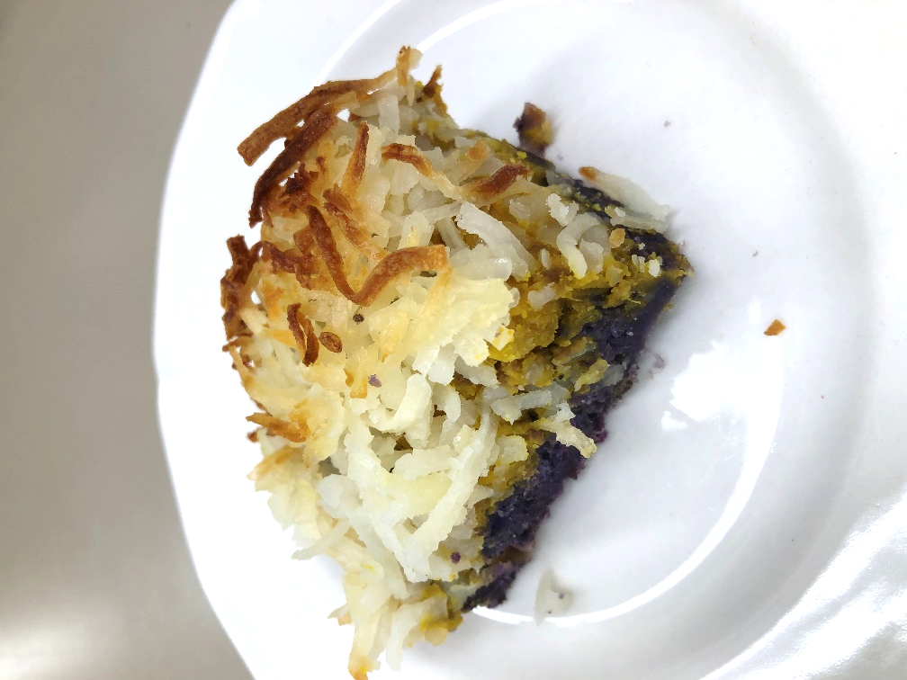

Kabocha Sweet Potato Pot Pie

Recipe Photo

Our Kabocha Sweet Potato Pot Pie is a combination of local raised cattle and produce. It features beef and fresh assorted garden vegetables

# Recipe Project Name: Fiscal Year 2021 Cohort B Team Nutrition Training Grant for School Meal Recipe Development

# *State Agency*

# Preparation Time: About 60 minutes

# Cook Time: 1 hour

**NSLP/SBP crediting information:**

One 6 oz serving provides 2 oz eq meat/meat alternate, ¼ cup red/orange vegetables and ¼ cup starchy vegetables.

| **INGREDIENTS** | | **50 SERVINGS** | | | **100 SERVINGS** | | | | **DIRECTIONS** |
| --- | --- | --- | --- | --- | --- | --- | --- | --- | --- |
| **Weight** | | **Measure** | **Weight** | | **Measure** | |
| **Kabocha/Butternut/ Acorn squash**- wash, remove stem, seeds, peel, large dice, coarse mash | | 8 lbs. 12.00 oz. | | 7 1/2 qts. | 17 lbs. 8.00 oz. | | 3 gal.  3 qts. | | 1. (CCP) Place squash and potato in separate full size perforated 2” hotel pans and steam uncovered or simmer in water until fork tender with internal temperature of 135 F/57 C or higher for 15 seconds. |
| **White/Purple sweet potato**- wash, peel, large dice, coarse mash | | 4.00 lb. | | 3 qts.  3/4 c. | 8.00 lb. | | 1 gal.  2 qts.  1 1/2 c. | | 1. Remove fork tender squash and potato from steamer or water and place in separate mixing machine bowls with paddle attachment then mash at low speed until coarse texture. Reserve in the mixing bowls on the side. |
| **Beef**- ready to use, (80/20) ground | | 8 lbs. 8.00 oz. | | 1 gal.  1 c. | 17.00 lb. | | 2 gal.  1 pt. | | 1. (CCP) Heat steam kettle/tilt skillet at medium heat with oil and cook the ground beef 20 minutes then add the minced garlic and continue cooking until garlic fragrance appears and internal temperature is 155 F/68 C for 15 seconds. |
| **Garlic clove**- ready to use clove, mince | 4.375 oz. | | 7/8 c. | 8.75 oz. | | 1 3/4 c. | | 1. Add half of the cooked meat mixture into mixing bowl with the squash and other half with the potato. Stir mixture together using paddle attachment until incorporated. Season with salt and pepper. |
| **Salt and black pepper seasoning mixture**- ready to use, table-iodized salt, ground pepper, see recipe | 0.05 oz. | 1/4 t. | | | 0.20 oz. | | 1/2 t. | 1. Remove meat and mashed squash/potato mixtures from mixing bowls. |
| **Canola oil**- ready to use, to cook ingredients | 1.69 oz. | 1/4 c. | | | 3.38 oz. | | 1/2 c. | 1. Place meat and mashed squash/potato mixture in two separate layers into12” x 20” x 2 ½” pans and evenly spread the mixture. Sprinkle cooked hash brown potato evenly on surface.   For 50 servings, 2 pans.  For 100 servings, 4 pans. |
| **Cooked dehydrated hash brown potato** (shredded) manufacture’s instructions | 4.50 lbs | 3 qts. | | | 9.00 lbs | | 1 gal.  2 qts. | 1. (CP) Pre-heat oven to 400 F/204 C and bake until crust is golden brown and internal temperature is 155 F/68 C for 15 seconds. |
|  |  |  | | |  | |  | 1. Cut into serving portions using a serrated knife for service.   Portion: 25 servings per pan. (cut 5 x 5) serving size one piece. (Approx. 2” x 3 ¾”) |

**NUTRITION INFORMATION**

Amount Per Serving 1 piece

**NUTRIENTS**

**Calories**

**AMOUNT**

**282**

**Total Fat**

Saturated Fat Cholesterol **Sodium**

**Total Carbohydrate** Dietary Fiber Total Sugars

Added Sugars included

**Protein**

**11 g**

4 g

58 mg  **293 mg**

**26 g**

2 g

3 g

N/A

**18 g**

Vitamin C Calcium Iron

11 mg

44 mg

2 mg

|  |  |  |
| --- | --- | --- |
| **MARKETING GUIDE** | | |
| **Food as Purchased for** | **50 Servings** | **100 Servings** |
| Kabocha squash  Purple sweet potato  Hash brown potato, dehydrated | 11 lbs.15.94 oz.  5.00 lbs.  1.50 lbs. | 23 lbs. 15.88 oz.  10.00 lbs.  3.00 lbs. |

|  |
| --- |
| **NOTES** |
| *See Marketing Guide for purchasing information on foods that will change during preparation or when a variation of the ingredients is available.  Cooking Process: Same Day Service |

|  |  |
| --- | --- |
| **YIELD/VOLUME** | |
| **50 Servings** | **100 Servings** |
| About 26 lbs. 2.12 oz. | About 52 lbs. 4.24 oz. |

**SOURCE:**

FY 2021 Cohort B Team Nutrition Training Grant