Kabocha Bean Dip

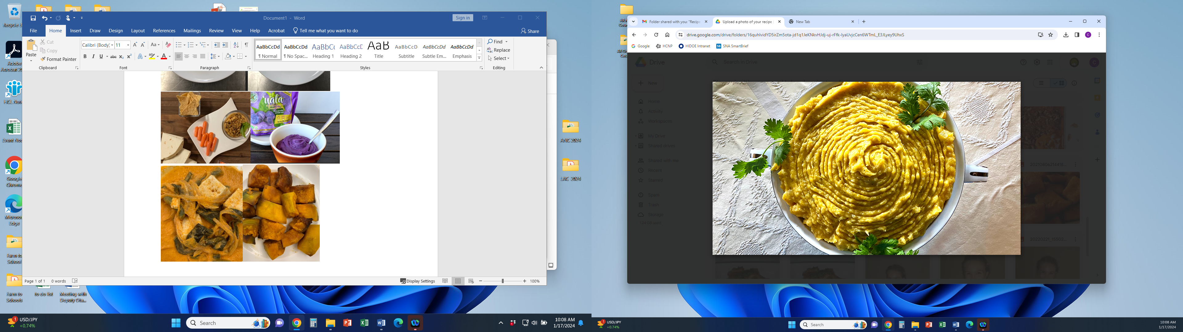

Our Kabocha Bean Dip is prepared from local grown produce. It features garden fresh squash from the fields with tender beans, tahini and aromatic flavorful ingredients.

# Recipe Project Name: Fiscal Year 2021 Cohort B Team Nutrition Training Grant for School Meal Recipe Development

# *State Agency*

# Preparation Time: About 45 minutes

# Cook Time: 30 minutes (fresh kabocha)

**NSLP/SBP crediting information:**

One ½ cup (4 oz scoop) provides:

*Legume as Meat/Meat Alternate:* 0.75 oz eq meat/meat alternate and 1/8 cup red/orange vegetables.

**OR**

*Legume as Vegetable:* 1/8 cup beans and peas (legumes) and 1/8 cup red/orange vegetables.

| **INGREDIENTS** | | **50 SERVINGS** | | | **100 SERVINGS** | | | | **DIRECTIONS** |
| --- | --- | --- | --- | --- | --- | --- | --- | --- | --- |
| **Weight** | | **Measure** | **Weight** | | **Measure** | |
| **Kabocha/Butternut/ Acorn squash**- wash, remove stem, seeds, peel, large dice, puree | | 4 lbs. 4.00 oz. | | 3 qts.  1 ½ pts. | 8 lbs. 8.00 oz. | | 1 gal.  3 qts.  1 pt. | | 1. (CCP) Place squash in full size perforated 2- inch hotel pans and steam uncovered or simmer in water until fork tender with internal temperature of 135 F/57 C or higher for 15 seconds. |
| **Water**- ready to use, cold water | | 1 lbs. 1.40 oz. | | 2 c.  1/8 c. | 2 lbs. 2.80 oz. | | 2 pts.  1/4 c. | | 1. (CP) Place whole garlic cloves in a mixing bowl and toss together with a little canola oil. Remove from bowl and place on full size sheet pans then bake in the oven at 375 F/190 C until tender with light brown color. Remove from oven and properly cool to 41 F/5 C or lower within 4 hours. Reserve on the side. |
| **Whole Garlic cloves**- peel, bake till tender/light brown, mince/mash | | 1 lbs. | | 1 ½ qts. | 2 lbs | | 3 qts. | | 1. Remove beans from can and drain in a strainer. Combine with garlic and place in mixing machine bowl with paddle attachment and puree until mashed. Remove from bowl and reserve on the side. |
| **Salad oil**- ready to use | | 8.47 oz. | | 1 ¼ c. | 1 lb. 15.04 oz. | | 2 1/2 c. | | 1. (CCP) Remove fork tender squash from steamer or water strained and place in mixing machine bowl with paddle attachment and puree until mashed then add beans with garlic. Blend together on medium speed until combined. Remove from machine bowl and properly cool to 41 F/5 C or lower within 4 hours. |
| **Cannellini beans/white kidney beans**- ready to use, low sodium, canned, drain, puree | | 4 lbs. | | 2 qts.  1 pt. | 8 lbs. | | 1 gal.  1 qt. | | 1. Place cool squash/bean mixture back into the machine mixing bowl with paddle attachment. Add remaining ingredients into mixing bowl and stir mixture together on low speed until incorporated. |
| **Lemon juice**- ready to use | | 6.525 oz. | | 3/4 c. | 13.05 oz. | | 1 1/2 c. | | 1. (CP) Remove from mixing bowl and place in hotel pans covered with plastic wrap and place in refrigerator at 41 F/5 C or lower until service. (12” x 20” x 2 ½”)   For 50 servings, use 1 pan.  For 100 servings, 2 pans.  Portion: ½ cup serving. Use 4 ounce, (# 8) disher |
| **Tahini paste**- ready to use, blend paste/liquid together | 13.05 oz. | 1 ½ c. | | | 1 lb. 10.10 oz. | | 1 pt.  1 c. |  |
| **Salt**- ready to use, table-iodized salt | 0.653 oz. | 2 ½ t. | | | 1.30 oz. | | 1 T.  2 t. |  |
| **White pepper**- ready to use, ground | 0.087 oz. | 1 t. | | | 0.174 oz. | | 2 t. |  |
| **Curly leaf parsley**- fresh, wash, dry, chop | 1.958 oz. | 1 ½ c. | | | 3.916 oz. | | 1 pt.  1 c. |  |
| **Cinnamon**- ready to use, ground | 0.087 oz. | 1 t. | | | 0.174 oz. | | 2 t. |  |
| **Cumin**- ready to use, ground | 0.131 oz. | 2 t. | | | 0.262 oz. | | 1 T.  1 t. |  |
| **Paprika**- ready to use, smoked, ground | 0.087 oz. | 1 t. | | | 0.174 oz. | | 2 t. |  |

**NUTRITION INFORMATION**

Amount Per Serving ½ cup (No. 8 scoop)

**NUTRIENTS**

**Calories**

**AMOUNT**

**163**

**Total Fat**

Saturated Fat Cholesterol **Sodium**

**Total Carbohydrate** Dietary Fiber Total Sugars

Added Sugars included

**Protein**

**10 g**

1 g

0 mg  **171 mg**

**17 g**

4 g

1 g

0 g

**4 g**

Vitamin C Calcium Iron

11 mg

73 mg

2 mg

|  |  |  |
| --- | --- | --- |
| **MARKETING GUIDE** | | |
| **Food as Purchased for** | **50 Servings** | **100 Servings** |
| Kabocha squash  Curly parsley, fresh | 5 lbs. 13.23 oz.  2.58 oz. | 11 lbs. 10.45 oz.  5.16 oz. |

|  |
| --- |
| **NOTES** |
| *See Marketing Guide for purchasing information on foods that will change during preparation or when a variation of the ingredients is available.  Cooking Process: Same Day Service |

|  |  |
| --- | --- |
| **YIELD/VOLUME** | |
| **50 Servings** | **100 Servings** |
| About 12 lbs. 4.45 oz. | About 24 lbs. 10.90 oz. |

**SOURCE:**

FY 2021 Cohort B Team Nutrition Training Grant