Honey Butter Roasted Squash

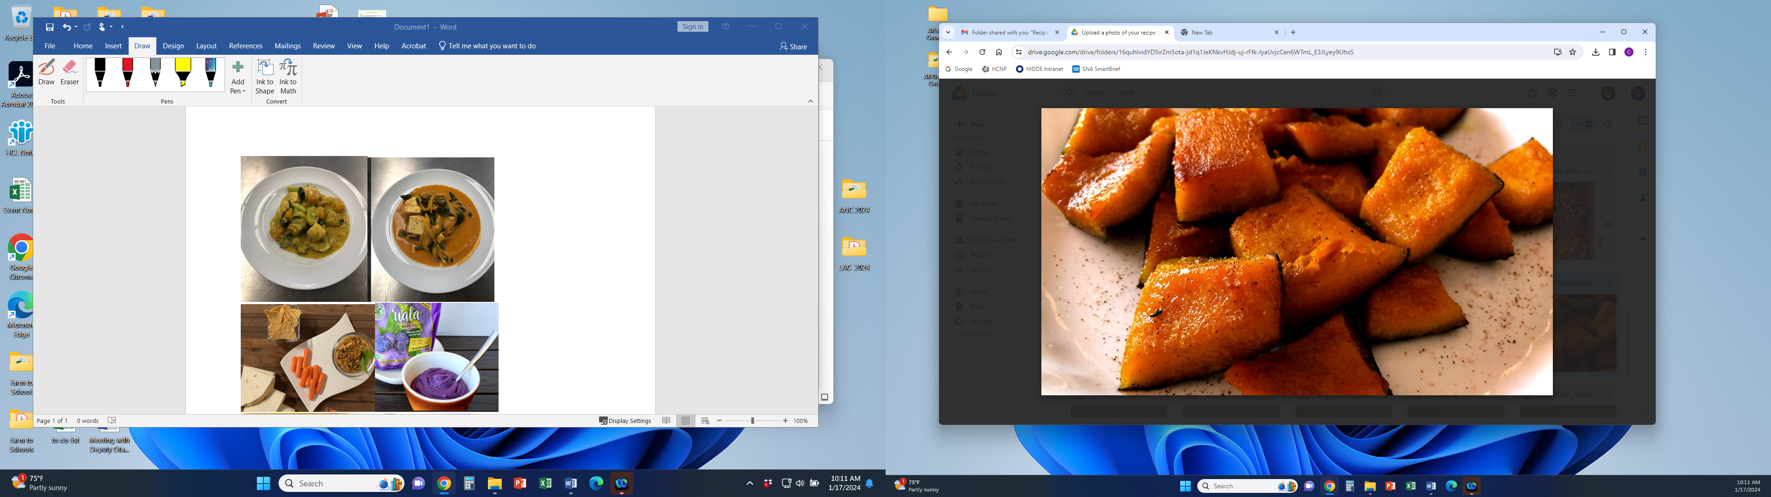

Our Honey Butter Roasted Squash is prepared from local grown produce. It features garden fresh winter squash from the fields with flavorful ingredients.

# Recipe Project Name: Fiscal Year 2021 Cohort B Team Nutrition Training Grant for School Meal Recipe Development

# *State Agency*

# Preparation Time: About 45 minutes

# Cook Time: 13 minutes

**NSLP/SBP crediting information:**

One 6 oz serving provides ½ cup of red/orange vegetable

| **INGREDIENTS** | | **50 SERVINGS** | | | **100 SERVINGS** | | | | **DIRECTIONS** |
| --- | --- | --- | --- | --- | --- | --- | --- | --- | --- |
| **Weight** | | **Measure** | **Weight** | | **Measure** | |
| **Kabocha/Butternut/ Acorn squash**- Wash, remove stem, seeds, cut 1 ½ inch cube | | 13 lbs. 8.00 oz. | | 11 qts.  1 ½ pts. | 27 lbs. | | 5 gal.  3 qts.  1 pt. | | 1. Pre- heat oven to 400 F/204 C. |
| **Butter**- ready to use, melt, low sodium) | | 14.25 oz. | | 1 c.  3/4 c. | 1 lb. 12.50 oz. | | 3 1/2 c. | | 1. Melt butter in a pot then pour into mixing bowl. Add honey and blend together until incorporated. |
| **Honey**- ready to use | | 1 lbs. 8.00 oz. | | 2 c. | 3 lbs. | | 2 pts. | | 1. Add squash and toss together with honey and butter until all the squash is coated. Season to taste with cayenne pepper. |
| **Cayenne pepper**- ready to use, ground | 0.285 oz. | | 1 T.  1 ½ t. | 0.57 oz. | | 3 T. | | 1. (CCP) Remove squash from bowl and place on foil lined full size sheet pans then bake at 400 F/204 C until tender and internal temperature is 135 F/57 C or higher for 15 seconds. |
|  |  |  | | |  | |  | 1. Remove from oven and place into hotel pans for service. (12” x 20” x 2 ½”)   For 50 servings, use 2 pans.  For 100 servings, use 4 pans.  Portion: 25 three quarter cup servings per pan. Use 6 ounce spoodle. |

**NUTRITION INFORMATION**

Amount Per Serving 1 cup (8 oz spoodle)

**NUTRIENTS**

**Calories**

**AMOUNT**

**148**

**Total Fat**

Saturated Fat Cholesterol **Sodium**

**Total Carbohydrate** Dietary Fiber Total Sugars

Added Sugars included

**Protein**

**7 g**

4 g

17 mg

**5 mg**

**24 g**

2 g

11 g

N/A

**1 g**

Vitamin C Calcium Iron

14 mg

43 mg

1 mg

|  |  |  |
| --- | --- | --- |
| **MARKETING GUIDE** | | |
| **Food as Purchased for** | **50 Servings** | **100 Servings** |
| Winter squash | 18 lbs. 8.13 oz. | 37 lbs. 0.27 oz. |

|  |
| --- |
| **NOTES** |
| *See Marketing Guide for purchasing information on foods that will change during preparation or when a variation of the ingredients is available.  Cooking Process: Same Day Service |

|  |  |
| --- | --- |
| **YIELD/VOLUME** | |
| **50 Servings** | **100 Servings** |
| About 15 lbs. 14.53 oz. | About 31 lbs. 13.07 oz. |

**SOURCE:**

FY 2021 Cohort B Team Nutrition Training Grant