Enchilada Casserole

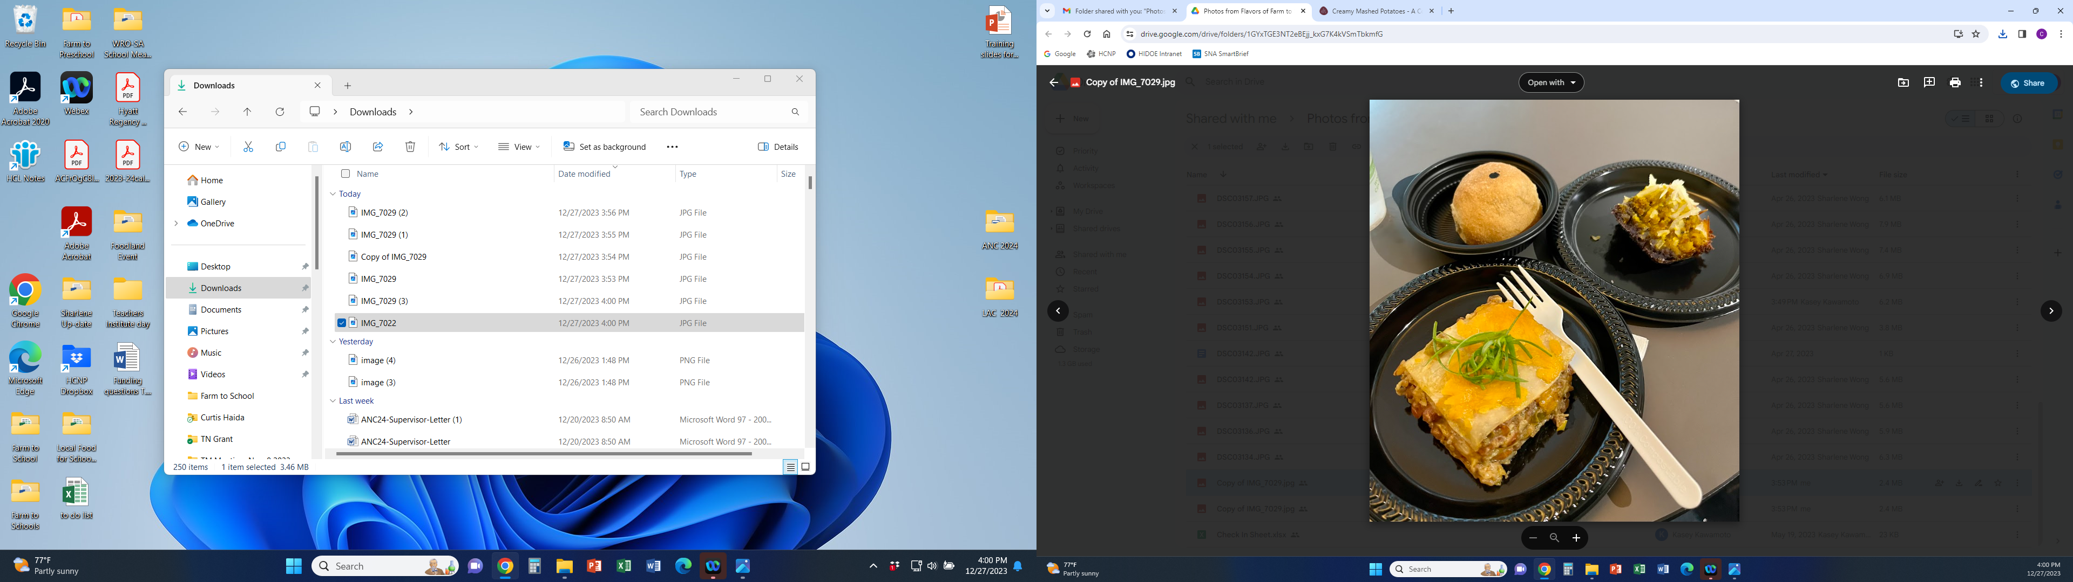

Our Enchilada Casserole is a combination of local raised cattle and produce. It features beef, beans, cheddar cheese, fresh assorted garden vegetables and aromatic spices served with flour tortilla

# Recipe Project Name: Fiscal Year 2021 Cohort B Team Nutrition Training Grant for School Meal Recipe Development

# *State Agency*

# Preparation Time: About 45 minutes

# Cook Time: 40 minutes

**NSLP/SBP crediting information:**

One 6 oz serving provides 2 oz eq meat/meat alternate, 0.5 oz eq grains, 1/8 cup other vegetables and 1/8 cup of additional vegetables

| **INGREDIENTS** | | **50 SERVINGS** | | | **100 SERVINGS** | | | | **DIRECTIONS** |
| --- | --- | --- | --- | --- | --- | --- | --- | --- | --- |
| **Weight** | | **Measure** | **Weight** | | **Measure** | |
| **Carrot**- wash, peel, remove root end, small dice | | 1 lb. 4.00 oz. | | 4 c. | 2 lb. 8.00 oz. | | 2 qts. | | 1. (CP) Heat steam kettle/tilt skillet at medium heat with oil. Cook the ground beef 20 minutes and internal temperature is 155 F/68 C for 15 seconds then add the minced garlic and carrot, green bell pepper, and onion. Continue the cooking process until beef and vegetables are cooked. |
| **Green bell pepper**- wash, remove stem/seeds, small dice | | 1 lb. 4.00 oz. | | 4 c. | 2 lb. 8.00 oz. | | 2 qts. | | 1. Add the enchilada seasoning and water then stir with metal stirring paddle until well incorporated. |
| **White onion**- wash, peel, remove root end, small dice | | 1.50 lb. | | 6 c. | 3.00 lb. | | 3 qts. | | 1. (CCP) Turn steam kettle/tilt skillet heat to low and add sour cream, beans, cilantro, green onion and lime juice. Simmer for another 5 minutes stirring occasionally and internal temperature is 155 F/68 C for 15 seconds. Turn heat off and remove mixture. |
| **Green onion**- wash, remove root end, small dice | 4.00 oz. | | 2 c. | 8.00 oz. | | 1 qt. | | 1. (CCP) Properly cool mixture down to 41 F/5 C or lower within 4 hours. Place into hotel pans for next day service covered with plastic wrap and refrigerated at 41 F/5 C or lower. |
| **Garlic clove**- ready to use clove, mince | 1.035 oz. | 2 T. | | | 2.07 oz. | | 1/4 c. | 1. Pre-heat oven to 400 F/205 C. Now to assemble the casserole. |
| **Cilantro with stem**- wash, dry, small chop | 2.00 oz. | 1 ½ c. | | | 4.00 oz. | | 1 pt.  1 c. | 1. Place flour tortilla on the bottom of 12” x 20” x 2 ½” rectangle hotel pan, a thin layer of grated cheese, and a layer of vegetable/meat mixture. |
| **Lime juice**- ready to use | 1.725 oz. | 2 T.  4 1/2 t. | | | 3.45 oz. | | 1/4 c.  3 T. | 1. Add another layer of flour tortilla, cheese and a layer of vegetable/meat mixture. Top it with last layer of flour tortilla then one more layer of grated cheese. Pre-cut into serving portions and cover pan with foil.   For 50 servings, use 2 pans.  For 100 servings, use 4 pans. |
| **Canola oil**- ready to use, to cook ingredients | 1.69 oz. | 1/4 c. | | | 3.38 oz. | | 1/2 c. | 1. (CCP) Bake for 45 minutes, remove foil and continue baking until cheese is melted and internal temperature reaches 165 F/74 C for 15 seconds. Remove from oven for service.   Portion: 25 servings per pan. (cut 5 x 5) Serving size is one piece. (Approx. 2” x 3 ¾”) |
| **Beef**- ready to use, (80/20) ground | 3.50 lb. | 1 qt.  3 c. | | | 7.00 lb. | | 3 qts.  1 pt. | Note: Each pan has 3 cheese layers, 3 tortilla layers, 2 meat mixture layers. |
| **Sour cream, fat free** ready to use | 1.75 lb. | 1 pt.  1 1/4 c. | | | 3.50 lb. | | 1 qt.  2 1/2 c. |  |
| **Enchilada seasoning**- ready to use | 5.175 oz. | 2 T.  1 t. | | | 10.35 oz. | | 1/4 c.  2 t. |  |
| **Water**- ready to use | 2.587 lb. | 1 qt.  1 1/8 c. | | | 5.175 lb. | | 2 qts.  2 1/4 c. |  |
| **Pinto beans, low sodium, canned**- ready to use | 3.25 lb. | 8 1/2 c. | | | 6.50 lb. | | 1 gal.  1 c. |  |
| **Cheddar cheese, low sodium**- ready to use, grated, (14.66 oz./layer) | 2.75 lb. | 5 1/2 pts. | | | 5.50 lb. | | 1 gal.  1 1/2 qts |  |
| **10” Wheat flour tortilla**- ready to use, (6-2.00 oz./ea.) | 2.25 lb. | 18 pcs. | | | 4.50 lb. | | 36 pcs. |  |

**NUTRITION INFORMATION**

Amount Per Serving 1 piece

**NUTRIENTS**

**Calories**

**AMOUNT**

**286**

**Total Fat**

Saturated Fat Cholesterol **Sodium**

**Total Carbohydrate** Dietary Fiber Total Sugars

Added Sugars included

**Protein**

**12 g**

6 g

43 mg  **820 mg**

**27 g**

4 g

2 g

0 g

**18 g**

Vitamin C Calcium Iron

11 mg

122 mg

2 mg

|  |  |  |
| --- | --- | --- |
| **MARKETING GUIDE** | | |
| **Food as Purchased for** | **50 Servings** | **100 Servings** |
| Carrot  Green bell pepper  White onion  Green onion  Cilantro | 1 lb. 8.39 oz.  1 lb. 8.39 oz.  1 lb. 10.97 oz.  6.67 oz.  2.67 oz. | 3 lbs. 0.78 oz.  3 lbs. 0.78 oz.  3 lbs. 5.94 oz.  13.34 oz.  5.34 oz. |

|  |
| --- |
| **NOTES** |
| *See Marketing Guide for purchasing information on foods that will change during preparation or when a variation of the ingredients is available.  Cooking Process: Complex Food Preparation |

|  |  |
| --- | --- |
| **YIELD/VOLUME** | |
| **50 Servings** | **100 Servings** |
| About 21 lbs. 0.353 oz. | About 42 lbs.0.706 oz. |

**SOURCE:**

FY 2021 Cohort B Team Nutrition Training Grant