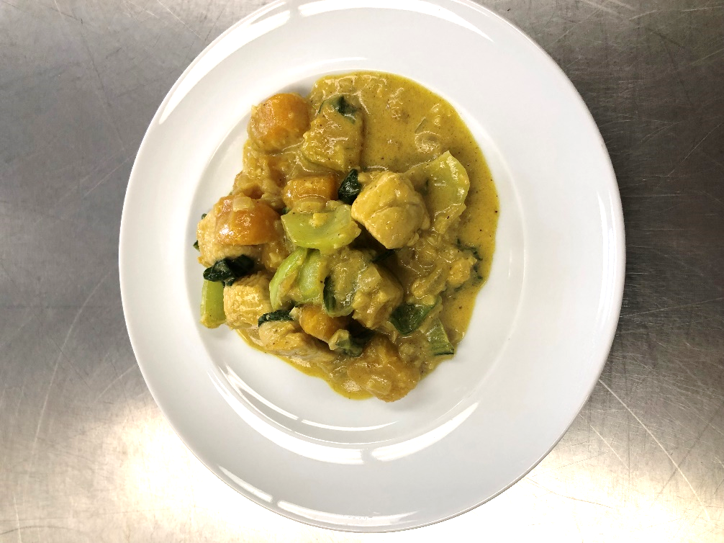

Curried Kabocha Squash and Chicken Stew

Recipe Photo

Our Curried Kabocha Squash and Chicken Stew is prepared from local grown produce. It features chicken, coconut milk and garden fresh vegetables from the fields

# Recipe Project Name: Fiscal Year 2021 Cohort B Team Nutrition Training Grant for School Meal Recipe Development

# *State Agency*

# Preparation Time: About 55 minutes

# Cook Time: 25 minutes

**NSLP/SBP crediting information:**

One 8 oz serving provides 2 oz eq meat/meat alternate, 3/8 cup dark green vegetables, 1/8 cup red/orange vegetables, and 1/8 cup additional vegetables

| **INGREDIENTS** | | **50 SERVINGS** | | | **100 SERVINGS** | | | | **DIRECTIONS** |
| --- | --- | --- | --- | --- | --- | --- | --- | --- | --- |
| **Weight** | | **Measure** | **Weight** | | **Measure** | |
| **Light coconut milk**- ready to use, low sodium | | 4 lbs. 0.34 oz. | | 2 qts. | 8 lbs. 0.68 oz. | | 1 gal. | | 1. Place squash in full size perforated 2” hotel pans and steam uncovered or simmer in water until half cooked. Remove from steamer or water and reserve on the side. |
| **Curry powder** – ready to use, ground | | 3.00 oz. | | 4 1/2 T. | 6.00 oz. | | 1/2 c.  1 T. | | 1. (CP) On a separate cutting board cut chicken. |
| **Ginger root**- wash, peel, mince | | 3.00 oz. | | 2/3 c. | 6.00 oz. | | 1 1/3 c. | | 1. (CP) Heat steam kettle/tilt skillet at medium heat with oil and cook the onion until translucent and garlic until sweet fragrance appears then add the chicken and cook until browned. Add bok choy and cook until tender. |
| **Kabocha/Butternut/**  **Acorn squash**- wash, remove stem, seed, peel, medium dice | 4 lbs. 8.00 oz. | | 6 qts.  1 1/2 pts. | 9 lbs. | | 3 gal.  1 qt.  1 pt. | | 1. Turn steam kettle/tilt skillet heat to low and add ginger, curry powder, coconut milk, water, squash, and stir mixture until incorporated. |
| **Chicken thigh, boneless/skinless**- medium dice | 10 lbs. | 7 qts.  3/4 c. | | | 20 lbs. | | 3 gal.  2 qts.  1 1/2 c. | 1. (CCP) Simmer mixture and add a little more water (as needed) to cover the squash to continue the cooking process until fork tender and internal temperature is 165 F/74 C for 15 seconds. |
| **Garlic clove**- mince | 9.00 oz. | 1 7/8 c. | | | 1 lb. 2.00 oz. | | 3 3/4 c. | 1. Season mixture with salt and pepper. Turn heat off and place mixture into hotel pans. (12” x 20” x 2 ½”)   For 50 servings, use 2 pans.  For 100 servings, use 4 pans  Portion: 25 one cup servings per pan. Use 8 ounce spoodle. |
| **White onion**- wash, peel, remove root end, small dice | 2 lbs. | 8 c. | | | 4 lbs. | | 1 gal. |  |
| **Bok choy/Pak choy**- wash, remove core end, chop 1 inch medium dice | 4 lbs. 8.00 oz. | 7 qts.  1 c. | | | 9 lbs. | | 3 gal.  2 qts.  1 pt. |  |
| **Water**- ready to use | 3 lbs. 5.00 oz. | 6 1/2 c. | | | 6 lbs. 10.00 oz. | | 3 qts.  1 c. |  |
| **Canola oil**- ready to use, to cook ingredients | 2.00 oz. | 4 T.  2 t. | | | 4.00 oz. | | 1/2 c.  4 t. |  |
| **Salt and white pepper seasoning mixture**- ready to use, table-iodized salt, ground pepper | 0.212 oz. | 1 t. | | | 0.424 oz. | | 2 t. |  |

**NUTRITION INFORMATION**

Amount Per Serving 1 cup (8 fl oz spoodle)

**NUTRIENTS**

**Calories**

**AMOUNT**

**272**

**Total Fat**

Saturated Fat Cholesterol **Sodium**

**Total Carbohydrate** Dietary Fiber Total Sugars

Added Sugars included

**Protein**

**16 g**

5 g

69 mg **99 mg**

**12 g**

3 g

2 g

0 g

**21 g**

Vitamin C Calcium Iron

26 mg

89 mg

2 mg

|  |  |  |
| --- | --- | --- |
| **MARKETING GUIDE** | | |
| **Food as Purchased for** | **50 Servings** | **100 Servings** |
| Ginger root  Winter squash  White onion  Bok choy | 3.75 oz.  6 lbs. 2.71 oz.  2 lbs. 3.95 oz.  5 lbs. 8.89 oz. | 7.50 oz.  12 lbs. 5.42 oz.  4 lbs. 7.90 oz.  11 lbs. 1.78 oz. |

|  |
| --- |
| **NOTES** |
| *See Marketing Guide for purchasing information on foods that will change during preparation or when a variation of the ingredients is available.  Cooking Process: Same Day Service |

|  |  |
| --- | --- |
| **YIELD/VOLUME** | |
| **50 Servings** | **100 Servings** |
| About 28 lbs. 6.55 oz. | About 56 lbs. 13.10 oz. |

**SOURCE:**

FY 2021 Cohort B Team Nutrition Training Grant