RECIPE FOR: Paniolo Stew

Our Paniolo Stew is a combination of local raised cattle and produce. It features beef and fresh assorted garden vegetables

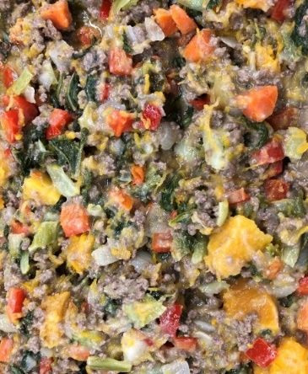

Prep Time: 30 minutes Serving per Recipe: 6
Cooking Time: 36 minutes Serving Size: 6.00 oz.
Amount Ingredient Preparation
1 tsp. Canola oil ready to use, to cook ingredients
13.28 oz. Beef (80/20) ground ready to use
5/8 c. White onion, medium peel, small dice
2 1/8 c. Choy sum/Bok choy remove root end, medium dice, par cook
3/8 c. Carrot, large wash, peel, medium dice, par cook
3/8 c. Red bell pepper remove stem/seed, medium dice
1 c. Mashed potatoes peel, large dice, cook, mash
1 3/4 c. Kabocha squash peel, remove seed, par cooked, large dice
to taste Salt and pepper table-iodized salt, ground pepper

Procedures-
- Place cut kabocha and potato in separate pots and steam or simmer in water until fork tender with (CCP) internal temperature of 135 F/57 C or higher for 15 seconds.
- Remove fork tender squash and potato from steamer or water and place in separate mixing bowls then mash until coarse texture. Reserve in the bowls on the side.
- Heat skillet pan at medium heat with oil and cook ground beef 6 minutes then add onions and continue the cooking process until both are cooked thoroughly. Add choy sum and all other vegetables and cook ingredients until tender and (CCP) internal temperature is 155º F/68º C for 15 seconds.
- Turn skillet pan heat down to low and add reserved mashed potatoes and squash then stir the mixture together with a wooden spoon until incorporated. Season to taste with salt and pepper.
- Turn heat off and place mixture into serving dish.
Note: (CCP) stands for Critical Control Point.

