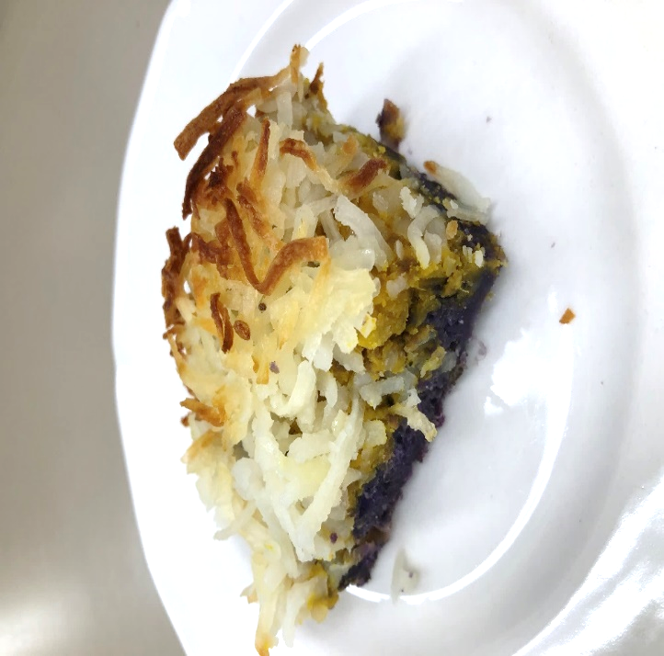
RECIPE FOR: Kabocha Sweet Potato Pot Pie
Our Kabocha Sweet Potato Pot Pie is a combination of local raised cattle and produce. It features beef and fresh assorted garden vegetables.

Prep Time: 26 minutes Serving per Recipe: 12
Cooking Time: 28 minutes Serving Size: 6.00 oz.
Amount Ingredient Preparation
7 1/2 c. (2 ¼ lb.) Kabocha squash wash, peel, remove stem/seed, large dice, cook, strain, coarse mash
3 1/8 c. (1 lb.) Purple sweet potato wash, peel, large dice, coarse mash
2 1/4 lb. Ground beef (80/20) ready to use
3 1/2 T. Garlic cloves fine chop ready to use
1 T. Canola oil ready to use, to cook ingredients
3 c. Dehydrated Hash brown potato cooked, follow the cooking instructions
(shredded) on the product packaging instructions
to taste Salt and black pepper table-iodized salt, ground pepper

Procedures-
- Place cut kabocha and sweet potato in separate pots and steam or simmer in water until fork tender with internal temperature of 135 F/57 C or higher for 15 seconds.
- Remove fork tender kabocha and sweet potato from steamer or water and place in separate mixing bowls. Mash until it is a coarse texture. Set the bowls on the side.
- Heat skillet pan at medium heat with oil and cook ground beef for 12 minutes. Then add garlic and continue cooking until garlic fragrance appears and internal temperature is 155 F/68 C for 15 seconds.
- Add half of the cooked meat mixture into the mixing bowl with the kabocha. Stir together with a wooden spoon until well incorporated. Season to taste with salt and pepper.
- Add the other half of the cooked meat mixture into the mixing bowl with the sweet potato. Stir together with a wooden spoon until well incorporated. Season to taste with salt and pepper.
- In a 13” x 9” X 2” baking pan, place the mashed sweet potato mixture on the bottom. Spread mixture evenly. Then, place the mashed kabocha mixture on top of the sweet potato layer. Spread mixture evenly. Sprinkle cooked hash brown potatoes on top of kabocha layer.
- Preheat oven to 400 F/ 204 C. Bake until crust is golden brown and internal temperature is 155 F/ 68 C or higher for 15 seconds

