Hawaii Child Nutrition Programs
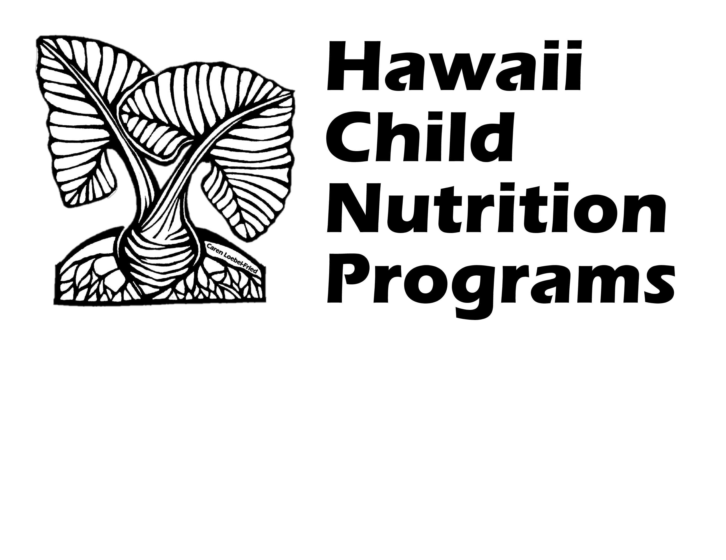
Calendar of School Nutrition Program Requirements and Activities for SY 2023-2024

This calendar should assist Hawaii schools and institutions that participate in the U. S. Department of Agriculture (USDA) school nutrition programs with planning for the school year. School Food Authorities (SFA) and sponsors should distribute this calendar to each person responsible for completing tasks related to the National School Lunch Program (NSLP), the School Breakfast Program (SBP), the Afterschool Snack Program (ASP), Fresh Fruit and Vegetable Program (FFVP), NSLP Equipment Grant, Summer Food Service Program (SFSP), and Seamless Summer Option (SSO).

Notes: Schedules/due dates are subject to change and do not represent all federal and state requirements for operating the USDA Child Nutrition Programs in schools and institutions. HCNP will notify all SFAs/sponsors via email of any updated guidance and deadlines provided by USDA as it becomes available. All SFAs/sponsors should continue to check their email regularly to ensure that updates from HCNP are received in a timely manner.

WHEN | REPORT/ACTION | DUE DATE | SUBMIT OR FILE
Monthly | Previous month’s claim for reimbursement | 10th of each month | Submit to HCNP: Submit via HCNP Systems.
Annually | Single Audit Report* | 30 days after completion, or 9 months after the end of the fiscal year, whichever is sooner. | Submit audit report to Federal Audit Clearinghouse
Annually | Annual NSLP Renewal Application and Upload of Required Offline Forms | Annually by specified deadline | Submit to HCNP: Submit via HCNP Systems. Annual update required. Update with any changes throughout the school year to keep information current.

WHEN | REPORT/ACTION | DUE DATE | SUBMIT OR FILE
Annually | Paid Lunch Equity Tool for SY 23-24* | September 8, 2023 | Submit to HCNP: Email response or completed tool to HCNP Accountants
Before the end of the academic school year | Summer Food Service Program (SFSP) Outreach  - Conduct outreach to inform families of the availability and location of free SFSP meals when school is not in session | Before the end of the academic school year | File at SFA: Copy of outreach done
Summer | Public Media Release for Free and Reduced Price Meals | July 2023 | File at SFA: Copy of public media release materials sent
Summer | Public Media Release for Community Eligibility Provision Schools / Provision 2 Schools | July 2023 | File at SFA: Copy of public media release materials sent
Annually | Annual Civil Rights Training | Annually | File at SFA: Training documentation
Annually Twice a Year | Two Food Safety Inspections (or written request for inspections)  - Post most current inspection in a publicly visible area | Twice each school year | File at SFA: Food safety inspections and/or written requests for inspections
Beginning of school year and throughout school year | School Breakfast Program Outreach  - Conduct outreach at the beginning of the school year and multiple times throughout the school year (e.g. at the beginning of each semester or quarter) | Beginning of school year and throughout school year | File at SFA: Copy of outreach done at each time

WHEN | REPORT/ACTION | DUE DATE | SUBMIT OR FILE
Prior to the 1st day of school and throughout school year | Free and Reduced Price Meal Application  - Distribute to all households  - SFAs cannot require any child/household to submit an application  - However, households have the right to submit an application at any time during the school year | After July 1 but prior to the start of school, distribute to all households. Process and implement within 10 operating days of receipt | File at SFA: Copies of letters to households, approved and denied application, lists of students enrolled in the federally funded Head Start Program, all direct certification lists, and a list of students designated as homeless, migrant or runaway.
July and ongoing | Identify Directly Certified Students in HCNP Systems  - SFAs participating in CEP in SY 23-24 are still required to conduct monthly direct certification matching. | Monthly throughout the school year | File at SFA: Documentation of student eligibility
Within 1st 4 weeks of participation and again during the year | Afterschool Snack Program Site Monitoring – Twice a year:  Complete ASP-3 Form | Review #1: within 1st 4 weeks of participation;  Review #2: during the year | File at SFA: Documentation of review, findings, and corrective action
End of Carryover of Student Eligibility | 31st day of school:  A student’s prior school year free or reduced price eligibility is in effect for up to 30 operating days into the current school year (or until a new eligibility determination is made, whichever comes first). | 31st day of school | File at SFA:  Documentation of students whose carryover eligibility from SY 22-23 ended.
June-October | Annual Financial Report* and Nonprogram Revenue Report* | November 10, 2023 | Submit to HCNP: Email completed reports to HCNP Accountant
October | National Farm to School Month |  | N/A
October | National School Lunch Week:  October 9-13, 2023 | October 2023 | N/A

WHEN | REPORT/ACTION | DUE DATE | SUBMIT OR FILE
October- November | Conduct Verification | November 15, 2023  Completion of verification activities | File at SFA: Verification activities must be fully documented and kept on file. Refer to USDA Eligibility Manual for School Meals for guidance.
October 31 | Civil Rights Ethnic Data Report (Form O-4c) | October 31, 2023 | File at SFA: Completed form
October 2 | October Survey | November 6, 2023 | Submit to HCNP: Submit via HCNP Systems
Prior to start of school year - November | Second Review of Applications Report:  Requires SFAs who are at risk to have another person, other than the determining official, do a second review of applications and document results (NOTE: HCNP notifies SFAs that are required to complete the report) |  | Submit to HCNP: Completed forms for the Second Review of Applications Report
December | Verification Collection Report (FNS-742)* | December 8, 2023 | Submit to HCNP: Submit via HCNP Systems and file at SFA
Prior to February | NSLP and SBP On-site Monitoring:  Complete Point of Service Review (Form MC-7)  - Required if the SFA has more than one site; however, HCNP highly recommends ALL SFAs conduct on-site monitoring  - If meals are also served in the classroom, complete the Meals in the Classroom Monitoring Checklist Form | Prior to February 1, 2024 | File at SFA: Documentation of review, findings, corrective action, and follow-up
March | Summer Mapper:  Complete Summer Mapper Template if participating in Seamless Summer Option (SSO) during summer 2024 | March 1, 2024 | Submit to HCNP: Email completed form to NSLP Specialist.
March | USDA Foods requests placed in Web Based Supply Chain Management system (WBSCM) | March 15, 2024 | Submit in WBSCM
March | National School Breakfast Week:  March 4-8, 2024 | March | N/A

WHEN | REPORT/ACTION | DUE DATE | SUBMIT OR FILE
April | Annual Community Eligibility Provision (CEP) Notification Requirement:  Complete CEP Data Collection Form for SY 2024-2025 | April 2024 (due annually by specified due date) | Submit to HCNP: Email completed form to NSLP Specialist.  File at SFA: Maintain copies of all CEP documentation.
April | Summer Food Service Program (SFSP) Application | April 2024 (due annually by specified due date) | Submit to HCNP: Submit via HCNP Systems
April-May | Seamless Summer Option (SSO) Application | April-May 2024 (due annually by specified due date) | Submit to HCNP: Submit via HCNP Systems
May | USDA Foods Participation Survey | May 17, 2024 | Submit to HCNP: Email forms to Food Distribution Program Specialist
June | Community Eligibility Provision (CEP) Election Deadline:  Notify HCNP if SFA intends to elect CEP for SY 24-25 | June 2024  (due annually by specified due date) | Submit to HCNP: Email NSLP Specialist.  File at SFA: Maintain copies of all CEP documentation
By June 30 | Annual USDA Foods Storage Facility Self Evaluation Form:  Complete one form for each storage facility | By June 28, 2024 | File at SFA: Completed form

Documented Corrective Action -- All required corrective action not received by the established due date may result in withholding of claim reimbursement until all documents are submitted to HCNP; per federal regulation 7CFR 210.18 (k)(2)(l).

* Failure to submit reports by the due date will result in withholding (2 CFR 200.338; 2 CFR 200.207) until Corrective Action is taken and approved.

