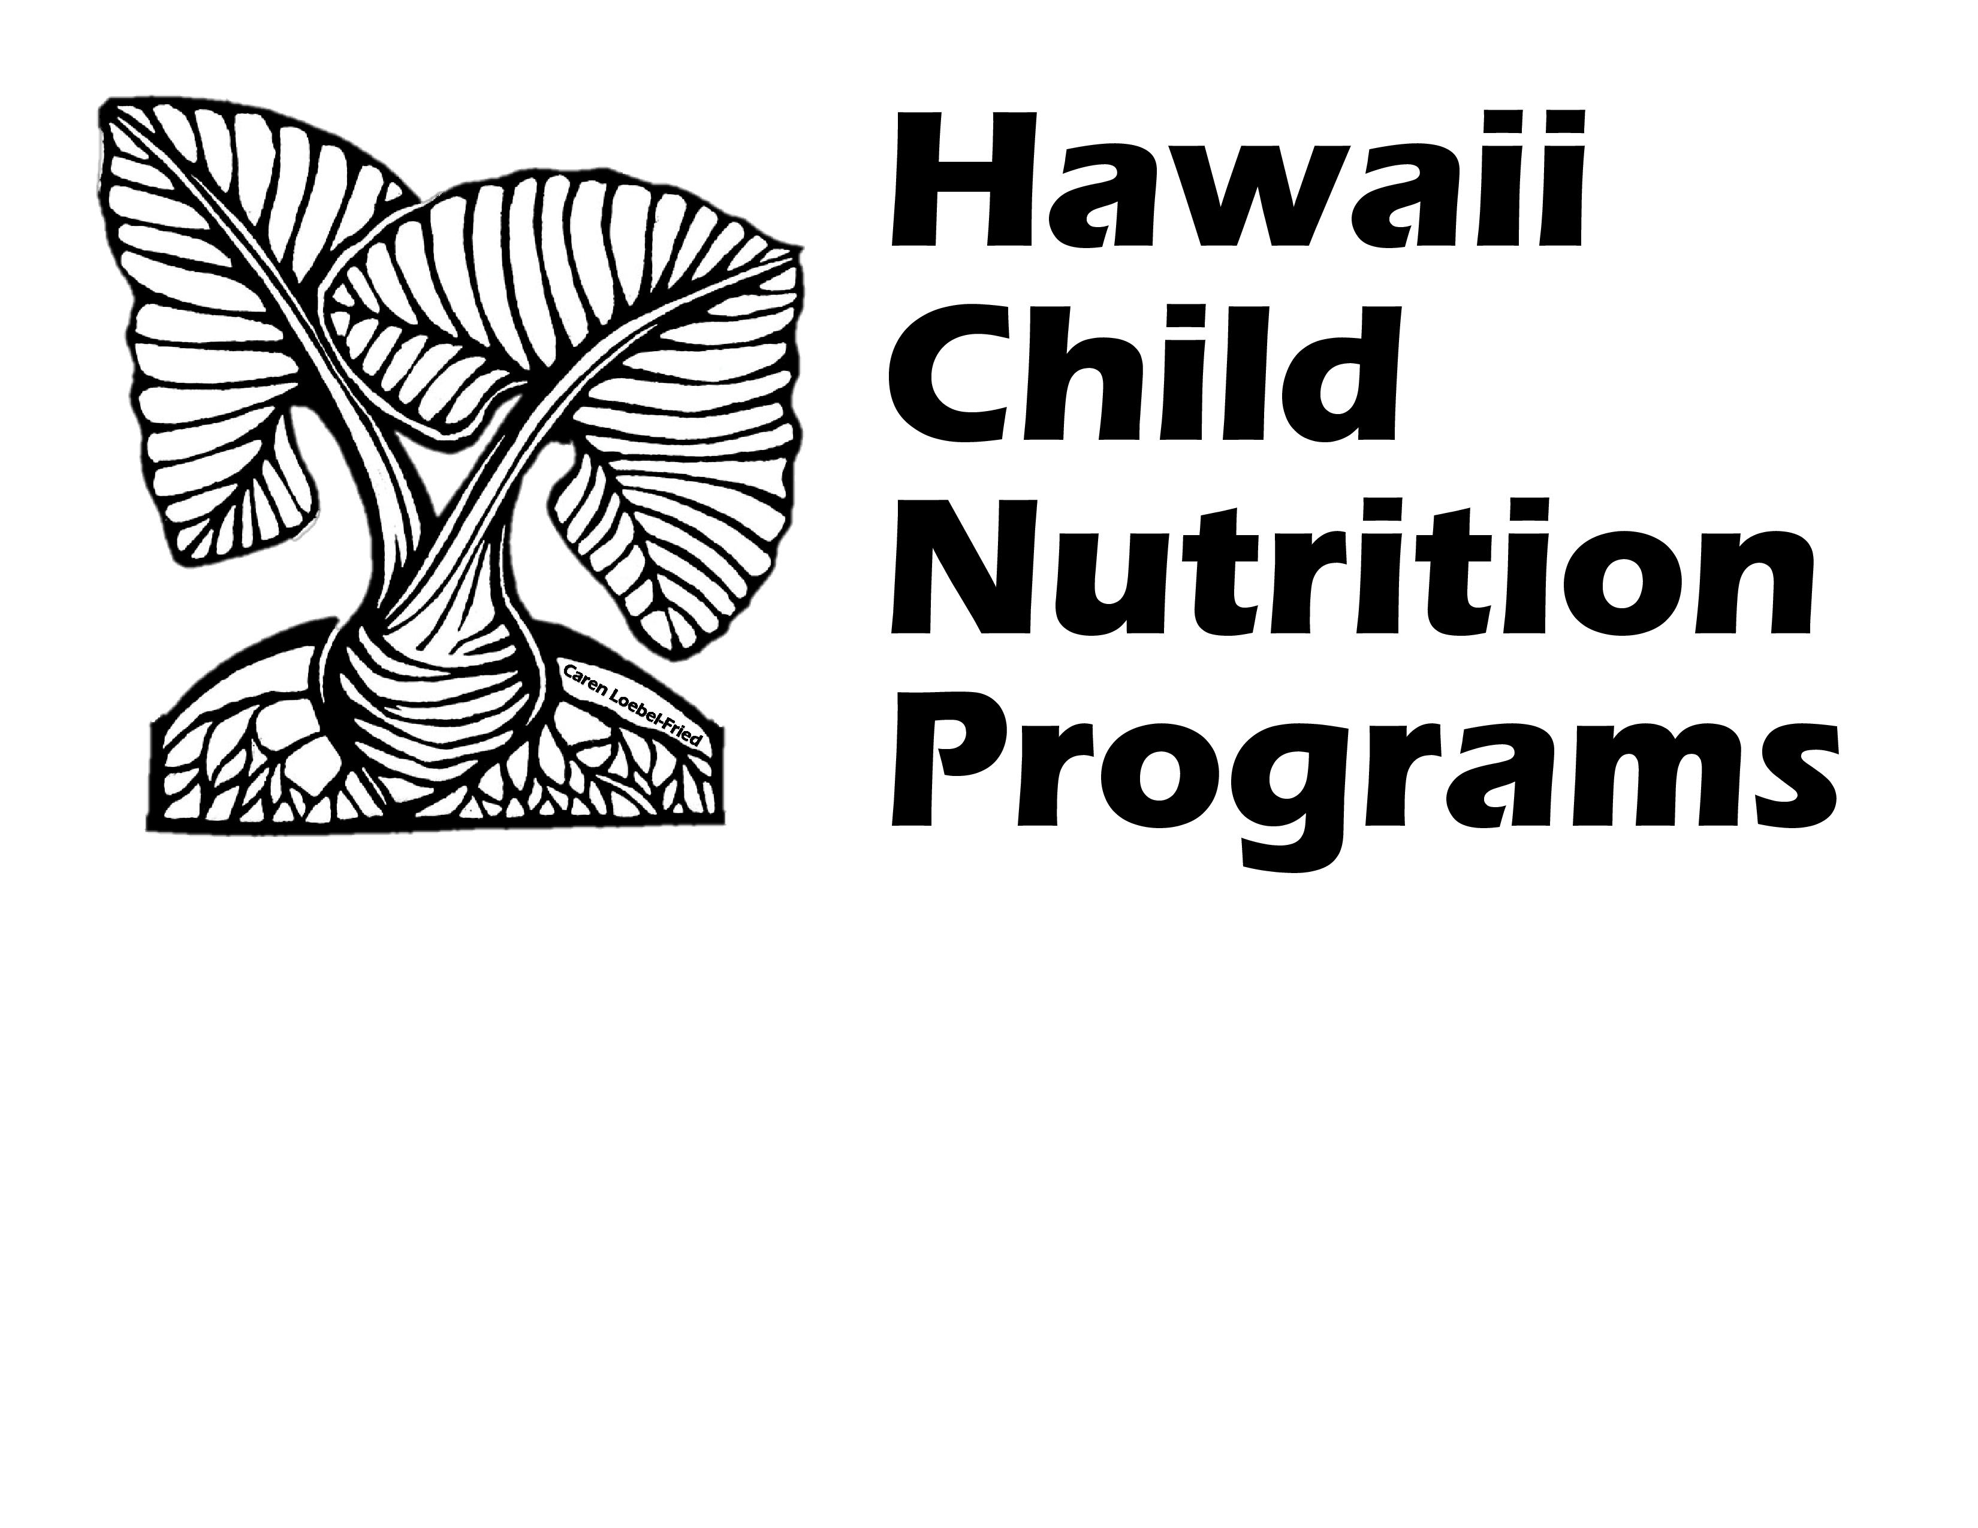
Child and Adult Care Food Program
Center Reimbursement
Effective July 1, 2023 – June 30, 2024

Breakfast
Free | $2.95
Reduced Price | $2.65
Above Scale | $0.47
Lunch**
Free | $5.54
Reduced Price | $5.14
Above Scale | $0.53

Snack
Free | $1.52
Reduced Price | $0.76
Above Scale | $0.13

**Cash In Lieu of Commodities $ To be determined

Hawaii Child Nutrition Programs
650 Iwilei Road Suite 270
Honolulu, Hawaii 96817
(808)587-3600 office
(808)587-3606 fax

