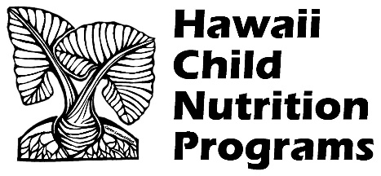
HOW TO OBTAIN DEPARTMENT OF HEALTH CLEARANCE

1. Go to www.health.hawaii.gov/san/ or the HCNP’s public website http://hcnp.hawaii.gov under SFSP, Food Safety
2. Find Special Events application. There is a different application for each island, so select the correct one.
3. Complete application entirely and scan or save digital copy.
4. Fax the Special Events application to (808) 586-8040 and write in the subject line: 2023 SFSP APP
5. After approval, the DOH will email the app to the site and copy you.
6. The DOH will not charge you an application fee.
7. The Special Events Food Permit is only good for 31 operating days. Please keep track of how many days you are approved for and reapply as necessary.

