School Year 2021-2022 Meal Service Waiver Request
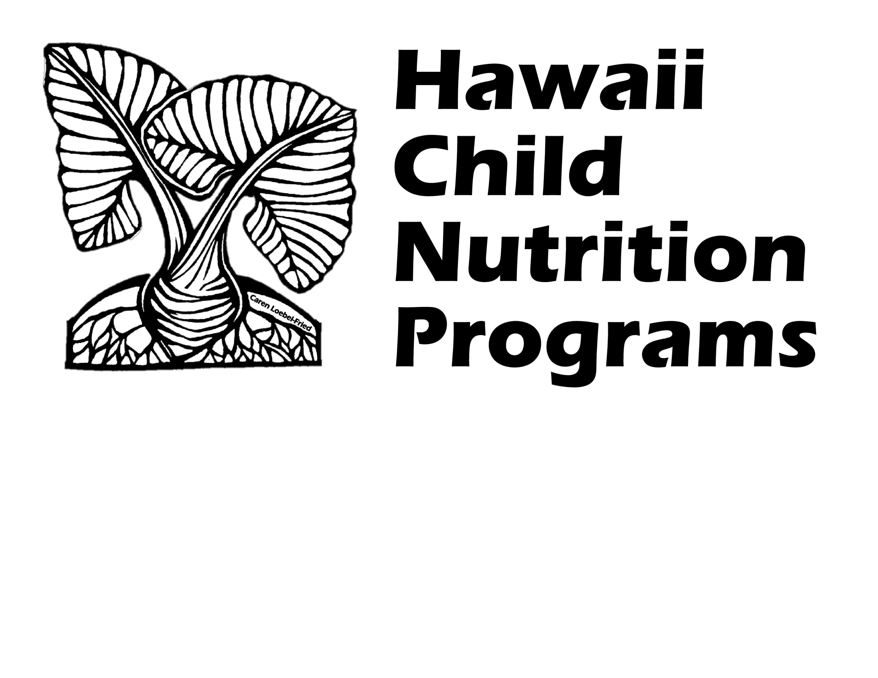
Related to the Novel Coronavirus (COVID-19) Pandemic –
Serving Meals Under the Seamless Summer Option (SSO)

Complete this form if your School Food Authority (SFA) has any school(s) that would like to request a waiver(s) relating to serving meals under the SEAMLESS SUMMER OPTION during the novel coronavirus (COVID-19) pandemic for SY 21-22.

Section 2202(a) of the Families First Coronavirus Response Act permits USDA Food and Nutrition Services (FNS) to grant nationwide waivers to support access to nutritious meals while minimizing potential exposure to the novel coronavirus (COVID-19).

The following nationwide waivers apply to the Seamless Summer Option (SSO) from July 1, 2021 through June 30, 2022. Please indicate which waiver(s) your SFA is applying for (check all that apply):

☐ Allow Seamless Summer Option (SSO) through School Year 2021-2022
(Must select if completing this waiver; SSO meals served may be claimed at the free rate.)

☐ Summer Food Service Program Reimbursement (SFSP) Rates in School Year 2021-2022
(SSO meals served may be claimed at the SFSP reimbursement rates - for up to two meals)

☐ Non-Congregate Meal Service for School Year 2021-2022^{1, 2}
(For meals consumed off campus)

☐ Meal Times for School Year 2021-2022^{1,2}
(For meals served outside the usual meal service time and/or if multiple days meals are distributed)

☐ Allowing Parents and Guardians to Pick Up Meals for Children for School Year 2021-2022²
(Must select Non-congregate Meal Service; for meal distribution on virtual learning days or feeding children in the community)

☐ Allow Specific School Meal Pattern Flexibility for School Year 2021-2022 (Must answer question #21)

☐ Allow Offer Versus Serve Flexibility for Senior High Schools in School Year 2021-2022

☐ Onsite Monitoring Requirements in the School Meals Programs³
(SFAs may conduct monitoring activities of program operations offsite, e.g. desk audits; must answer question #22)

¹ If your school(s) chooses to distribute multiple meals at one time, please check both the Meal Times and the Non-Congregate Meal Service boxes.

² While these three waivers are available through June 30, 2022, flexibilities under these waivers should be implemented by program operators for only the duration and extent that they are needed.

³ The Waiver of Onsite Monitoring Requirements remains in effect until 30 days after the end of the public health emergency, which was declared on January 31, 2020 by the United States Department of Health and Human Services.
NOTE: if your SFA has five (5) or more schools, please complete HCNP’s Excel spreadsheet that was sent with this waiver form.

- SFA Name:

- List all school(s) covered by this waiver request:

- Time period of waiver request (start and end dates):

- The schools/sites listed on this waiver request will operate as:
(Select one. If operating more than one type, complete a separate waiver form for each type of site.)
☐ Open Site ☐ Restricted Open ☐ Closed Enrolled
If Restricted Open was selected, explain why attendance/participation is being restricted:

If Closed Enrolled was selected, explain why the sponsor is operating as a closed enrolled site instead of an open site:

- Describe your SFA’s instructional model for this school year. Be as specific as possible.
(For example, if students will be on an alternating schedule of in-person instruction and online learning, indicate which grade(s) will be on campus on which day(s) of the week, and which day(s) are designated for online learning)
☐ 100% Face-to-Face Instruction
(All students attend school on campus daily)
☐ 100% Online Instruction
(All students attend online instruction/distance learning daily)
☐ Hybrid Model (please provide specific details below)
- Explain:
☐ Other (please provide specific details below)
- Explain:

- Type of meal(s) to be served under SSO (maximum of two: select up to two meals or one meal and one snack)**:
☐ Breakfast ☐ Lunch ☐ Snack

- **If your school would like to serve three meals (breakfast, lunch, and afterschool snack), please select breakfast and lunch above and select the NSLP Afterschool Snack checkbox below:
☐ NSLP Afterschool Snack

If ‘NSLP Afterschool Snack’ is selected above, indicate below if your school would like to request the following waiver:
☐ Area Eligibility in the Afterschool Programs (ASP) in School Year 2021-2022
(regardless of location, afterschool snacks may be claimed at the free rate)

- Start and end time of each meal service:
NOTE: schools are to provide sufficient time to give all students adequate time to be served and to eat their meals. Minimum meal service times for open/restricted open sites: 1.5 hours per meal service; Closed enrolled sites: Breakfast, Lunch: 25 minutes per meal service; Snack: 15 minutes.

- Indicate the meal distribution method(s) the school will use:
(Check all that apply below. If all schools listed in this waiver request do not operate the same meal distribution method(s) indicated below, complete a separate waiver form. For example, if you have two schools and for one school you select ‘Meals served in the classroom’ and ‘Grab and go meal service - Daily’ but for the other school you need to select ‘Meals served in the classroom’ and ‘Grab and go meal service - Multiple Meals Distribution’, please complete two separate waiver forms.)
☐ Cafeteria/Main Dining Area

☐ Meals served in the classroom

☐ Grab and go meal service - Daily (one type of meal is distributed at each meal service)
☐ Drive-thru ☐ Walk up

☐ Grab and go meal service - Multiple Meals Distribution (more than one type of meal is distributed at one time OR more than one day’s worth of meals is distributed at one time)
☐ Drive-thru ☐ Walk Up

What days of the week will drive-thru/walk up service be held:

Describe which meals (breakfast/lunch/snack) and how many days’ worth of meals will be distributed at one time:

☐ OTHER Explain:

- Will the meal distribution method allow parents / guardians to pick up meals for their children?
☐ YES ☐ NO
If ‘YES’ is selected, make sure “Allowing Parents and Guardians to Pick Up Meals for Children for School Year 2021-2022” and the “Non-Congregate Meal Service for SY 21-22” are selected on page 1.

Indicate the documents the SFA will verify to ensure the parent/guardian is picking up a meal for a child (check all that apply):
☐ Report card ☐ Birth certificate
☐ Student ID card ☐ State ID
☐ Official school letter/email with child’s name ☐ High school student’s driver license
☐ Other Explain:

- Indicate the meal counting method(s) that will be used to count meals at the point of service
(check all that will apply):
☐ Computer POS System ☐ Checklist/Roster
☐ Daily Meal Count Form (cross out a number as each meal is served)
☐ Other Explain:

When more than one meal counting method is selected, please explain how each meal counting method will be used:

- Assure HCNP that all meal counting staff will be trained on the SFA’s meal counting procedures:

- Explain how the SFA will ensure duplicate meals will not be distributed to any child/household on any day - during both congregate and non-congregate meal distribution, hybrid and distance learning models:

- Methods for informing the families about the availability of your school’s meal service:
Date of Public Notification:
(Check all that apply below. If operating as an open/restricted open site, must select more than one.)
☐ Public Media Notice ☐ School’s website
☐ Social Media ☐ Email
☐ Robocalls
☐ Other Explain:

- How will the SFA ensure proper operation of the program, including meal content, nutrition standards, food safety, oversight, etc.?

- Explain how the SFA will accommodate meal modifications for disabilities:

- How will the waiver(s) improve children’s access to nutritious meals?

- Describe how the waiver(s) will help improve meal service operations:

- Number of anticipated participants:

- Number of anticipated meals to be served daily:

- Indicate in the chart below which of the following meal pattern requirement(s) cannot be met (Complete this question only if requesting a waiver for the Specific Meal Pattern Flexibility):

REQUIREMENT | BREAKFAST | LUNCH
Menus meet the dietary specification for sodium,  at 7 CFR 210.10(b), (c), and (f); 7 CFR 220.8(b), (c), and (f) | ☐ | ☐
All grains offered must be whole grain-rich,  at 7 CFR 210.10(c); 7 CFR 220.8(c) | ☐ | ☐
For pre-schoolers, at least one serving per day, across all eating occasions, must be whole grain-rich,  at 7 CFR 210.10(o)(3) and (p); 7 CFR 220.8(o) | ☐ | ☐
To offer a variety of vegetables from the vegetable subgroups,  at 7 CFR 210.10(c); 7 CFR 220.8(c) | ☐ | ☐
To offer a variety (at least two different options) of fluid milk,  at 7 CFR 210.10(d)(1)(i); 7 CFR 220.8(d) | ☐ | ☐
Low-fat milk must be unflavored,  at 7 CFR 210.10(c) and (d)(1)(i); 7 CFR 220.8(c) and (d) | ☐ | ☐
Plan menus and offer food components for specified age/grade groups in the stated combinations,  at 7 CFR 210.10(c); 7 CFR 220.8(c) | ☐ | ☐

Describe why each meal pattern requirement selected above cannot be met. Clearly explain what the resolution is for each affected requirement and the date range that the requirement cannot be met.

- Explain why the onsite monitoring requirements cannot be met.
(Only answer this question if requesting the Onsite Monitoring Requirements in the School Meals Programs Waiver).
- Explain how monitoring will be conducted:
-------------------------------------------------------------------------------------------------------------------------------
The below signee/SFA representative certifies that the following information will be provided to HCNP within 3 weeks of the end date of the waiver(s). Failure to provide information for each school will result in withholding of further claim reimbursements until such time the SFA's obligation is fulfilled to HCNP.

1. A description of the impact each waiver had on school meal service operations, children's access to nutritious meals and participation in each the meal program (SBP, NSLP, SSO, ASP).

2. The number of participants and sites that used each individual waiver.

3. The amount of funds used and the number of meals/snacks provided at each school site during the use of each individual waiver.

4. Additional information needed for Area Eligibility in ASP Waiver only: A summary of how new meal sites were targeted to benefits for children who were previously eligible or newly eligible for program benefits due to economic impacts of COVID-19.

Signature: __________________________________
Print Name: _________________________________
Job Title: ___________________________________
Date: ______________________________________
Submit the completed form to rachel.itano@k12.hi.us, kasey.kawamoto@k12.hi.us, and shirley.robinson@k12.hi.us
HCNP will notify you if the waiver is approved or if additional information is needed. Please note, the waiver request must be approved by HCNP before your SFA can implement the waivers and claim meals for reimbursement.

_____________________________________________________________________________________
HCNP USE ONLY
☐ Approved ☐ Not Approved
Approved for the following waivers:
☐ Allow Seamless Summer Option (SSO) through School Year 2021-2022
☐ Summer Food Service Program (SFSP) Reimbursement Rates in School Year 2021-2022
☐ Non-Congregate Meal Service for School Year 2021-2022
☐ Meal Times for School Year 2021-2022
☐ Allowing Parents and Guardians to Pick Up Meals for Children for School Year 2021-2022
☐ Allow Specific School Meal Pattern Flexibility for School Year 2021-2022
☐ Allow Offer Versus Serve Flexibility for Senior High Schools in School Year 2021-2022
☐ Onsite Monitoring Requirements in the School Meals Programs
☐ Area Eligibility in Afterschool Snack Programs (ASP) in SY 21-22

Signature: ______________________________ Date: __________________
Comments:

