School Year 2020-2021 Meal Service Waiver Request
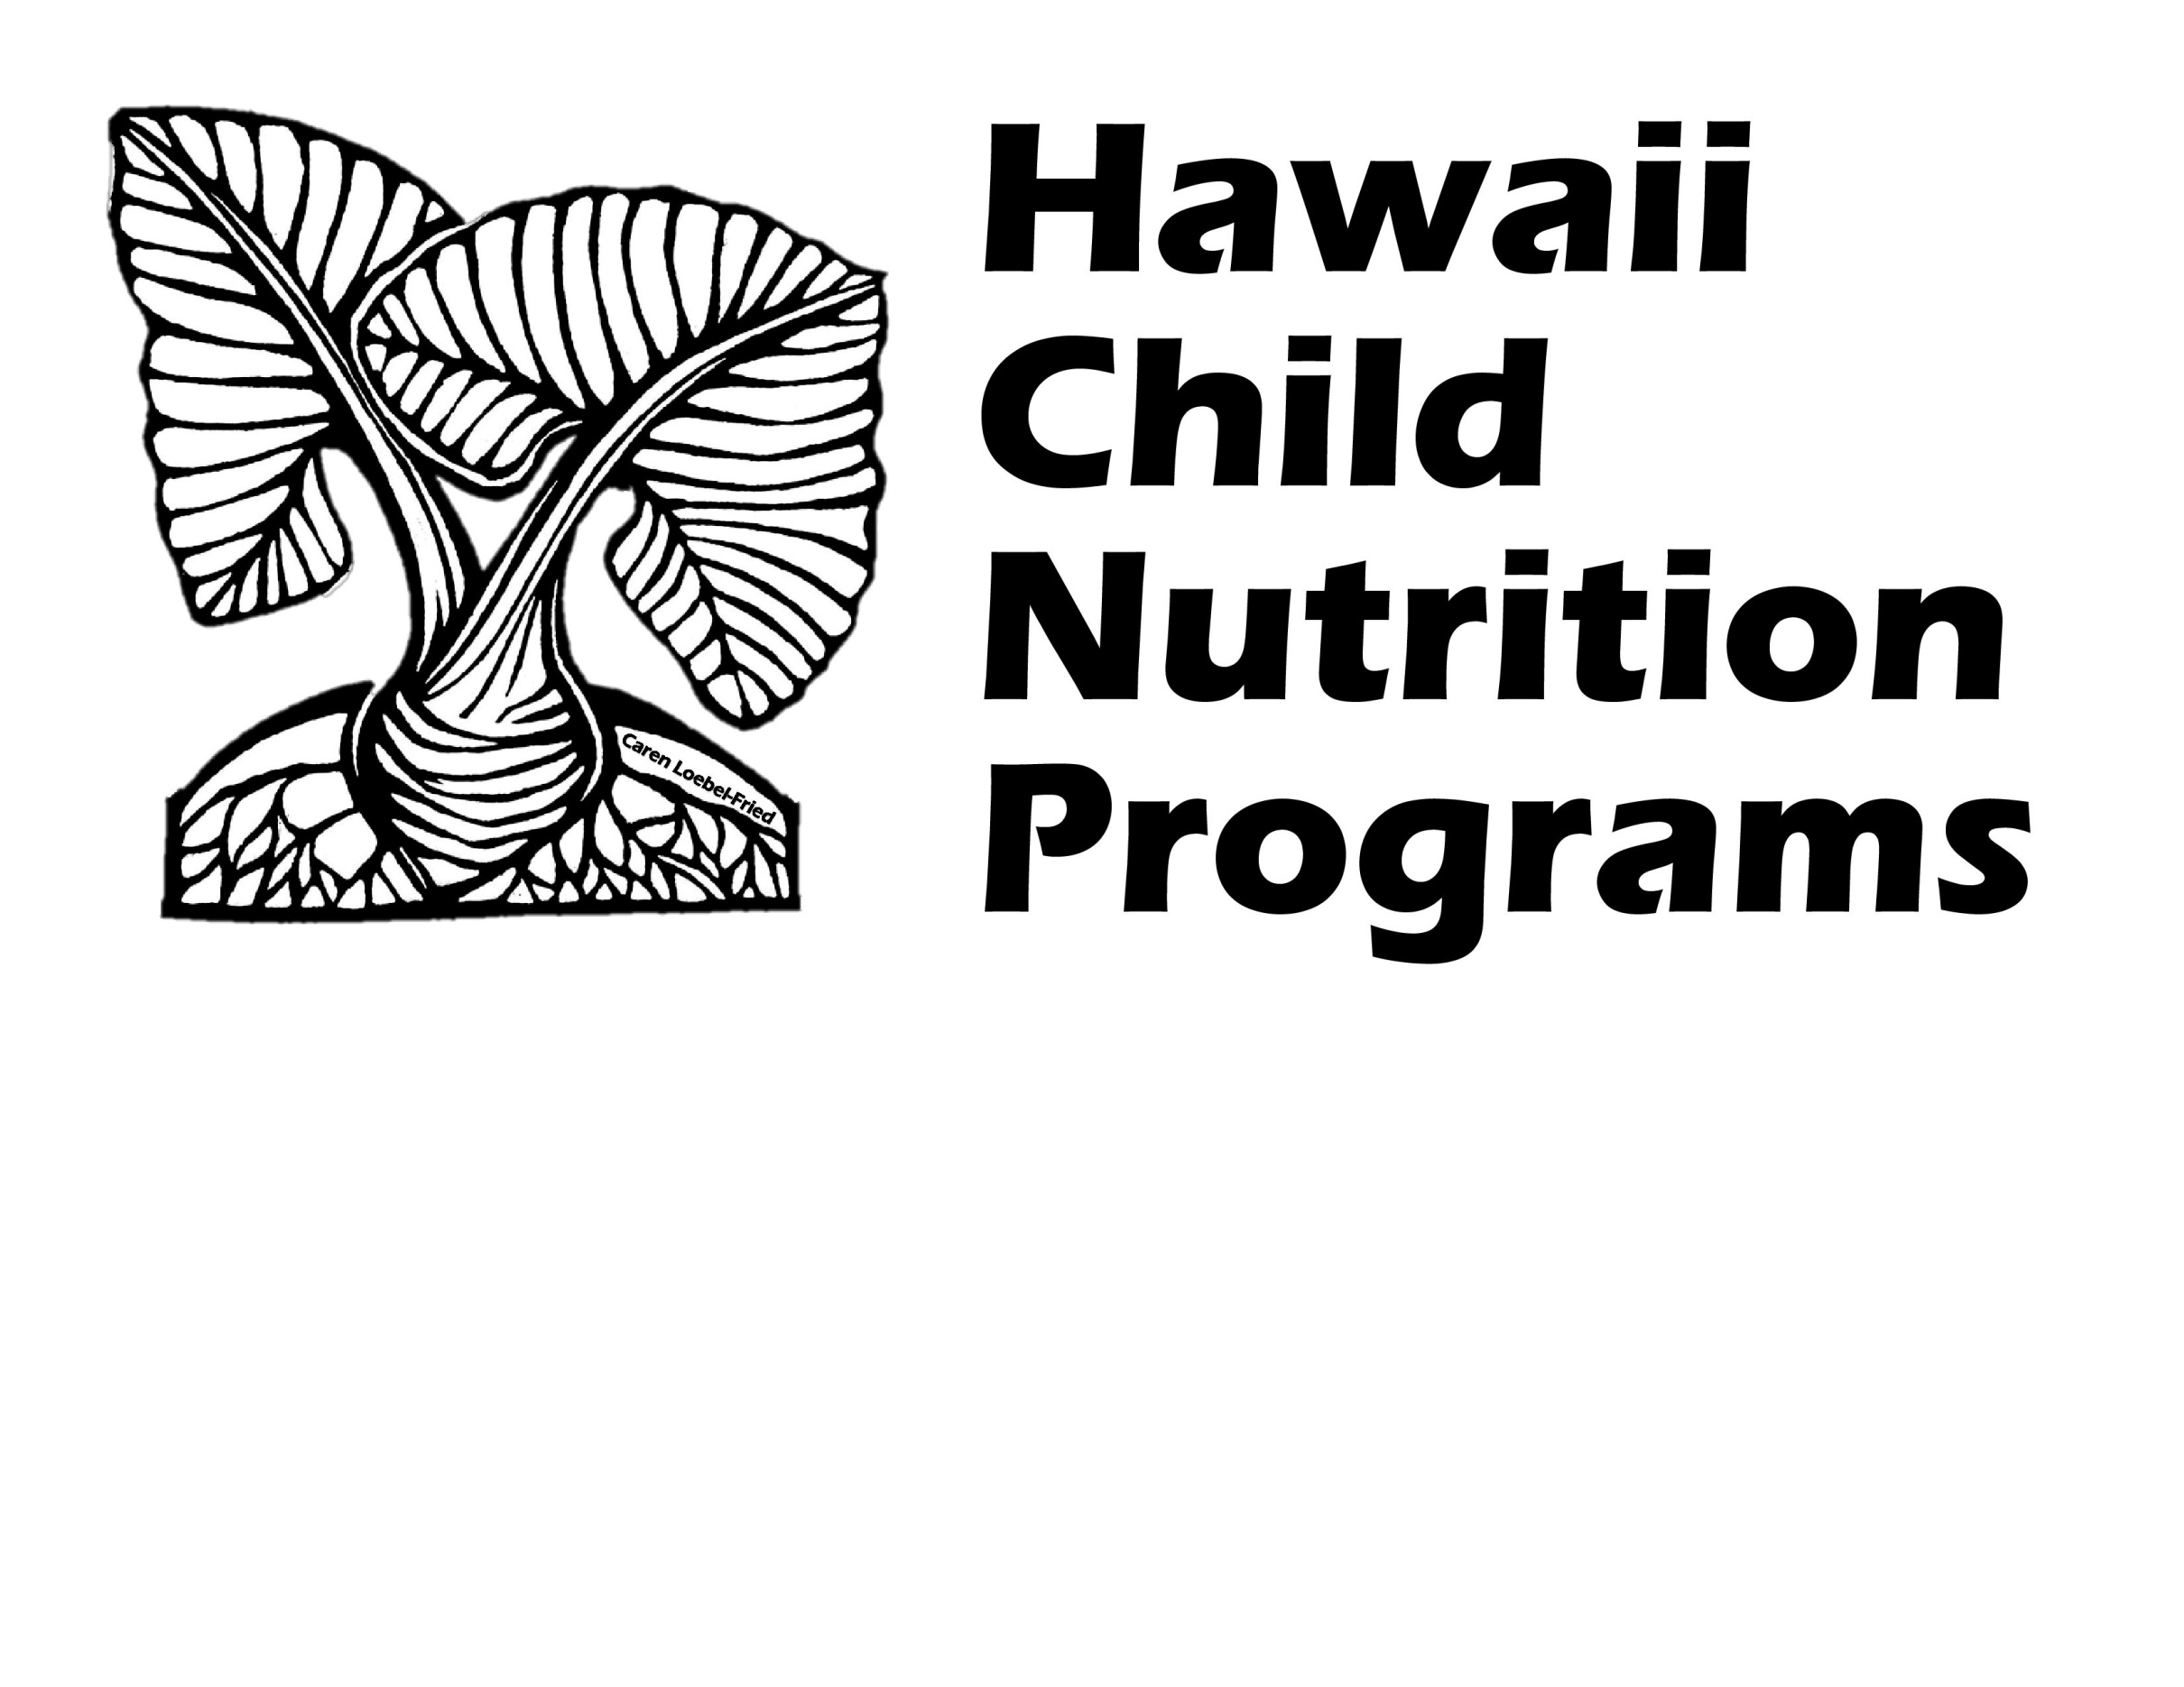
Related to the Novel Coronavirus (COVID-19) Pandemic –
Serving Meals Under the
National School Lunch Program (NSLP) / School Breakfast Program (SBP)

Complete this form if your School Food Authority (SFA) has any school(s) that would like to request a waiver(s) relating to meal service during the novel coronavirus (COVID-19) pandemic.

Section 2202(a) of the Families First Coronavirus Response Act permits USDA Food and Nutrition Services (FNS) to grant nationwide waivers to support access to nutritious meals while minimizing potential exposure to the novel coronavirus (COVID-19).

The following nationwide waivers apply to the National School Lunch Program (NSLP) and School Breakfast Program (SBP) from July 1, 2020 through June 30, 2021. Please indicate which waivers your SFA is applying for (check all that currently apply):

☐ Meal Service Time Flexibility in the Child Nutrition Programs*
(For meals served outside the usual meal service time and/or if multiple days meals are distributed)

☐ Non-Congregate Feeding in the Child Nutrition Programs*
(For meals consumed off campus)

☐ Meal Pattern Flexibility in the Child Nutrition Programs (Must answer question #22)

☐ Allowing Parents and Guardians to Pick Up Meals for Children
(For meal distribution on virtual learning days)

☐ Allowing Offer versus Serve Flexibility for High Schools in the National School Lunch Program

* If your school(s) choose to distribute multiple meals at one time, please check both the Meal Service Time Flexibility and the Non-Congregate Feeding boxes.

NOTE: if your SFA has five or more schools, please complete HCNP’s Excel spreadsheet that was sent with this waiver form.

- SFA Name:

- List all school(s) covered by this waiver request:

- Time period of waiver request (start and end dates):

- Describe your SFA’s reopening plans for this school year. Be as specific as possible.
(For example, if students will be on an alternating schedule of in-person instruction and online learning, indicate which grade(s) will be on campus on which day(s) of the week, and which day(s) are designated for online learning)
☐ 100% Face-to-Face Instruction
☐ 100% Online Instruction
☐ Hybrid Model (please provide specific details below)
- Explain:

☐ Other (please provide specific details below)
- Explain:

- Is the school providing some type of distance learning at any time during the school year?
(Distance learning includes online instruction, mailing assignments to students, etc.)
☐ YES ☐ NO

- Dates distance learning was implemented (start and end dates):

- If the school is providing distance learning, is school considered an instructional day?
☐ YES ☐ NO

- Type of meal(s) to be served:
☐ Breakfast ☐ Lunch ☐ Afterschool Snack ☐ Supper

- Start and end time of each meal service:

- Indicate the meal distribution method(s) the school will use:
(Check all that apply below. If all schools listed in this waiver request do not operate the same meal distribution method(s) indicated below, complete a separate waiver form. For example, if you have two schools and for one school you select ‘Meals delivered to the classroom’ and ‘Grab and go meal service - Daily’ but for the other school you need to select ‘Meals delivered to the classroom’ and ‘Grab and go meal service - Multiple Meals Distribution’, please complete two separate waiver forms.)

☐ Meals delivered to the classroom

☐ Grab and go meal service - Daily (one type of meal is distributed at each meal service)
☐ Drive-thru
☐ Walk up

(QUESTION #10 CONTINUED TO NEXT PAGE)

☐ Grab and go meal service - Multiple Meals Distribution (more than one type of meal is distributed at one time OR more than one day’s worth of meals is distributed at one time)
☐ Drive-thru
☐ Walk up
Indicate how many days’ worth of meals will be distributed at one time:
☐ 1 day ☐ 2 days ☐ 3 days ☐ 4 days ☐ 5 days
Indicate which day(s) meals will be distributed:

☐ Home delivery - Daily (one type of meal is distributed at each meal service)

☐ Home delivery - Multiple Meals Distribution (more than one type of meal is distributed at one time OR more than one day’s worth of meals is distributed at one time)
Indicate how many days’ worth of meals will be distributed at one time:
☐ 1 day ☐ 2 days ☐ 3 days ☐ 4 days ☐ 5 days
Indicate which day(s) meals will be distributed:

☐ OTHER Explain:

- Will the meal distribution method allow parents / guardians to pick up meals for their children?
☐ YES ☐ NO
If ‘YES’ is selected, make sure “Allowing Parents and Guardians to Pick Up Meals for Children” is selected on page 1.
Indicate the documents the SFA will verify to ensure the parent/guardian is picking up a meal for a child (check all that apply):
☐ Report card ☐ Birth certificate
☐ Student ID card ☐ State ID
☐ Official school letter/email with child’s name ☐ High school student’s driver license
☐ Other Explain:

- Indicate the meal counting method(s) that will be used to count meals at the point of service
(check all that will apply):
☐ Computer POS System
☐ Checklist/Roster
☐ Daily Meal Count Form (cross out a number as each meal is served)
☐ Other Explain:

When more than one meal counting method is selected, please explain how each meal counting method will be used:

- Assure HCNP that all meal counting staff will be trained on the SFA’s meal counting procedures:

- Explain how the SFA will ensure duplicate meals will not be distributed to any child/household on any day - during both congregate and non-congregate meal distribution, hybrid and distance learning models:

- Methods for informing the families about the availability of your school’s meal service:
(Check all that apply below)
☐ School’s website
☐ Email
☐ Social Media
☐ Robocalls
☐ Other Explain:

- How will the SFA ensure proper operation of the program, including meal content, nutrition standards, food safety, oversight, etc.?

- Explain how the SFA will accommodate meal modifications for disabilities:

- How will the waiver(s) improve children’s access to nutritious meals?

- Describe how the waiver(s) will help improve meal service operations:

- Number of anticipated participants:

- Number of anticipated meals to be served daily:

- Describe why the 2012 NSLP/SBP meal pattern requirements cannot be met. Clearly state the meal component(s) that is being affected, what the resolution is for each affected component, and the date range that the meal pattern requirements cannot be met. Reasons may include but are not limited to procurement has been finalized based on the SY 2019-2020 meal pattern requirements, disruptions to the availability of food products resulting from unprecedented impacts of COVID-19, etc. (Complete this question only if requesting a waiver for Meal Pattern Flexibility)

-------------------------------------------------------------------------------------------------------------------------------
The below signee/SFA representative certifies that the following information will be provided to HCNP within 3 weeks of the end date of the waiver(s). Failure to provide information for each school will result in withholding of further claim reimbursements until such time the SFA's obligation is fulfilled to HCNP.

1. A description of the impact the waiver had on school meal service operations, children's access to nutritious meals and participation in each the meal program (SBP, NSLP, SFSP, SSO, ASP and CACFP).

2. The number of participants and sites that used each individual waiver.

3. The amount of funds used and the number of meals/snacks/suppers provided at each school site during the use of each individual waiver.

Signature: __________________________________
Print Name: _________________________________
Job Title: ___________________________________
Date: ______________________________________
Submit the completed form to rachel.itano@k12.hi.us, kasey.kawamoto@k12.hi.us, and shirley.robinson@k12.hi.us
HCNP will notify you if the waiver is approved or if additional information is needed. Please note, the waiver request must be approved by HCNP before your SFA can implement the waivers and claim meals for reimbursement.
_____________________________________________________________________________________
HCNP USE ONLY
☐ Approved ☐ Not Approved
Approved for the following waivers:
☐ Meal Service Time Flexibility ☐ Non-Congregate Feeding
☐ Meal Pattern Flexibility ☐ Allowing Parents & Guardians to Pick Up Meals
☐ Offer vs Serve for High School Lunch

Signature: ______________________________ Date: __________________
Comments:

