Waiver Request to Serve Meals Due to a School Closure
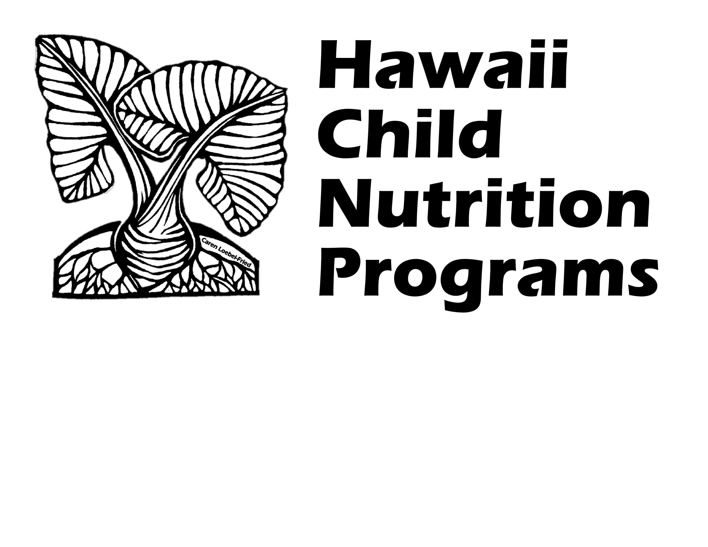
Related to the Novel Coronavirus (COVID-19)

Complete this form if your School Food Authority (SFA) has any school(s) that would like to request a waiver to serve meals due to a school closure related to the novel coronavirus (COVID-19).

Section 2202(a) of the Families First Coronavirus Response Act permits USDA Food and Nutrition Services (FNS) to grant nationwide waivers to support access to nutritious meals while minimizing potential exposure to the novel coronavirus (COVID-19).

The following nationwide waivers apply to the National School Lunch Program (NSLP) and School Breakfast Program (SBP). Please indicate which waivers your SFA is applying for (check all that currently apply):

☐ Meal Service Time Flexibility in the Child Nutrition Programs
☐ Non-Congregate Feeding in the Child Nutrition Programs
☐ Activity Requirement in Afterschool Care Child Nutrition Programs
☐ Meal Pattern Flexibility in the Child Nutrition Programs
☐ Allowing Parents and Guardians to Pick Up Meals for Children
☐ Area Eligibility Waiver for Hawaii

- SFA Name:

- Name of school(s) covered by waiver request:
(Complete a separate waiver request form for each different type of meal service method)

- At what point following school dismissal would the meal service start?

- Time period of waiver request (start and end dates):

- Is the school providing some type of distance learning at any time during the school closure?
(Distance learning includes online instruction, mailing assignments to students, etc.)
☐ YES ☐ NO

Dates distance learning was implemented (start and end dates):

- If the school is providing distance learning, is school considered to be “in-session”?
☐ YES ☐ NO

- Type of meal(s) to be served: ☐Breakfast ☐Lunch ☐Snack ☐Supper
- Start and end time of each meal service:

- What meal distribution method will the institution use and how will the waiver target the children from the dismissed schools?

- Will the meal distribution method allow parents / guardians to pick up meals for their children?
☐ YES ☐ NO

Describe the processes that the SFA will set in place to ensure that meals are distributed only to parents/guardians of eligible children, and that duplicate meals are not distributed to any child:
(Examples may include asking parents to present an official document that contains the child’s name, such as a school letter or email, individual student report card, birth certificate, passport, or student ID cards)

- Methods for communicating with families:

- How will the meal distribution target low-income children if the school(s) does not have 50% or more free or reduced price children enrolled?

If ALL schools included in this waiver request are Area Eligible, skip to question #17.

If any of the schools included in this waiver are Non-Area Eligible*, please complete questions #13-16, below
(*Non-area eligible = either your school or a school in the attendance area does not have at least 50% of its enrolled students certified eligible for free or reduced price meals)

- List all non-area eligible schools included in this waiver request:

- Do ALL of the schools listed in question #13 have a free/reduced student percentage of at least 45% in the most current October data?
☐ YES ☐ NO
If ‘YES’, skip to question #17.

- Are any of the schools listed in question #13 currently accepting new free and reduced price meal applications?
(only complete if ‘NO’ to question #14)
☐ YES ☐ NO

Please indicate which schools:

- If YES to #15, did the approval of new applications result in at least 45% or more of enrolled students qualifying for free or reduced price meal benefits?
☐ YES ☐ NO

Indicate new % of Free/Reduced price student %: %
(To calculate your school’s Free/Reduced price student %, divide the total number of students approved for free and reduced price meals by the total number of enrolled students)

Total Number of Free Students:
Total Number of Reduced Price Students:
Total Enrolled:
Date of Data:

- Explain how the SFA will ensure that the non-area eligible meal sites are targeting benefits to children in need, for example, children who may be newly eligible for benefits due to the economic impacts of COVID-19.

- How will the SFA ensure proper operation of the program, including meal content, nutrition standards, meal counts, food safety, oversight, etc.?

- Describe any disruptions to the availability of food products resulting from unprecedented impacts of COVID-19 that is impairing the SFA’s ability to meet meal pattern requirements. Clearly state the meal component that is being affected and the date range of the disruption. Attach documentation to support your response.
(Complete this question only if requesting a waiver for Meal Pattern Flexibility)

- Explain how the SFA will accommodate meal modifications for disabilities:

- Describe the impact the waiver will have on meal service operations, children’s access to nutritious meals, and participation in the Summer Food Service Program (SFSP) and Seamless Summer Option (SSO):

- Number of anticipated participants:

- Number of anticipated meals to be served daily:

By signing below, you agree to submit to Hawaii Child Nutrition Programs a summary of the impact of this waiver within two weeks of the conclusion of the waiver request.
Signature:
Print Name:
Job Title:
Date:
Submit the completed form to rachel.itano@k12.hi.us AND kasey.kawamoto@k12.hi.us
HCNP will notify you if the waiver is approved or if additional information is needed.
_____________________________________________________________________________________
HCNP USE ONLY
Approved to Operate As: ☐ SSO / Open Site ☐ NSLP / SBP ☐ Not Approved
Approved for the following waivers:
☐ Meal Service Time Flexibility ☐ Non-Congregate Feeding
☐ Activity Requirement in Afterschool Care ☐ Meal Pattern Flexibility
☐ Allowing Parents & Guardians to Pick Up Meals ☐ Area Eligibility Waiver for Hawaii
Signature: Date:
Comments:

