Waiver Request to Serve Meals During the Summer
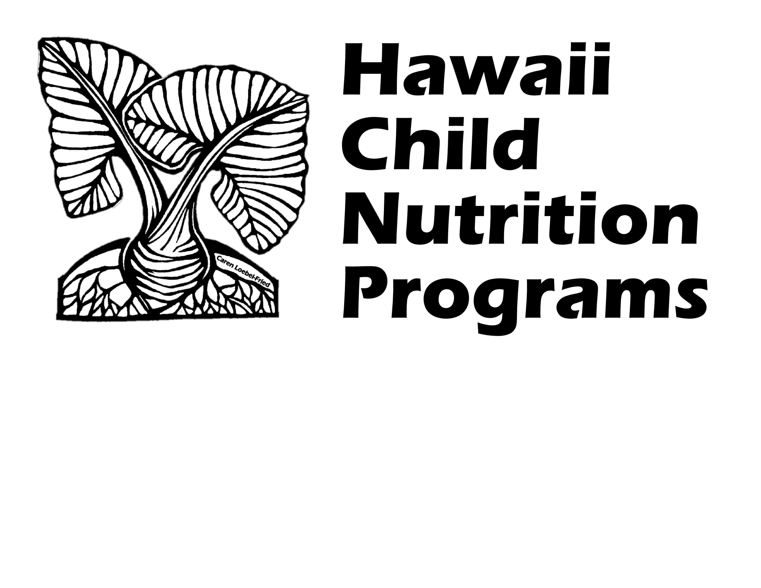
During the Novel Coronavirus (COVID-19)

Complete this form if your School Food Authority (SFA) has any school(s) that would like to request a waiver to serve meals during the summer (May-August 2020) during the novel coronavirus (COVID-19).

Section 2202(a) of the Families First Coronavirus Response Act permits USDA Food and Nutrition Services (FNS) to grant nationwide waivers to support access to nutritious meals while minimizing potential exposure to the novel coronavirus (COVID-19).

The following nationwide waivers apply to the National School Lunch Program (NSLP), including the Seamless Summer Option (SSO). Please indicate which waivers your SFA is applying for (check all that currently apply):

☐ Meal Service Time Flexibility in the Child Nutrition Programs (valid until September 30, 2020)
☐ Non-Congregate Feeding in the Child Nutrition Programs (valid until August 31, 2020)
☐ Meal Pattern Flexibility in the Child Nutrition Programs (valid until June 30, 2020)
☐ Allowing Parents and Guardians to Pick Up Meals for Children (valid until August 31, 2020)
☐ Area Eligibility Waiver for Hawaii (pending USDA approval – not valid until approved by USDA)

- SFA Name:

- Name of school(s) covered by waiver request:
(Complete a separate waiver request form for each different type of meal service method/operation)

- Time period of waiver request (start and end dates):

- Is the school operating an academic summer school?
☐ YES ☐ NO

- If YES to #4, will the school serve meals to the community children and children attending summer school?
☐ YES ☐ NO

(If this site intends to serve meals only to children in a summer school program, the site is not eligible to participate in the Seamless Summer Option. The site may be eligible to operate NSLP/SBP. Contact HCNP for more information.)

- Type of site: ☐Open Site ☐Restricted Open ☐Closed Enrolled ☐Migrant Site ☐Camp

If Restricted Open was selected, explain why attendance is being restricted:

If Closed Enrolled was selected, explain why the sponsor is operating as a closed enrolled site instead of an open site:

- Type of meal(s) to be served: ☐Breakfast ☐Lunch ☐Snack ☐Supper

- Start and end time of each meal service:

- What meal distribution method will the institution use? Please be specific.

- Will the meal distribution method allow parents / guardians to pick up meals for their children?
☐ YES ☐ NO

Describe the processes that the SFA will set in place to ensure that meals are distributed only to parents/guardians of eligible children, and that duplicate meals are not distributed to any child:
(Examples may include asking parents to present an official document that contains the child’s name, such as a school letter or email, individual student report card, birth certificate, passport, or student ID cards)

- Methods for communicating with families and advertising availability of meals to the community:

If ALL schools included in this waiver request are Area Eligible, skip to question #15.

If any of the schools included in this waiver are Non-Area Eligible*, please complete questions #12-14, below
(*Non-area eligible = either your school or a school in the attendance area does not have at least 50% of its enrolled students certified eligible for free or reduced price meals)
- List all non-area eligible schools included in this waiver request:

- Did any of the schools listed in question #12 accept new free and reduced price meal applications during the COVID-19 school closure?
☐ YES ☐ NO

Please indicate which schools:

- If YES to #13, did the approval of new applications result in at least 50% or more of enrolled students qualifying for free or reduced price meal benefits?
☐ YES ☐ NO

Indicate new % of Free/Reduced price student %: %
(To calculate your school’s Free/Reduced price student %, divide the total number of students approved for free and reduced price meals by the total number of enrolled students. Use additional sheets if necessary. Submit supporting documentation to demonstrate the increase in Free/Reduced price student %)

School Name:
Total Number of Free Students:
Total Number of Reduced Price Students:
Total Enrolled:
Date of Data:

- How will the SFA ensure proper operation of the program, including meal content, nutrition standards, meal counts, food safety, oversight, etc.?

- Describe any disruptions to the availability of food products resulting from unprecedented impacts of COVID-19 that is impairing the SFA’s ability to meet meal pattern requirements. Clearly state the meal component that is being affected and the date range of the disruption. Attach documentation to support your response.
(Complete this question only if requesting a waiver for Meal Pattern Flexibility)

- Explain how the SFA will accommodate meal modifications for disabilities:

- Describe the impact the waiver will have on meal service operations, children’s access to nutritious meals, and participation in the Seamless Summer Option (SSO):

- Number of anticipated participants:

- Number of anticipated meals to be served daily:

By signing below, you agree to submit to Hawaii Child Nutrition Programs a summary of the impact of this waiver within two weeks of the conclusion of the waiver request.
Signature:
Print Name:
Job Title:
Date:
Submit the completed form to rachel.itano@k12.hi.us AND kasey.kawamoto@k12.hi.us
HCNP will notify you if the waiver is approved or if additional information is needed.
_____________________________________________________________________________________
HCNP USE ONLY
Approved to Operate As: ☐ SSO / Open Site ☐ SSO / Restricted Open ☐ SSO / Closed Enrolled ☐ SSO / Migrant Site ☐ SSO / Camp ☐ NSLP / SBP ☐ Not Approved
Approved for the following waivers:
☐ Meal Service Time Flexibility ☐ Non-Congregate Feeding
☐ Meal Pattern Flexibility ☐ Allowing Parents & Guardians to Pick Up Meals
☐ Area Eligibility Waiver for Hawaii (PENDING USDA APPROVAL)
Signature: Date:
Comments:

