Child and Adult Care Food Program
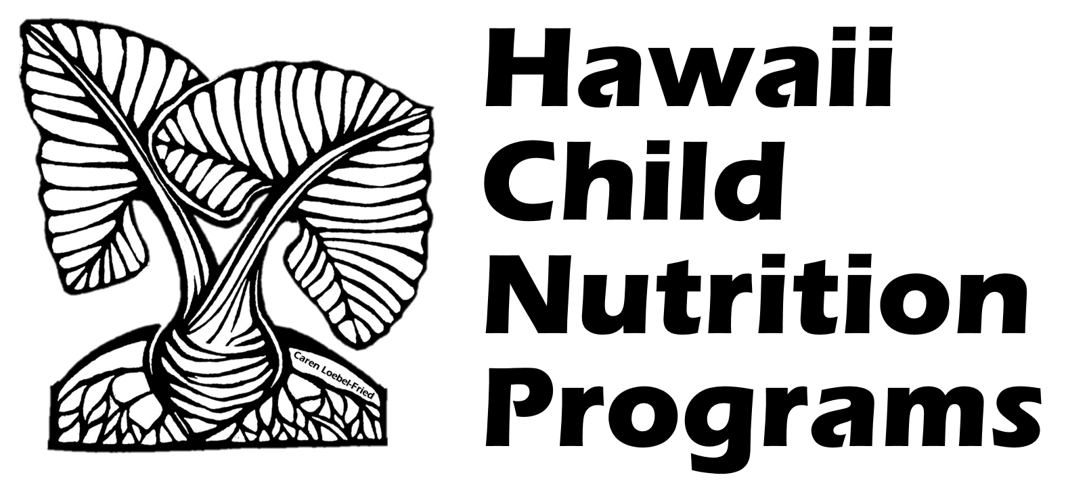
Family Day Care Home Enrollment Statement

____________________________________ ____________________________
Name of Child Birthdate and Age
is enrolled at:
Name of Provider:______________________________________________________________
Address:______________________________________________________________________
Beginning on:______________________________________
Month/Day/Year

Child’s Normal days & hours of care | **If attendance time and meals are the same Monday to Friday, Fill in Monday and initial ____________ | Circle meals child will participate in
Monday ** | _____ a.m. to _____ p.m. ** | Breakfast ** | AM Snack** | Lunch** | PM Snack**
Tuesday | _____ a.m. to _____ p.m. | Breakfast | AM Snack | Lunch | PM Snack
Wednesday | _____ a.m. to _____ p.m. | Breakfast | AM Snack | Lunch | PM Snack
Thursday | _____ a.m. to _____ p.m. | Breakfast | AM Snack | Lunch | PM Snack
Friday | _____ a.m. to _____ p.m. | Breakfast | AM Snack | Lunch | PM Snack
Saturday | _____ a.m. to _____ p.m. | Breakfast | AM Snack | Lunch | PM Snack
Sunday | _____ a.m. to _____ p.m. | Breakfast | AM Snack | Lunch | PM Snack

Signature____________________________________________ Date_________________
Parent/Guardian
Signature_____________________________________ Date_________________
Name of Provider
In accordance with Federal civil rights law and U.S. Department of Agriculture (USDA) civil rights regulations and policies, the USDA, its Agencies, offices, and employees, and institutions participating in or administering USDA programs are prohibited from discriminating based on race, color, national origin, sex, disability, age, or reprisal or retaliation for prior civil rights activity in any program or activity conducted or funded by USDA.
Persons with disabilities who require alternative means of communication for program information (e.g. Braille, large print, audiotape, American Sign Language, etc.), should contact the Agency (State or local) where they applied for benefits. Individuals who are deaf, hard of hearing or have speech disabilities may contact USDA through the Federal Relay Service at (800) 877-8339. Additionally, program information may be made available in languages other than English.
To file a program complaint of discrimination, complete the USDA Program Discrimination Complaint Form, (AD-3027) found online at: http://www.ascr.usda.gov/complaint_filing_cust.html, and at any USDA office, or write a letter addressed to USDA and provide in the letter all of the information requested in the form. To request a copy of the complaint form, call (866) 632-9992. Submit your completed form or letter to USDA by:
(1) mail: U.S. Department of Agriculture
Office of the Assistant Secretary for Civil Rights
1400 Independence Avenue, SW
Washington, D.C. 20250-9410;
(2) fax: (202) 690-7442; or
(3) email: program.intake@usda.gov.
This institution is an equal opportunity provider.

Provider Use Only

Child withdrew on: _________________________________________

