CHILD AND ADULT CARE FOOD PROGRAM

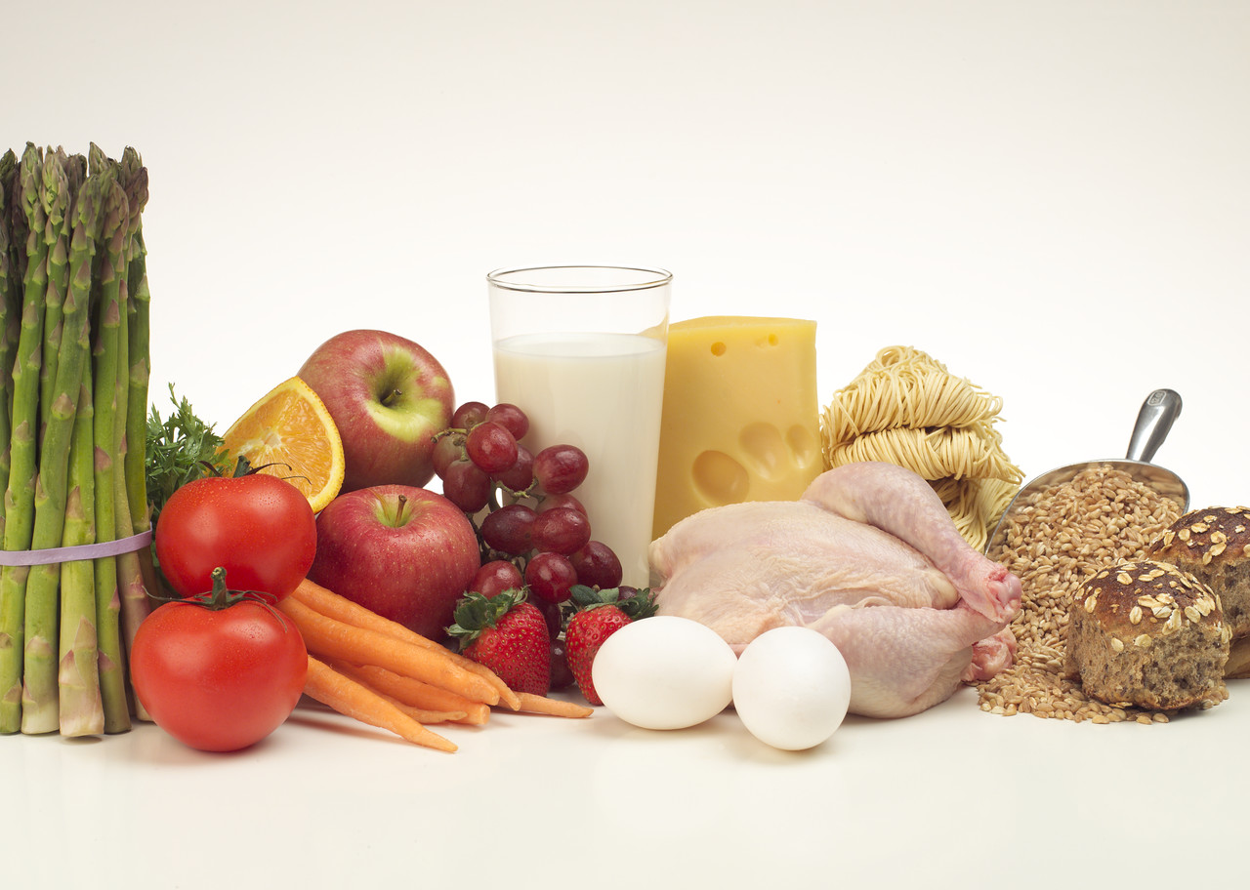

INVITATION FOR BID AND CONTRACT – DELIVERY
Procurement of Vended Meals

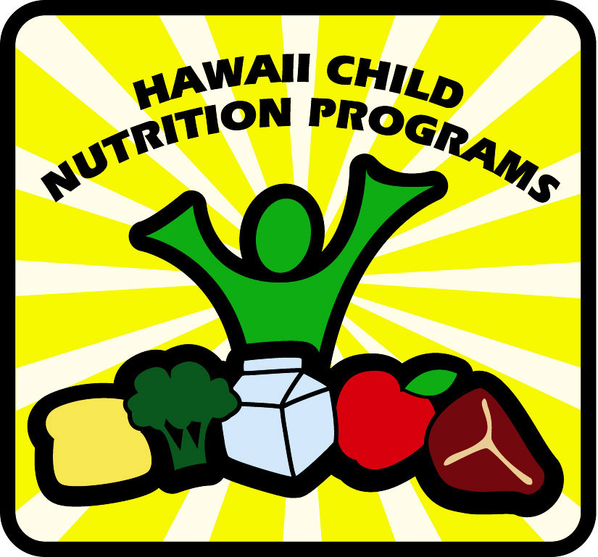

In accordance with federal civil rights law and U.S. Department of Agriculture (USDA) civil rights regulations and policies, the USDA, its agencies, offices, and employees, and institutions participating in or administering USDA programs are prohibited from discriminating based on race, color, national origin, sex, disability, age, or reprisal or retaliation for prior civil rights activity in any program or activity conducted or funded by USDA.

Persons with disabilities who require alternative means of communication for program information (e.g. Braille, large print, audiotape, American Sign Language, etc.), should contact the agency (state or local) where they applied for benefits. Individuals who are deaf, hard of hearing or have speech disabilities may contact USDA through the Federal Relay Service at 800-877-8339. Additionally, program information may be made available in languages other than English.

To file a program complaint of discrimination, complete the USDA Program Discrimination Complaint Form (AD-3027), found online at http://www.ascr.usda.gov/complaint_filing_cust.html and at any USDA office, or write a letter addressed to USDA and provide in the letter all of the information requested in the form. To request a copy of the complaint form, call 866-632-9992. Submit your completed form or letter to USDA by:

(1) Mail: U.S. Department of Agriculture
Office of the Assistant Secretary for Civil Rights
1400 Independence Avenue, SW
Washington, D.C. 20250-9410

(2) Fax: 202-690-7442

(3) E-mail: program.intake@usda.gov

HCNP and USDA are equal opportunity providers and employers.

Note: The protected classes for the Child and Adult Care Food Program are race, color, national origin, age, sex, and disability.

INTRODUCTION
The sample materials contained in this Invitation for Bid (IFB) and Contract package are supplied for use by agencies in the Child and Adult Care Food Program (CACFP) who contract for meals from vendors whose contracts for those meals would total more than $150,000 annually.

Agencies should familiarize themselves with procurement procedures and requirements as found in Title 2 Code of Federal Regulations, sections 200.318 through .326 (2 CFR 200.318–326) and Title 7 Code of Federal Regulations, Section 226.22 (7 CFR 226.22).

These materials and the processes described within meet the regulatory requirements prescribed by 7 CFR, sections 226.21 and 226.22 and 2 CFR, sections 200.318 through .326. If the agency uses a different contracting instrument, compliance with 7 CFR, sections 226.21, 226.22, and 2 CFR, sections 200.318 through .326 is mandatory.

Attachment I “Solicitation of Bids for Vended Meals” (a description of what the agency must do to start the bidding procedure) and the "Notice Inviting Bids" (a sample Legal Notice)

Attachment II "Summary of Process and Bid"—a form in which the agency summarizes the bid process and bids received, and which HCNP reviews.

Attachment III “Invitation for Bid and Contract”

Section A "Contract for Vended Meals"—the contractual agreement signature page

Section B "Independent Price Determination No Sanctions, and Drug Free Workplace Certification"

Section C "Instruction to Bidders"

Section D "Scope of Services"

Section E "Unit Price Schedule and Instructions"—for the agency and the bidder to complete

Section F "Contract Provisions and Specifications"

Section G "General Conditions"

Section H "General Provisions for Contracts Exceeding $150,000" and the "Clean Air and Water Certification"—to attach to IFB/Contracts

Schedule A "Centers Where the Program Will Operate"

Schedule B "Child and Adult Care Food Program Meal Pattern"—for infants, older children, and adults

Schedule C “Delivery Template”

Schedule D "Menu Cycle"— each meal type, for the agency to complete as required (including a “Modified Menu for Medically Prescribed Diets”)

The IFB package is available at http:\\ hcnp.hawaii.gov under the CACFP tab.

INTRODUCTION, PAGE 2

INSTRUCTIONS

- Review 7 CFR sections 226.21, 226.22, and 2 CFR sections 200.317 through 200.328 and the U.S. Department of Agriculture Child and Adult Care Food Program (CACFP) handbooks available at http://www.fns.usda.gov/cacfp/cacfp-handbooks

- State and Local entities may use competitive negotiation or small purchase procedures and must follow the federal small purchase threshold of $150,000.00, unless your institution’s small purchase threshold is more restrictive.

- Have, or develop, a written method for conducting technical evaluations of the proposals received and for selecting recipients (see 2 CFR 200.320).

- Complete the bid package with the agency’s information.

- Develop a bid advertisement or public notice inviting bids (may use Attachment I) and publish the notice at least once fourteen days before opening bids. Publish the notice in the Legal Notices section of a local newspaper that has general daily circulation in the agency’s area or in an appropriate trade journal.

- Solicit, in writing, bids from known food vendors in the agency’s area. The solicitation must be documented and contain the same information found in the notice.

- Receive an adequate number of bids—two or more. (If you do not receive an adequate number, contact your assigned CACFP specialist.)

- On the bid closing date and time announced in the public notice, open all sealed bids received.

- Complete page 7 (Attachment II).

- Mail, scan, or fax the following copies to your assigned CACFP specialist:

  - Each published notice

  - Documentation of all solicitations

  - The complete IFB (pages 5–34), including the federal, state, or local health certification for the facility in which the bidding vendor proposes to prepare meals, from each bidding vendor. For the Contract for Vended Meals (Section A) complete, but do not sign.

- Wait for your CACFP specialist to fax or scan a signed copy of page 6 (Attachment III). (The state must respond within 10 working days of receipt.) This marks approval of the chosen food vendor.

- Once you have receipt of approval, inform the chosen vendor in writing that you have selected them.

- Fax or scan your CACFP specialist a completed and signed copy of page 8—the executed contract itself (Section A of Attachment III).

MENU PLANNING: When planning menus, all CACFP agencies should follow CACFP Meal Pattern guidance found on pages 27-30 as well as the Key Recommendations found in the 2016 Dietary Guidelines for Americans www.dietaryguidelines.gov.

ATTACHMENT I

SOLICITATION OF BIDS FOR VENDED MEALS

A formal bidding procedure must include a Public Notice or Advertisement Inviting Bids with adequate purchasing descriptions. This invitation for bids must appear in a newspaper having general circulation in the agency's area or in an appropriate trade journal. At least fourteen calendar days should elapse between the Notice or Advertisement and the closing date for submission of bids. (These requirements are found in 7 CFR, Section 226.22.)

The Public Notice must include:

1. A complete description of the product subject for bid

2. The agency’s name and the address at which the bid is to be submitted

3. The closing date and time for acceptance of bids

4. Information that only sealed bids may be accepted

5. Information that the bid opening will be made public at the time and place referred to in the public notice

6. Information that the contract will be awarded to the lowest, most responsible and responsive bidder

In addition to the Public Notice or Advertisement Inviting Bids, bids must be solicited from two or more known suppliers within the agency's area. The solicitation must be made in writing and must contain the same information found in the Public Notice or Advertisement Inviting Bids. IFB Solicitation should also be posted on Agency’s website and other procurement sites as appropriate.

ATTACHMENT I, PAGE 2

This sample notice may be placed in the Legal Notices section of a local newspaper that has general daily circulation in the agency’s area. The agency shall supply a completed IFB to each bidder who responds to the notice.

NOTICE INVITING BIDS

Sealed bids will be received by ________________________________________________________________
agency name

at _______________________________________________________________________________________
agency address

until ____________________________________________ for meals to be served in the center(s).
time and date for bid closing period

At the time and place advertised, and promptly thereafter, all bids that have been duly received will be publicly opened and read aloud.

Description of Product for Bid:
complete description of product desired: types of meals or products needed, number of days service is desired, number of delivery points, and packaging

OR

The following types and quantities of meals:
breakfast, a.m. snack, lunch, p.m. snack, supper, and/or evening snack

Daily delivery of meals to |  | site(s).
number of serving sites
Types or forms of packaging or containerizing to be used for meals (based on a 5 or 6 week menu cycle the agency will provide):
bulk, prepackaged, unitized, inclusive of or exclusive of milk

All meals of each type must meet the minimum standards set by the USDA for CACFP meals of that type.

The contract will be awarded to the responsible bidder that possesses the potential ability to perform successfully under the terms and conditions of the proposed procurement and is lowest in price. Other factors shall be given consideration when there are sound documented business reasons such as contractor integrity, compliance with public policy, record of past performance, and financial and technical resources.

ATTACHMENT II

SUMMARY OF PROCESS AND BIDS
NOTICE INVITING BIDS*
publication date | name of newspaper or trade journal
*Attach copies of the Media Certification(s) of Publication
BID OPENING
date | time | place
agency official who opened bid(s) |  | title
WITNESSES
1. | 3.
2. | 4.
SUMMARY OF BIDS
name of bidder | unit prices per meal | total estimated bid

Was the lowest bid accepted?  Yes No | If No, provide justification for acceptance of another bid (or attach it to this page):

I certify the information provided above is true and correct. I understand that this information is being given in connection with the receipt of federal funds; that department officials may, for cause, verify information; and that deliberate misrepresentation will subject me to prosecution under applicable state and federal criminal statutes.
signature of authorized agency representative | title | date

ATTACHMENT III

INVITATION FOR BID AND CONTRACT
(DELIVERY)
ISSUED BY (AGENCY):
name |  |  |  |  |  |  | address
city |  |  |  | state |  |  |  | zip code | telephone number
bid opening:
date | time |  | location |  |  |  |  |  |  |  |  |  |  |  | issue date
BID
This document contains an IFB for the furnishing of meals (unitized if applicable) to be served to participants of the CACFP established by the USDA (7 CFR, Part 226) and sets forth the terms and conditions applicable to the proposed procurement.
name of vendor |  |  |  |  |  |  |  |  |  | federal id number
street address |  |  |  |  |  |  |  |  |  | telephone number
city |  |  |  |  |  | state |  |  |  |  | zip code
total estimated amount of bid |  |  |  |  | Prompt Payment Discount: % for payment within days.
By submission of this proposal, the contractor certifies that, in the event they receive an award under this solicitation, they shall operate in accordance with all applicable, current CACFP regulations.
signature of authorized representative of vendor |  |  |  |  |  | title |  |  |  |  |  |  |  | date
ACCEPTANCE
Accepting a bid does not constitute acceptance of the contract. Upon acceptance by the agency and review and approval by the HCNP, the bid documents shall constitute the covenants, conditions, agreements, and stipulations of the contract between the contractor making the proposal and the agency named above.
contract number |  | agency name |  |  |  |  |  |  |  |  |  |  | date

signature of agency representative
PROCUREMENT METHOD: (Check One)

Sealed Bids (IFB) Competitive Proposals (RFP) Noncompetitive Negotiation
FOR HCNP USE ONLY
This contract was reviewed for compliance with 7 CFR, Part 226 by:
signature |  |  |  |  |  |  |  |  |  |  |  | date
Approved by HCNP
YES________ NO_________

SECTION a
CONTRACT FOR VENDED MEALS

THIS AGREEMENT, made and entered this day of , 20 ,
in the State of Hawaii, by and between hereinafter referred to as the agency and ¹ hereinafter referred to as the contractor.

WITNESSETH:
That the contractor for and in consideration of the covenants, conditions, agreements, and stipulations of the agency hereinafter expressed, does hereby agree to furnish to the agency services and materials as described in the original IFB, Sections A, B, C, D, E, F, G, and H, and Schedules A, B, C, and D, which were attached and made a part hereof by this reference.

The period of this contract shall be from through . ² This contract may be renewed for one-year periods up to four times upon agreement of the agency and the contractor no later than 30 days before the expiration of bid. Any increase of the unit price(s) shall be negotiated during the renewal process only and may be increased on an annual basis by the Yearly Percentage Change in the Consumer Price Index for All Urban Consumers, as published by the U.S. Department of Labor, Bureau of Labor Statistics, and Food Eaten Away from Home. Such increases shall be effective on a prospective basis on each anniversary date of this Contract and will be allowed only if approved in advance by State Agency.

In consideration of the service, performed in a manner acceptable to the agency and in compliance with the CACFP regulations, 7 CFR, Part 226, the agency shall pay the contractor within ____days of receipt, the full amount of the itemized invoices as confirmed by delivery receipts, at the unit price(s) specified in the contract. The total amount payable by the agency to the contractor under this contract shall not exceed $ _______________.

IN WITNESS WHEREOF, this agreement has been executed by the parties hereto, upon the date first above written.
AGENCY | CONTRACTOR
agency name | contractor (state whether a corporation, partnership, etc.)
by (authorized signature) | by (authorized signature)
printed name of person signing | printed name and title of person signing
title | address
initial contract year  YES ________ NO _________ | Renewal  YR 2______ YR 3______ YR 4 ______ YR 5 ______

¹ Sole proprietorship, partnership, corporation, etc.
² The original contract period cannot exceed one year.

SECTION B

CERTIFICATE OF INDEPENDENT PRICE DETERMINATION,

NO SANCTIONS, DRUG FREE WORKPLACE, AND ANTI-LOBBYING

by submission of this bid, the bidder certifies and in the case of a joint bid, each party thereto certifies as to its own organizations, that in connection with this procurement:

INDEPENDENT PRICE DETERMINATION

- The prices in this bid have been arrived at independently, without consultation, communication, or agreement, for the purpose of restricting competition, as to any matter relating to such prices with any other bidder or with any competitor.

- Unless otherwise required by law, the prices that have been quoted in this bid have not been knowingly disclosed by the bidder and will not knowingly be disclosed by the bidder prior to bid opening, directly or indirectly to any other bidder or to any competitor.

- No attempt has been made or will be made by the bidder to induce any person or firm to submit or not to submit a bid for the purpose of restricting competition.

DEBARMENT AND SUSPENSION (No Sanctions)

Entities are subject to the non-procurement debarment and suspension regulations implementing Executive Orders 12549 and 12689, 2 CFR part 180. These regulations restrict awards, subawards, and contracts with certain parties that are debarred, suspended, or otherwise excluded from or ineligible for participation in Federal assistance programs or activities.

- Are not presently debarred, suspended, proposed for debarment, declared ineligible, or voluntarily excluded from covered transactions by any Federal department or agency;

- Have not within a three-year period preceding this proposal been convicted of or had a civil judgment rendered against them for commission of fraud or a criminal offense in connection with obtaining, attempting to obtain, or performing a public (Federal, State or local) transaction or contract under a public transaction; violation of Federal or State antitrust statutes or commission of embezzlement, theft, forgery, bribery, falsification or destruction of records, making false statements, or receiving stolen property;

- Are not presently indicted for or otherwise criminally or civilly charged by a governmental entity (Federal, State or local) with commission of any of the offenses enumerated in paragraph (1)(b) of this certification; and

- Have not within a three-year period preceding this application/proposal had one or more public transactions (Federal, State or local) terminated for cause or default.

- Where the prospective food vendor is unable to certify to any of the statements in this certification, such prospective food vendor shall attach an explanation to this proposal.

DRUG FREE WORKPLACE

The bidder certifies that it will continue to provide a drug-free workplace as required by the State Drug-Free Workplace Act of 1990 (Government Code Section 8350 et. Seq.) and the Federal Drug-Free Workplace Act of 1988, and implemented at Title 34, Code of Federal Regulations (34 CFR), Part 85, Subpart F, for grantees, as defined at 34 CFR, Part 85, sections 85.605 and 85.610.

ANTI-LOBBY CERTIFICATION (for bids over $100k)
Byrd Anti-Lobbying Amendment (31 U.S.C. 1352)—Contractors that apply or bid for an award exceeding $100,000 must file the required certification. Each tier certifies to the tier above that it will not and has not used Federal appropriated funds to pay any person or organization for influencing or attempting to influence an officer or employee of any agency, a member of Congress, officer or employee of Congress, or an employee of a member of Congress in connection with obtaining any Federal contract, grant or any other award covered by 31 U.S.C. 1352. Each tier must also disclose any lobbying with non-Federal funds that takes place in connection with obtaining any Federal award. Such disclosures are forwarded from tier to tier up to the non-Federal award.

Submission of this certification is a prerequisite for making or entering into this transaction and is imposed by section 1352, Title 31, U.S. Code. This certification is a material representation of fact upon which reliance was placed when this transaction was made or entered into. Any person who fails to file the required certification shall be subject to a civil penalty of not less than $10,000 and not more than $100,000 for each such failure.

Compliance with 2CFR200.322
Agrees to comply with Procurement of recovered materials per 2CFR 200.322 and Appendix II of 2CFR200 if applicable.

THE PERSON SIGNING THE BID DOCUMENTS CERTIFIES:

- The bidder is the person in the bidder's organization responsible within that organization for the decision as to the prices being offered herein or that the bidder has been authorized in writing to act as agent for the persons responsible for such decisions in certifying that such persons have not participated and will not participate, in any action contrary to the above Independent Price Determination sections (1) through (3).

- The bidder has not participated, and will not participate, in any action contrary to (1) through (3) above Independent Price Determination sections (1) through (3).

AND, AS THEIR AGENT, DOES HEREBY CERTIFY:

signature of authorized agent (vendor) | title | date
printed name of authorized agent (vendor) | vendor’s legal business name
In accepting this bid, the agency certifies that the agency's officers, employees, or agents have not taken any action that may have jeopardized the independence of the bid referred to above.
signature of authorized agency representative | title | date

ACCEPTING A BID DOES NOT CONSTITUTE ACCEPTANCE OF THE CONTRACT

NOTE: Authorized representatives of both the agency and bidder must execute this or a similar certificate of independent price determination.

SECTION C

INSTRUCTION TO BIDDERS
Definitions (as used herein):
- The term "Invitation for Bid," hereafter referred to as IFB, means the document soliciting bids through the formal advertising method of procurement. In the case of this Program, the IFB becomes a part of the contract upon acceptance by the agency, review by HCNP, and execution of the contractual agreement.
- The term "Bid" means an offer to perform the work described in the IFB at the fixed unit price specified in accordance with the terms and conditions of the solicitation.
- The term "Bidder" means a food service management company submitting a bid in response to this IFB.
- The term "Contractor" means the food service management company to whom the bid is awarded and with whom the contractual agreement is executed.
- The term "HCNP" means the Hawaii Child Nutrition Program.
- The term "Food Service Management Company" means an organization, other than a public or private nonprofit school, with which the agency may contract for preparing, and unless otherwise provided for, delivering meals, with or without milk, for use in the program.
- The term "Agency" means the CACFP Agency that issues this IFB.
- The term "Program" means the CACFP as set forth in 7 CFR, Part 226.
- The term "Unitized Meal" means an individual pre-portioned meal consisting of a combination of foods meeting the complete meal requirements, delivered as a unit and served as a unit, with or without milk.
- The term “Bulk packaging” means food not pre-portioned consisting of a combination of bulk foods which meeting the complete meal requirements, delivered in bulk to be portioned out by the Agency, with or without milk.
- All breakfasts, lunches, and suppers delivered for service in outside-school-hours care centers shall be unitized, with or without milk, unless SA determines that unitization would impair the effectiveness of food service operations. For meals delivered to child care centers and day care homes, the SA may require unitization, with or without milk, of all breakfasts, lunches, and suppers only if the SA has evidence which indicates that this requirement is necessary to ensure compliance with 7 CFR 226.6(i)(11).

2. Submission of Bids
- Bidders are expected to examine carefully the specifications, schedules, attachments, terms, and conditions of this IFB. Failure to do so shall be at the bidder's own risk.
- Bids shall be executed and submitted in triplicate with one copy being marked "original". If accepted, this IFB will become a part of the contract and one copy of the accepted bid/contract will be forwarded to the successful bidder with the notice of award. The copy marked "original" shall be governing should there be a variance between that "original" copy of the bid and other copies submitted by the bidder. No changes in the specifications or general conditions as presented by the agency herein are allowed. Cross-outs on this bid shall be initialed by the bidder prior to submission
- A copy of a current state or local food permit for the food preparation facilities shall be submitted with the bid.
SECTION C, PAGE 2

- Bids must include an Independent Price Determination, No Sanctions, Anti- Lobbying, Drug Free Workplace Certification and Procurement of recovered materials.
Failure to comply with any of the above shall be reason for rejection of the bid.

3. Explanation to Bidders
Any explanation desired by a bidder regarding the meaning or interpretation of the IFB specifications, etc., must be requested in writing prior to bid opening and with sufficient time allowed for a reply to reach all bidders before bid opening. Oral explanations or instructions given before the award of the contract shall not be binding. Any information given to a prospective bidder concerning an IFB shall be furnished to all prospective bidders as an amendment to the IFB if such information is necessary to bidders in submitting bids on the IFB, or if the lack of such information would be prejudicial to uninformed bidders.

- Acknowledgment of Amendments to IFBs
Receipt of an amendment to an IFB by a bidder must be acknowledged by signing and returning the amendment. Such acknowledgment must be received prior to the hour and date specified for bid opening.

- Bidders Having Interest in More Than One Bid
If more than one bid is submitted by any one person, by, or in the name of a clerk, partner, or other person, all such bids shall be rejected.

- Time for Receiving Bids
Sealed bids shall be deposited at the address specified on the IFB of the agency no later than the exact time and date indicated on the face of this IFB. Bids received prior to the time of opening will be securely kept, unopened.

- Errors in Bids
Bidders or their authorized representatives are expected to fully inform themselves as to the conditions, requirements, and specifications before submitting bids; failure to do so shall be at the bidder's own risk and the bidder cannot secure relief on the plea of error.

- Award of Contract
- The contract will be awarded to the responsive and responsible bidder whose bid will be most advantageous to the agency, price, and other factors considered. Consideration shall be given to such matters as contractor integrity, compliance with public policy, record of past performance, and financial and technical resources.
- The agency reserves the right to reject any or all bids and to waive informalities and minor irregularities in bids received when there are sound documented business reasons in the best interest of the program.
- The agency reserves the right to reject the bid of a bidder who has previously failed to perform properly or complete on-time contracts of a similar nature, or the bid of a bidder who investigation shows is unable to perform the contract.

SECTION C, PAGE 3

9. Late Bids, Modifications of Bids, or Withdrawals of Bids
(a) Any bid received after the exact time specified for receipt will not be considered unless it is received before the award is made and it was sent by registered or certified mail, no later than the fifth calendar day prior to the date specified for the receipt of bids (e.g., a bid submitted in response to an IFB requiring receipt of bids by the 20th of the month must have been mailed by the 15th or earlier).
(b) Any modification or withdrawal of a bid is subject to the same conditions as in (a). A bid may also be withdrawn in person by a bidder or a bidder’s authorized representative, provided that person’s identity is made known and s/he signs a receipt for the bid, but only if the withdrawal is made prior to the exact time set for receipt of bids.
(c) The only acceptable evidence to establish the date of mailing of a late bid, modifications, or withdrawal sent either by registered or certified mail is the postmark. If the date on the postmark is illegible, the bid, modification, or withdrawal shall be deemed to have been mailed late. (The term "postmark" means, a printed, stamped, or otherwise placed impression that is readily identifiable without further action as having been supplied and affixed on the date of mailing.)
(d) Notwithstanding the above, a late modification of an otherwise successful bid that makes its terms more favorable to the agency will be considered at any time it is received and may be accepted.

SECTION D

SCOPE OF SERVICES

- The contractor agrees to deliver unitized or bulk¹ meals (Select one) to locations set in the Schedule A, attached hereto and made a part hereof, subject to the terms and conditions of this solicitation. (Does not apply to outside-school-hours care centers.)

- The contractor agrees to deliver unitized or bulk² milk (Select one) to locations set in the Schedule A, attached hereto and made a part hereof, subject to the terms and conditions of this solicitation.

- All meals furnished for the program under this contract must meet or exceed USDA requirements set out in Schedule B, attached hereto and made a part hereof. All yields of cooked and uncooked products shall conform to yields identified in the USDA’s Food Buying Guide.

- The contractor agrees to furnish meals for the program in accordance with the menu cycle that appears in Schedule D, attached hereto and made a part hereof.

- The contractor shall furnish meals for the program as ordered by the Agency during the period of
to ³ to ³.

- The contractor shall furnish meals for the program as ordered by the agency ⁴ days a week.

- The contractor agrees to deliver unitized meals to outside-school-hours care centers with or without milk.⁵ (Select one)

¹ Agency shall select meal service type.
² Agency shall select milk service type.
³ Agency shall insert contract commencement date and expiration date (cannot exceed one year).
⁴ Agency shall insert appropriate number of serving days.
⁵ Agency shall select with or without milk.

SECTION E

UNIT PRICE SCHEDULE AND INSTRUCTIONS

Unit Price Schedule

Bidders are to submit prices on the following meal types meeting the contract specifications set forth in Schedules B and D for meals to be delivered to all of the centers stated in Schedule A. (See the example on the next page.)
A.  Meal Type¹ | B.  Estimated  Servings Per Day² | C.  Estimated Number  of Serving Days³ | D.  Unit Price⁴ | E.  Total Price⁵
Breakfast
A.M. Snack
Lunch
P.M. Snack
Supper
Evening Snack
Bidders shall submit their bids on an "all or none" basis. Except as otherwise provided in this solicitation, if a contract is awarded as a result of this solicitation, it will bind the agency during the term of the contract, secure all of the identified meals from the successful bidder, and such contract shall bind the bidder/contractor to perform all such work ordered by the agency at prices specified in the contract. Award will be made to a single responsive and responsible bidder on the basis of the lowest aggregate cost to the agency. Evaluation of prices will be on the basis of the estimated requirements set forth herein.

In the event of any inconsistencies or errors, the unit price (D) shall take precedence.

Instructions for completion of the Unit Price Schedule: (See the example on the next page.)
¹ The agency shall indicate which meal types the contractor will be providing meals for during the contract period (strike-out extraneous meal types in Column A). If unitized meals will be required, the agency must indicate so by placing "unitized meal" in parenthesis after the meal type.

² The agency shall fill in the estimated number of meals that will be served each day (Column B) by meal type during the contract period.

³ The agency shall fill in the number of anticipated operating days that meals will be served (Column C) during the contact period.

⁴ The bidder shall insert the appropriate unit price (Column D) for each meal type indicated by the agency.

⁵ The bidder shall calculate the total price (Column E) by multiplying B x C x D.

SECTION E, PAGE 2

EXAMPLE
A.  Meal Type¹ | B.  Estimated  Servings Per Day² | C.  Estimated Number  of Serving Days³ | D.  Unit Price⁴ | E.  Total Price⁵
Breakfast | 100 | 180 | .73 | $13,140.00
A.M. Snack
Lunch
P.M. Snack
Supper (Unitized Meal) | 100 | 180 | 2.92 | $26,280.00
Evening Snack

Instructions for completion of the Unit Price Schedule:
¹ The agency shall indicate which meal types the contractor will be providing meals for during the contract period (strike-out extraneous meal types in Column A). If unitized meals will be required, the agency must indicate so by placing "unitized meal" in parenthesis after the meal type.
² The agency shall fill in the estimated number of meals that will be served each day (Column B) by meal type during the contract period.
³ The agency shall fill in the number of anticipated operating days that meals will be served (Column C) during the contact period.
⁴ The bidder shall insert the appropriate unit price (Column D) for each meal type indicated by the agency.
⁵ The bidder shall calculate the total price (Column E) by multiplying B x C x D.

SECTION F

CONTRACT PROVISIONS AND SPECIFICATIONS

- Requirements Contract
- This is a requirements contract for services specified in the Sections and Schedules and for the period set forth herein. The quantities of such services specified herein are estimates only and are not purchased hereby. Except as may be otherwise provided herein, in the event the Agency's requirements for services set forth in the Sections and Schedules do not result in orders in the amounts or quantities described as "estimated" in the Sections and Schedules, such event shall not constitute the basis for an equitable price adjustment under this contract.
- The agency shall not be required to purchase from the contractor requirements in excess of the limit on total orders under this contract, if any.
- The agency may issue orders that provide for delivery or performance at multiple destinations.
- The agency shall not be obligated to place any minimum dollar amount of orders under this contract or any minimum number of orders. The utilization of the Contractor for services specified in the Sections and Schedules will be dependent upon the needs and requirements of the agency.
- Regulatory or guidance changes prescribed by the USDA or HCNP, during the duration of this contract, shall be considered a basis for renegotiation with prior approval and agreement from HCNP, of the terms and conditions of the contract between the agency and the contractor. Authority for such renegotiation must be requested from HCNP, in writing by the agency, prior to the commencement of any such renegotiation.
- Any deviations from this contract template will require prior approval by your assigned CACFP specialist.

2. Pricing
Pricing shall be on the numbers described in Section E, “Unit Price Schedule”. All bidders must submit bids on the same menu cycle provided by the agency. Bid prices must include the price of food, milk (if applicable), packaging, transportation, and all other related costs (e.g., condiments, utensils, etc.) that are essential to the content of the food service.

3. Evaluation of Bidders
Each bidder will be evaluated on the following factors:
- Financial capability to perform a contract of the scope required.
- Adequacy of plant facilities for food preparation, with approved licensing certification that facilities meet all applicable state and local health, safety, and sanitation standards.
- Previous experience performing services similar in nature and scope.
- Other factors such as transportation capability, sanitation, and packaging.
Bidders that do not satisfactorily meet the above criteria may be rejected as unresponsive and not considered for award.

SECTION F, PAGE 2

- Unit Prices
The unit prices of each meal type that the bidder agrees to furnish must be written in ink or typed in the blank space provided in Section E of the Unit Price Schedule, including proper packaging as required in the specifications, and the costs of delivery to the designated sites. Unit prices shall include taxes; but, any charges or taxes that are required to be paid under future laws must be paid by the bidder at no additional charge to the agency.
- Meal Orders
The agency will order meals on ¹ of the week preceding the week of delivery; orders will be placed for the total number of days in the succeeding week, and will include breakdown totals for each center and each type of meal. The agency reserves the right to increase or decrease the number of meals ordered on a ² hour notice (or less if mutually agreed upon between the parties to this contract).

- Menu-cycle Change Procedure
Meals shall be delivered on a daily basis in accordance with the menu cycle which appears in Schedule D. Deviation from this menu cycle shall be permitted only upon authorization of the agency. When an emergency situation prevents the contractor from delivering a specified meal component, the contractor shall notify the agency immediately so substitutions can be agreed upon. The agency reserves the right to periodically suggest menu changes that are within the contractor's food cost.

- Noncompliance
The agency reserves the right to inspect and determine the quality of food delivered and reject any meals that do not comply with the requirements and specifications of the contract. The contractor shall not be paid for unauthorized menu changes, incomplete meals, meals not delivered within the specified delivery time period, and meals rejected because they do not comply with the specifications. The agency reserves the right to obtain meals from other sources if meals are rejected due to any of the stated reasons. The contractor shall be responsible for any excess cost, but will receive no adjustment in the event the meals are procured at a lesser cost. The agency or agency representative inspecting shall notify the contractor in writing as to the number of meals rejected and the reasons for rejection.
- Title III C Assurance
The Contractor assures the agency that no Title III C funds will be applied to the cost of the meals furnished for the program under this contract.

¹ Indicate the day of the week orders for the next week will be placed.
² Timeframe should be no longer than 24 hours.

SECTION F, PAGE 3

- Specifications
- Packaging
- Hot Meal Unit packaging shall be suitable for maintaining meals in accordance with local health standards. Container and overlay should have an airtight closure, be of non-toxic material, and be capable of withstanding temperatures of 400°F (204°C) or higher.
- Cold Meal Unit or Unnecessary-to-heat Container and overlay shall be plastic or paper and non-toxic.
- Cartons—each carton shall be labeled and the label shall include:
- The processor's (plant) name and address
- Item identity and meal type
- Date of production
- Quantity of individual units per carton
- Meals shall be delivered with the following non-food items: condiments, straws, napkins, single service ware, etc.³
- Food Preparation
Meals shall be prepared under properly controlled temperatures and assembled not more than 24 hours prior to delivery.
- Food Specifications*
Bids are to be submitted on the menu cycle included as D and shall include, at a minimum, the portions specified by the USDA for each meal, which are included in Schedule B of this IFB.
All meat and meat products, except sausage products, shall have been slaughtered, processed, and manufactured in plants inspected under a USDA approved inspection program and bear the appropriate seal. Upon delivery, all meat and meat products must be sound, sanitary, and free of objectionable odors or signs of deterioration.
- Product Specifications *
Milk and milk products are defined as "...fluid types of pasteurized flavored or unflavored whole milk or low fat milk, or skim milk or cultured buttermilk, which meets State and local standards for such milk..." Milk delivered hereunder shall conform to these specifications. Note: only low fat (1 percent) or non-fat milk can be served to individuals two years and older. Whole white milk must be served to individuals under two years of age.

*USDA Food s specifications and grading standards: http://www.fns.usda.gov/fdd/specifications-us-grading-standards
³ The agency shall insert or delete non-food items that are necessary for the meal to be eaten.

SECTION G

GENERAL CONDITIONS

- Delivery Requirements
- Deliveries shall be made by the contractor to each center listed on the attached Schedule A in accordance with the order from the agency.
- Meals shall be delivered, unloaded, and placed in the designated center daily by the contractor's personnel at each of the locations and times listed on the Schedule A.
- The contractor shall be responsible for the delivery of all meals and dairy products at the specified time. Adequate refrigeration or heating shall be provided during the transportation and delivery of all food to insure the wholesomeness of food at delivery in accordance with state or local health codes.
- The agency reserves the right to add or delete centers. This shall be done by amendment of the Schedule A. The agency shall notify the contractor of such amendments to the Schedule A not less than one week prior to the required date of service. Any changes in transportation costs that occur as a result of adding or deleting centers shall be negotiated and noted in the modification. The contractor's invoice shall show the cost as a separate item for that center.

- Supervision and Inspection
The contractor shall provide management supervision at all times and maintain constant quality control inspections to check for portion size, appearance, and packaging, in addition to the quality of products.

- Record Keeping
- Transport records must be prepared by the contractor—one for the contractor, one for center personnel, and one for the agency. Transport records must be itemized to show the number of meals of each type delivered to each center. Designees of the agency at each center will check the adequacy of the delivery and the meals before signing the delivery ticket. Invoices shall be accepted by the agency only if they accurately represent the transport records signed by the agency's designee at the center. See Schedule C for delivery template.
- The contractor shall maintain records supported by transport records, purchase orders, and production records for this contract or other evidence for inspection and reference to support payments and claims.
- The books and records of the contractor pertaining to this contract shall be available for a period of three years from the date the agency submits to HCNP the final claim for reimbursement for meals provided under this contract, or until the final resolution of any audits for inspection and audit by representatives of HCNP, the USDA, the agency, and the Controller General of the United States at any reasonable time and place.

SECTION G, PAGE 2

- Method of Payment

The contractor shall submit its itemized invoice to the agency . ¹ Each invoice shall give a detailed breakdown of the number of meals delivered and signed for at each center during the preceding . ² Payment will be made at the unit price specified in the contract. No payment shall be made unless the required delivery receipts have been signed by the center representative of the agency.

- Inspection of Facility
- The agency, HCNP, and the USDA reserve the right to inspect the contractor's preparation facilities prior to award and without notice at any time during the contract period, including the right to be present during preparation and delivery of meals.
- The contractor's facilities shall be subject to periodic inspections by the USDA, state, and local health departments, or any other agency designated to inspect meal quality for the state. This will be accomplished in accordance with USDA regulations.
- The contractor shall provide for meals which it prepares to be periodically inspected by the local health department or an independent agency to determine bacteria levels in the meals being prepared, transported, and delivered. Such levels shall conform to the standards which are applied by the local health authority with respect to the level of bacteria which may be present in meals served by other establishments in the locality.

- Insurance/Bond

Offer Guaranty (bid bond) shall be the part of the contractor for 5% percent of the contract price per 2CFR 200.325

- Availability of Funds
The agency shall have the option to cancel this contract if the federal government withdraws funds to support the CACFP. It is further understood that, in the event of cancellation of the contract, the agency shall be responsible for meals that have already been assembled and/or delivered in accordance with this contract.

- Number of Meals and Delivery Times
The contractor must provide the exact number of meals ordered. Counts of meals will be made at all centers before meals are accepted. Damaged or incomplete meals shall not be included when the number of delivered meals is determined.

¹ Insert weekly, biweekly, or monthly as applicable.
² Insert week, two weeks, or month to correspond to the previous footnote.
³ Agencies may insert their own insurance or bonding requirements or specifications as applicable. See 2CFR 200.325 bonding requirements for details.

SECTION G, PAGE 3

- Emergencies

In the event of unforeseen emergency circumstances, the contractor shall immediately notify the agency of the following: (a) the impossibility of on-time delivery; (b) the circumstance(s) precluding delivery; and (c) a statement of whether or not succeeding deliveries will be affected. No payments will be made for deliveries made later than ⁴ hour(s) after specified mealtime. Emergency circumstances at the center precluding utilization of meals are the concern of the agency. The agency may cancel orders provided it gives the contractor at least ⁵ hours’ notice. Adjustments for emergency situations affecting the contractor's ability to deliver meals or the agency's ability to utilize meals for periods longer than 24 hours will be mutually worked out between the contractor and the agency.

- Termination
- The agency reserves the right to terminate this contract if the contractor fails to comply with any of the requirements of this contract. The agency shall notify the contractor of specific instances of noncompliance in writing. In instances where the contractor has been notified of noncompliance with the terms of the contract and has not taken immediate corrective action, the agency shall have the right upon written notice to immediately terminate the contract and the contractor shall be liable for any damages incurred by the agency. The agency shall negotiate a repurchase contract on a competitive basis to arrive at a fair and reasonable price.
- The agency shall by written notice to the contractor, terminate the right of the contractor to proceed under this contract if it is found by the agency that gratuities in the form of entertainment, gifts, or otherwise were offered or given by the contractor to any officer or employee of the agency, with a view toward securing the contract or securing favorable treatment with respect to the awarding or amending of the contract; provided that the existence of the facts upon which the agency makes such findings shall be in issue and may be reviewed in any competent court.
- In the event this contract is terminated as provided in paragraph (b) hereof, the agency shall be entitled (i) to pursue the same remedies against the contractor as it could pursue in the event of a breach of the contract by the contractor, and (ii) as a penalty in addition to any other damages in an amount which shall not be less than three nor more than 10 times the cost incurred by the contractor in providing any such gratuities to any such officer or employee.
- The contract may be terminated for convenience by either party by written notification provided to the other party at least sixty (60) days prior to the date of proposed termination.
- The rights and remedies of the agencies provided in this clause shall not be exclusive and are in addition to any other rights and remedies provided by law or under this contract.

- Subcontracts and Assignments
The contractor shall not subcontract with any other contractor for the meal or for the assembly of the meal; and shall not assign, without the advance written consent of the agency, this contract or any interest therein. In the event of any assignment, the contractor shall remain liable to the agency as principal for the performance of all the contractor’s obligations under this contract.

⁴ Timeframe should be no longer than two hours.
⁵ Timeframe should be no longer than 48 hours.

SECTION G, PAGE 4

- Equal Opportunity
The following clause is applicable unless this contract is exempt under the rules, regulations, and relevant orders of the Secretary of Labor (Title 41, Code of Federal Regulations, Chapter 60).
During the performance of this contract, the contractor agrees as follows:
- The contractor will not unlawfully discriminate against any employee or applicant for employment because of race, color, religion, national origin, or sex.
The contractor will take affirmative action to ensure that the evaluation and treatment of his/her employees and applicants for employment are free of such discrimination. Such action shall include, but not be limited to, the following: employment, upgrading, demotion, or transfer; recruitment or recruitment advertising; layoff or termination; rates of pay or other forms of compensation; and selection for training, including apprenticeship.
(b) The contractor will comply with all provisions of Executive Order No. 11246 of September 24, 1965, as amended by Executive Order No. 11375 of October 13, 1967, and of the rules, regulations, and relevant orders of the Secretary of Labor.
The contractor will furnish all information and reports required by Executive Order No. 11246 of September 24, 1965, as amended by Executive Order No. 11375 of October 13, 1967, and by the rules, regulations, and orders of the Secretary of Labor for purposes of investigation to ascertain compliance with such rules, regulations, and orders.
(c) In the event of the contractor's noncompliance with the equal opportunity clause of this contract or with any of the said rules, regulations, or orders, this contract may be canceled, terminated, or suspended, in whole or in part, and the contractor may be declared ineligible for further state or federally funded contracts in accordance with procedures authorized in Executive Order 11246 of September 24, 1965, as amended by Executive Order No. 11375 of October 13, 1967, and such other sanctions as may be imposed and remedies invoked as provided in Executive Order No. 11246 of September 24, 1965, as amended by Executive Order 11375 of October 13, 1967, or by rule, regulations, or order of the Secretary of Labor, or as otherwise provided by law.

SECTION H

GENERAL PROVISIONS FOR CONTRACTS EXCEEDING $150,000

per 7 cfr part 226.22 (l)(6), under section 306 of the clean air act [42 united states code (usc) 1837(h)], section 508 of the clean water act [33 usc 1368], executive order 11738, and u.s. environmental protection agency (epa) regulations [title 40, code of federal regulations,
(40 cfr) part 15] which prohibit the use under nonexempt federal contracts, grants or loans of facilities included on the epa list of violating facilities, this certification is applicable if the bid or offer exceeds $150,000, or the agency official has determined that orders under an indefinite quantity contract in any year will exceed $150,000.

Clean Air and Water

The contractor agrees as follows:

- To comply with all the requirements of Section 114 of the Clean Air Act, as amended (41 USC 1857, et seq., as amended by Public Law 91-604), and all requirements adopted pursuant to Division 26 of the California Health and Safety Code, Section 39000, et seq., respectively, relating to inspection, monitoring, entry, reports, and information, as well as other requirements so specified, and all regulations and guidelines issued thereunder before the award of this contract.

- To comply with all the requirements of Section 308 of the Federal Water Pollution Control Act (33 USC 1251, et seq., as amended by Public Law 92-500) and those adopted pursuant to the Porter-Cologne Water Quality Control Act (California Water Code, Division 7, Section 13000, et seq.), respectively, relating to inspection, monitoring, entry, reports, and information, as well as other requirements specified in said acts, and all regulations and guidelines issued thereunder before the award of this contract.

- That no portion of the work required by this contract will be performed at a facility listed on the EPA List of Violating Facilities on the date when this contract was awarded unless and until the EPA eliminates the name of such facility or facilities from such listing.

- To use his/her best efforts to comply with clean air standards and clean water standards at the facilities in which the contract is being performed.

- To insert the substance of the provisions of this clause in any nonexempt subcontract including this paragraph.

Energy Policy and Conservation Act (Public Law 94-163)

The contractor agrees to comply with all mandatory standards and policies relating to energy efficiency in compliance with Public Law 94-163.

SECTION H, PAGE 2

CLEAN AIR AND WATER CERTIFICATION

per 7 cfr part 226.22 (l)(6), under section 306 of the clean air act [42 usc 1837(h)], section 508 of the clean water act [33 usc1368], executive order 11738, and epa regulations [40 cfr part 15] which prohibit the use under nonexempt federal contracts, grants or loans of facilities included on the epa list of violating facilities, this certification is applicable if the bid or offer exceeds $150,000, or the agency official has determined that orders under an indefinite quantity contract in any year will exceed $150,000.

1. The bidder certifies any facility to be utilized in the performance of this proposed contract
has has not
been listed on the EPA List of Violating Facilities.

2. The bidder will promptly notify the agency official, prior to award, of the receipt of any communication from the Director, Office of Federal Activities, EPA, indicating that any facility that the bidder proposes to use for the performance of the contract is under consideration to be listed on the EPA List of Violating Facilities.

3. The bidder will include substantially this certification, in its entirety, in every nonexempt subcontract.

printed name of authorized agent (contractor) | contractor’s legal business name
signature of authorized agent (contractor) | title | date

SCHEDULE A

INVITATION FOR BID AND CONTRACT (DELIVERY)

SITES WHERE THE PROGRAM WILL OPERATE
name of center | address and  telephone number | authorized  designee | types of meals | number of  each meal type  needed | delivery time  for each  meal type | beginning and ending  dates of program  at each center

SCHEDULE B

CHILD AND ADULT CARE FOOD PROGRAM

MEAL PATTERN FOR INFANTS+

Breakfast
Birth through 5 months | 6 through 11 months
4-6 fluid ounces breastmilk1 or formula2 | 6-8 fluid ounces breastmilk1 or formula2; and  0-4 tablespoons infant cereal2,3 meat,  fish, poultry, whole egg,  cooked dry beans, or cooked dry peas; or  0-2 ounces of cheese; or  0-4 ounces (volume) of cottage cheese; or 0-8 ounces or 1 cup of yogurt4; or a combination of the above5; and  0-2 tablespoons vegetable or fruit3 or a combination of both5,6

1 Breastmilk or formula, or portions of both, must be served; however, it is recommended that
breastmilk be served in place of formula from birth through 11 months. For some breastfed infants who regularly consume less than the minimum amount of breastmilk per feeding, a serving of less than the minimum amount of breastmilk may be offered, with additional breastmilk offered at a later time if the infant will consume more.
2 Infant formula and dry infant cereal must be iron-fortified.
3 Beginning October 1, 2019, ounce equivalents are used to determine the quantity of creditable grains.
4 Yogurt must contain no more than 23 grams of total sugars per 6 ounces.
5 A serving of this component is required when the infant is developmentally ready to accept it.
6 Fruit and vegetable juices must not be served.

CHILD AND ADULT CARE FOOD PROGRAM

MEAL PATTERN FOR INFANTS+

Lunch and Supper
Birth through 5 months | 6 through 11 months
4-6 fluid ounces breastmilk1 or formula2 | 6-8 fluid ounces breastmilk1 or formula2; and  0-4 tablespoons infant cereal2,3 meat,  fish, poultry, whole egg,  cooked dry beans, or cooked dry peas; or  0-2 ounces of cheese; or  0-4 ounces (volume) of cottage cheese; or 0-8 ounces or 1 cup of yogurt4; or a combination of the above5; and  0-2 tablespoons vegetable or fruit3 or a combination of both5,6

1 Breastmilk or formula, or portions of both, must be served; however, it is recommended that
breastmilk be served in place of formula from birth through 11 months. For some breastfed infants who regularly consume less than the minimum amount of breastmilk per feeding, a serving of less than the minimum amount of breastmilk may be offered, with additional breastmilk offered at a later time if the infant will consume more.
2 Infant formula and dry infant cereal must be iron-fortified.
3 Beginning October 1, 2019, ounce equivalents are used to determine the quantity of creditable grains.
4 Yogurt must contain no more than 23 grams of total sugars per 6 ounces.
5 A serving of this component is required when the infant is developmentally ready to accept it.
6 Fruit and vegetable juices must not be served.

CHILD AND ADULT CARE FOOD PROGRAM

MEAL PATTERN FOR INFANTS+

Snack
Birth through 5 months | 6 through 11 months
4-6 fluid ounces breastmilk1 or formula2 | 2-4 fluid ounces breastmilk1 or formula2; and  0-½ slice bread3,4; or 0-2 crackers3,4; or  0-4 tablespoons infant cereal2,3,4 or ready-to-eat breakfast cereal3,4,5,6; and  0-2 tablespoons vegetable or  fruit, or a combination of both6,7

1 Breastmilk or formula, or portions of both, must be served; however, it is recommended that
breastmilk be served in place of formula from birth through 11 months. For some breastfed infants who regularly consume less than the minimum amount of breastmilk per feeding, a serving of less than the minimum amount of breastmilk may be offered, with additional breastmilk offered at a later time if the infant will consume more.
2 Infant formula and dry infant cereal must be iron-fortified.
3 Beginning October 1, 2019, ounce equivalents are used to determine the quantity of creditable grains.
4 A serving of grains must be whole grain-rich, enriched meal, or enriched flour.
5 Breakfast cereals must contain no more than 6 grams of sugar per dry ounce (no more than 21 grams sucrose and other sugars per 100 grams of dry cereal).
6 A serving of this component is required when the infant is developmentally ready to accept it.
7 Fruit and vegetable juices must not be served.
+CACFP Infant meal pattern requirements: http://www.fns.usda.gov/sites/default/files/cacfp/CACFP_infantmealpattern.pdf

CERTIFICATION
I hereby certify that all meals claimed shall meet the minimum requirements set forth in the meal patterns for infants and older children as prescribed by Title 7, Code of Federal Regulations, Section 226.20.
printed name of agency’s authorized representative | signature | date
agency name

SCHEDULE B

CHILD AND ADULT CARE FOOD PROGRAM

MEAL PATTERN FOR OLDER CHILDREN+

Breakfast
(Select all three components for a reimbursable meal)
Food Components and Food Items1 | Ages 1-2 | Ages 3-5 | Ages 6-12 | Ages 13-182  (at-risk afterschool programs and emergency shelters)
Fluid Milk3 | 4 fluid ounces | 6 fluid ounces | 8 fluid ounces | 8 fluid ounces
Vegetables, fruits, or portions of both4 | ¼ cup | ½ cup | ½ cup | ½ cup
Grains (oz eq)5,6,7
Whole grain-rich or enriched bread | ½ slice | ½ slice | 1 slice | 1 slice
Whole grain-rich or enriched bread product, such as biscuit, roll or muffin | ½ serving | ½ serving | 1 serving | 1 serving
Whole grain-rich, enriched or fortified cooked breakfast  cereal8, cereal grain, and/or pasta | ¼ cup | ¼ cup | ½ cup | ½ cup
Whole grain-rich, enriched or fortified ready-to-eat breakfast cereal (dry, cold)8,9
Flakes or rounds | ½ cup | ½ cup | 1 cup | 1 cup
Puffed cereal | ¾ cup | ¾ cup | 1 ¼ cup | 1 ¼ cup
Granola | ⅛ cup | ⅛ cup | ¼ cup | ¼ cup
1 Must serve all three components for a reimbursable meal. Offer versus serve is an option for only adult and at-risk afterschool
participants.
2 Larger portion sizes than specified may need to be served to children 13 through 18 years old to meet their nutritional needs.
3 Must be unflavored whole milk for children age one. Must be unflavored low-fat (1 percent) or unflavored fat-free (skim) milk for children two through five years old. Must be unflavored low-fat (1 percent), unflavored fat-free (skim), or flavored fat-free (skim) milk for children six years old and older and adults.
4 Pasteurized full-strength juice may only be used to meet the vegetable or fruit requirement at one meal, including snack, per day.
5 At least one serving per day, across all eating occasions, must be whole grain-rich. Grain-based desserts do not count towards meeting the grains requirement.
6 Meat and meat alternates may be used to meet the entire grains requirement a maximum of three times a week. One ounce of
meat and meat alternates is equal to one ounce equivalent of grains.
7 Beginning October 1, 2019, ounce equivalents are used to determine the quantity of creditable grains.
8 Breakfast cereals must contain no more than 6 grams of sugar per dry ounce (no more than 21 grams sucrose and other sugars per 100 grams of dry cereal).
9 Beginning October 1, 2019, the minimum serving size specified in this section for ready-to-eat breakfast cereals must be served.
Until October 1, 2019, the minimum serving size for any type of ready-to-eat breakfast cereals is ¼ cup for children ages 1-2; 1/3 cup for children ages 3-5; ¾ cup for children 6-12; and 1 ½ cups for adults.
+CACFP Child meal pattern requirements: http://www.fns.usda.gov/sites/default/files/Child_Meals.pdf

CHILD AND ADULT CARE FOOD PROGRAM

MEAL PATTERN FOR OLDER CHILDREN+

Lunch and Supper
(Select all five components for a reimbursable meal)
Food Components and Food Items1 | Ages 1-2 | Ages 3-5 | Ages 6-12 | Ages 13-182  (at-risk afterschool programs and emergency shelters)
Fluid Milk3 | 4 fluid ounces | 6 fluid ounces | 8 fluid ounces | 8 fluid ounces
Meat/meat alternates
Lean meat, poultry, or fish | 1 ounce | 1 ½ ounce | 2 ounces | 2 ounces
Tofu, soy product, or alternate protein products4 | 1 ounce | 1 ½ ounce | 2 ounces | 2 ounces
Cheese | 1 ounce | 1 ½ ounce | 2 ounces | 2 ounces
Large egg | ½ | ¾ | 1 | 1
Cooked dry beans or peas | ¼ cup | ⅜ cup | ½ cup | ½ cup
Peanut butter or soy nut butter or other nut or seed butters | 2 tbsp | 3 tbsp | 4 tbsp | 4 tbsp
Yogurt, plain or flavored unsweetened or sweetened5 | 4 ounces or  ½ cup | 6 ounces or  ¾ cup | 8 ounces or  1 cup | 8 ounces or  1 cup
The following may be used to meet no more than 50% of the requirement:  Peanuts, soy nuts, tree nuts, or seeds, as listed in program guidance, or an equivalent quantity of any combination of the above meat/meat alternates (1 ounces of nuts/seeds = 1 ounce of cooked lean meat, poultry, or fish) | ½ ounce = 50% | ¾ ounce = 50% | 1 ounce = 50% | 1 ounce = 50%
Vegetables6 | ⅛ cup | ¼ cup | ½ cup | ½ cup
Fruits6,7 | ⅛ cup | ¼ cup | ¼ cup | ¼ cup
Grains (oz eq)8,9
Whole grain-rich or enriched bread | ½ slice | ½ slice | 1 slice | 1 slice
Whole grain-rich or enriched bread product, such as biscuit, roll or muffin | ½ serving | ½ serving | 1 serving | 1 serving
Whole grain-rich, enriched or fortified cooked breakfast  cereal10, cereal grain, and/or pasta | ¼ cup | ¼ cup | ½ cup | ½ cup
1 Must serve all five components for a reimbursable meal. Offer versus serve is an option for only adult and at-risk afterschool participants.
2 Larger portion sizes than specified may need to be served to children 13 through 18 years old to meet their nutritional needs.
3 Must be unflavored whole milk for children age one. Must be unflavored low-fat (1 percent) or unflavored fat-free(skim) milk for children two through five years old. Must be unflavored low-fat (1 percent), unflavored fat-free (skim), or flavored fat-free (skim) milk for children six years old and older and adults.
4 Alternate protein products must meet the requirements in Appendix A to Part 226.
5 Yogurt must contain no more than 23 grams of total sugars per 6 ounces.
6 Pasteurized full-strength juice may only be used to meet the vegetable or fruit requirement at one meal, including snack, per day.
7 A vegetable may be used to meet the entire fruit requirement. When two vegetables are served at lunch or supper, two different kinds of vegetables must be served.
8 At least one serving per day, across all eating occasions, must be whole grain-rich. Grain-based desserts do not count towards the grains requirement.
9 Beginning October 1, 2019, ounce equivalents are used to determine the quantity of the creditable grain.
10 Breakfast cereals must contain no more than 6 grams of sugar per dry ounce (no more than 21 grams sucrose and other sugars per 100 grams of dry cereal).

CHILD AND ADULT CARE FOOD PROGRAM

MEAL PATTERN FOR OLDER CHILDREN+

Snack
(Select two of the five components for a reimbursable snack)
Food Components and Food Items1 | Ages 1-2 | Ages 3-5 | Ages 6-12 | Ages 13-182  (at-risk afterschool programs and emergency shelters)
Fluid Milk3 | 4 fluid ounces | 4 fluid ounces | 8 fluid ounces | 8 fluid ounces
Meat/meat alternates
Lean meat, poultry, or fish | ½ ounce | ½ ounce | 1 ounce | 1 ounce
Tofu, soy product, or alternate protein products4 | ½ ounce | ½ ounce | 1 ounce | 1 ounce
Cheese | ½ ounce | ½ ounce | 1 ounce | 1 ounce
Large egg | ½ | ½ | ½ | ½
Cooked dry beans or peas | ⅛ cup | ⅛ cup | ¼ cup | ¼ cup
Peanut butter or soy nut butter or other nut or seed butters | 1 tbsp | 1 tbsp | 2 tbsp | 2 tbsp
Yogurt, plain or flavored unsweetened or sweetened5 | 2 ounces or  ¼ cup | 2 ounces or  ¼ cup | 4 ounces or  ½ cup | 4 ounces or  ½ cup
Peanuts, soy nuts, tree nuts, or seeds | ½ ounce | ½ ounce | 1 ounce | 1 ounce
Vegetables6 | ½ cup | ½ cup | ¾ cup | ¾ cup
Fruits6 | ½ cup | ½ cup | ¾ cup | ¾ cup
Grains (oz eq)7,8
Whole grain-rich or enriched bread | ½ slice | ½ slice | 1 slice | 1 slice
Whole grain-rich or enriched bread product, such as biscuit, roll or muffin | ½ serving | ½ serving | 1 serving | 1 serving
Whole grain-rich, enriched or fortified cooked breakfast  cereal9, cereal grain, and/or pasta | ¼ cup | ¼ cup | ½ cup | ½ cup
Whole grain-rich, enriched or fortified ready-to-eat
breakfast cereal (dry, cold)9,10
Flakes or rounds | ½ cup | ½ cup | 1 cup | 1 cup
Puffed cereal | ¾ cup | ¾ cup | 1 ¼ cup | 1 ¼ cup
Granola | ⅛ cup | ⅛ cup | ¼ cup | ¼ cup
1 Select two of the five components for a reimbursable snack. Only one of the two components may be a beverage.
2 Larger portion sizes than specified may need to be served to children 13 through 18 years old to meet their nutritional needs.
3 Must be unflavored whole milk for children age one. Must be unflavored low-fat (1 percent) or unflavored fat-free(skim) milk for children two through five years old. Must be unflavored low-fat (1 percent), unflavored fat-free
(skim), or flavored fat-free (skim) milk for children six years old and older and adults.
4 Alternate protein products must meet the requirements in Appendix A to Part 226.
5 Yogurt must contain no more than 23 grams of total sugars per 6 ounces.
6 Pasteurized full-strength juice may only be used to meet the vegetable or fruit requirement at one meal, including snack, per day.
7 At least one serving per day, across all eating occasions, must be whole grain-rich. Grain-based desserts do not count
towards meeting the grains requirement.
8 Beginning October 1, 2019, ounce equivalents are used to determine the quantity of creditable grains.
9 Breakfast cereals must contain no more than 6 grams of sugar per dry ounce (no more than 21 grams sucrose and other sugars per 100 grams of dry cereal).
10 Beginning October 1, 2019, the minimum serving sizes specified in this section for ready-to-eat breakfast cereals must
be served. Until October 1, 2019, the minimum serving size for any type of ready-to-eat breakfast cereals is ¼ cup for children ages 1-2; 1/3 cup for children ages 3-5; ¾ cup for children 6-12; and 1 ½ cups for adults.
+CACFP Child meal pattern requirements: http://www.fns.usda.gov/sites/default/files/cacfp/CACFP_childmealpattern.pdf

CHILD AND ADULT CARE FOOD PROGRAM

MEAL PATTERN FOR ADULTS

Breakfast
(Select all three components for a reimbursable meal)
Food Components and Food Items1 | Minimum Quantities
Fluid Milk2 | 8 fluid ounces
Vegetables, fruits, or portions of both3 | ½ cup
Grains (oz eq)4,5,6
Whole grain-rich or enriched bread | 2 slices
Whole grain-rich or enriched bread product, such as biscuit, roll or muffin | 2 servings
Whole grain-rich, enriched or fortified cooked breakfast cereal7, cereal grain, and/or pasta | 1 cup
Whole grain-rich, enriched or fortified ready-to-eat breakfast cereal (dry, cold)7,8
Flakes or rounds | 2 cups
Puffed cereal | 2 ½ cups
Granola | ½ cup
1 Must serve all three components for a reimbursable meal. Offer versus serve is an option for only adult and at-risk afterschool participants.
2 Must be unflavored low-fat (1 percent), unflavored fat-free (skim), or flavored fat-free (skim) milk for children six years old and older and adults. For adult participants, 6 ounces (weight) or ¾ cup (volume) of yogurt may be used to meet the equivalent of 8 ounces of fluid milk once per day when yogurt is not served as a meat alternate in the same meal.
3 Pasteurized full-strength juice may only be used to meet the vegetable or fruit requirement at one meal, including snack, per day.
4 At least one serving per day, across all eating occasions, must be whole grain-rich. Grain-based desserts do not count towards meeting the grains requirement.
5 Meat and meat alternates may be used to meet the entire grains requirement a maximum of three times a week. One ounce of meat and meat alternates is equal to one ounce equivalent of grains.
6 Beginning October 1, 2019, ounce equivalents are used to determine the quantity of creditable grains. 7 Breakfast cereals must contain no more than 6 grams of sugar per dry ounce (no more than 21 grams sucrose and other sugars per 100 grams of dry cereal).
8 Beginning October 1, 2019, the minimum serving size specified in this section for ready-to-eat breakfast cereals must be served. Until October 1, 2019, the minimum serving size for any type of ready-to-eat breakfast cereals is ¼ cup for children ages 1-2; 1/3 cup for children ages 3-5; ¾ cup for children 6-12; and 1 ½ cups for adults.

CHILD AND ADULT CARE FOOD PROGRAM

MEAL PATTERN FOR ADULTS

Lunch and Supper
(Select all five components for a reimbursable meal)
Food Components and Food Items1 | Minimum Quantities
Fluid Milk2,3 | 8 fluid ounces
Meat/meat alternates
Lean meat, poultry, or fish | 2 ounces
Tofu, soy product, or alternate protein product4 | 2 ounces
Cheese | 2 ounces
Large egg | 1
Cooked dry beans or peas | ½ cup
Peanut butter or soy nut butter or another nut or seed butter | 4 tbsp
Yogurt, plain or flavored, sweetened or unsweetened5 | 8 ounces or 1 cup
The following may be used to meet no more than 50% of the requirement:  Peanuts, soy nuts, tree nuts, or seeds, as listed  in program guidance, or an equivalent quantity of any combination of the above meat/meat alternates (1 ounces of nuts/seeds = 1 ounce of cooked lean meat, poultry, or fish) | 1 ounce = 50%
Vegetables6 | ½ cup
Fruits6,7 | ½ cup
Grains (oz eq)8,9
Whole grain-rich or enriched bread | 2 slices
Whole grain-rich or enriched bread product, such as biscuit, roll or muffin | 2 servings
Whole grain-rich, enriched or fortified cooked breakfast cereal10, cereal grain, and/or pasta | 1 cup
1 Must serve all five components for a reimbursable meal. Offer versus serve is an option for only adult
and at-risk participants.
2 Must be unflavored low-fat (1 percent), unflavored fat-free (skim), or flavored fat-free (skim) milk for children six years old and older and adults. For adult participants, 6 ounces (weight) or ¾ cup (volume) of yogurt may be used to meet the equivalent of 8 ounces of fluid milk once per day when yogurt is not served as a meat alternate in the same meal.
3 A serving of fluid milk is optional for suppers served to adult participants.
4 Alternate protein products must meet the requirements in Appendix A to Part 226.
5 Yogurt must contain no more than 23 grams of total sugars per 6 ounces.
6 Pasteurized full-strength juice may only be used to meet the vegetable or fruit requirement at one meal, including snack, per day.
7 A vegetable may be used to meet the entire fruit requirement. When two vegetables are served at lunch or supper, two different kinds of vegetables must be served.
8 At least one serving per day, across all eating occasions, must be whole grain-rich. Grain-based desserts
do not count towards the grains requirement.
9 Beginning October 1, 2019, ounce equivalents are used to determine the quantity of the creditable grain.
10 Breakfast cereals must contain no more than 6 grams of sugar per dry ounce (no more than 21 grams sucrose and other sugars per 100 grams of dry cereal).

CHILD AND ADULT CARE FOOD PROGRAM

MEAL PATTERN FOR ADULTS

Snack
(Select two of the five components for a reimbursable meal)
Food Components and Food Items1 | Minimum Quantities
Fluid Milk2 | 8 fluid ounces
Meat/meat alternates
Lean meat, poultry, or fish | 1 ounce
Tofu, soy product, or alternate protein product3 | 1 ounce
Cheese | 1 ounce
Large egg | ½
Cooked dry beans or peas | ¼ cup
Peanut butter or soy nut butter or another nut or seed butter | 2 tbsp
Yogurt, plain or flavored, sweetened or unsweetened4 | 4 ounces or ½ cup
Peanuts, soy nuts, tree nuts, or seeds | 1 ounce
Vegetables5 | ½ cup
Fruits5 | ½ cup
Grains (oz eq)6,7
Whole grain-rich or enriched bread | 1 slice
Whole grain-rich or enriched bread product, such as biscuit, roll or muffin | 1 serving
Whole grain-rich, enriched or fortified cooked breakfast cereal8, cereal grain, and/or pasta | ½ cup
Whole grain-rich, enriched or fortified ready-to-eat breakfast cereal (dry, cold)8,9
Flakes or rounds | 1 cup
Puffed cereal | 1 ¼ cup
Granola | ¼ cup
1 Select two of the five components for a reimbursable snack. Only one of the two components may be a
beverage.
2 Must be unflavored low-fat (1 percent), unflavored fat-free (skim), or flavored fat-free (skim) milk for children six years old and older and adults. For adult participants, 6 ounces (weight) or ¾ cup (volume) of yogurt may be used to meet the equivalent of 8 ounces of fluid milk once per day when yogurt is not served as a meat alternate in the same meal.
3 Alternate protein products must meet the requirements in Appendix A to Part 226.
4 Yogurt must contain no more than 23 grams of total sugars per 6 ounces.
5 Pasteurized full-strength juice may only be used to meet the vegetable or fruit requirement at one meal, including snack, per day.
6 At least one serving per day, across all eating occasions, must be whole grain-rich. Grain-based desserts
do not count towards meeting the grains requirement.
7 Beginning October 1, 2019, ounce equivalents are used to determine the quantity of creditable grains.
8 Breakfast cereals must contain no more than 6 grams of sugar per dry ounce (no more than 21 grams sucrose and other sugars per 100 grams of dry cereal).

9 Beginning October 1, 2019, the minimum serving sizes specified in this section for ready-to-eat breakfast
cereals must be served. Until October 1, 2019, the minimum serving size for any type of ready-to-eat breakfast cereals is ¼ cup for children ages 1-2; 1/3 cup for children ages 3-5; ¾ cup for children 6-12; and 1 ½ cups for adults.
+CACFP Adult meal pattern requirements: http://www.fns.usda.gov/sites/default/files/cacfp/CACFP_adultmealpattern.pdf

CHILD AND ADULT CARE FOOD PROGRAM

MEAL PATTERN FOR ADULTS

CERTIFICATION
i certify that the agency and the vendor will comply with all meal and component requirements set forth in the federal regulations, 7 cfr, part 226 and outlined above. i understand that the vendor may not be paid for any meal provided that does not meet these requirements as stated in the agreement to furnish food service, under item 9 of the vendor provisions.
for Agency by: | date
for contractor by: | date

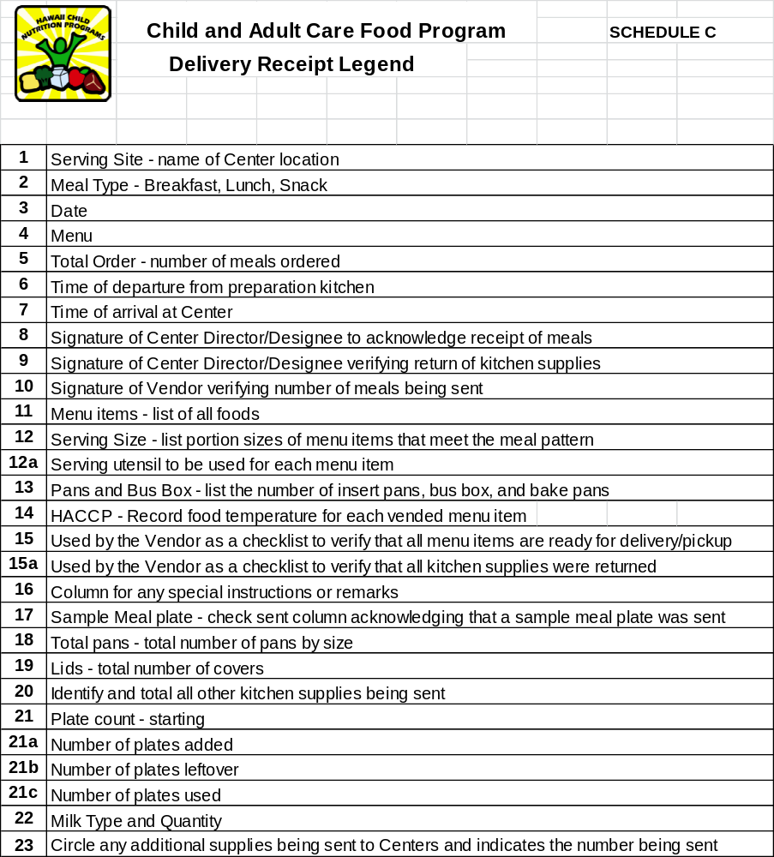
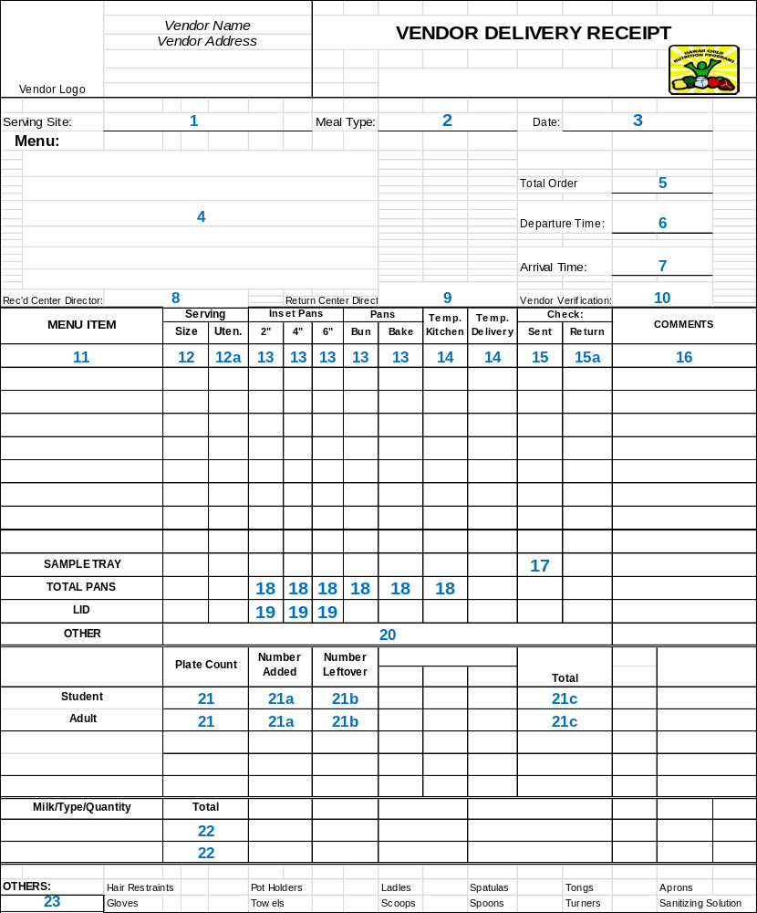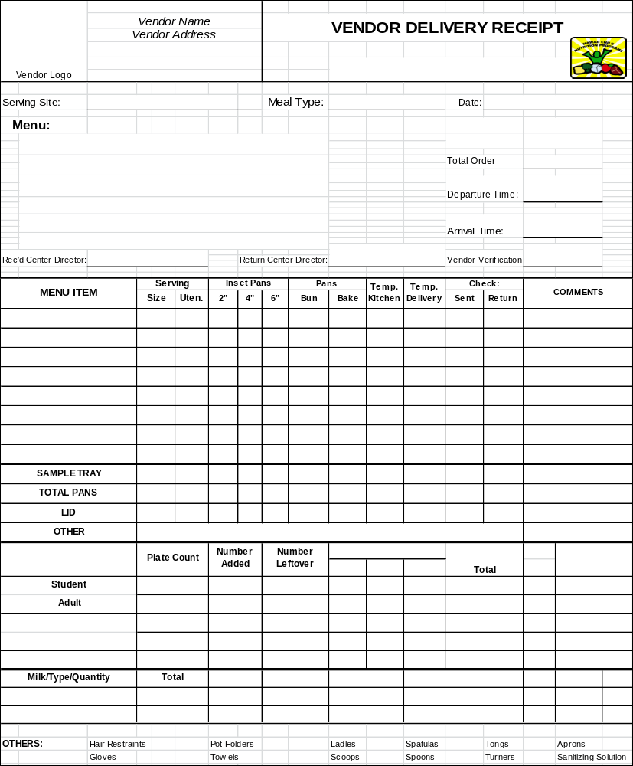

SCHEDULE D

MENU CYCLE – Week 1

FOOD COMPONENTS | SERVING  SIZE |  |  | DAY 1 |  | DAY 2 | DAY 3 | DAY 4 | DAY 5
Breakfast

Grain/bread
Vegetable/Fruit
Milk, fluid
Other
A.M. Snack
Meat/meat alternate
Grain/bread
Vegetable/Fruit
Milk, fluid
Other
Lunch
Meat/meat alternate
Grain/bread
Vegetable/Fruit
(two or more kinds)
Milk, fluid
Other
P.M. Snack
Meat/meat alternate
Grain/bread
Vegetable/Fruit
Milk, fluid
Other
Supper
Meat/meat alternate
Grain/bread
Vegetable/Fruit
(two or more kinds)
Milk, fluid
Other

SCHEDULE D, PAGE 2
MENU CYCLE – Week 2

FOOD COMPONENTS | SERVING  SIZE |  |  | DAY 1 |  | DAY 2 | DAY 3 | DAY 4 | DAY 5
Breakfast

Grain/bread
Vegetable/Fruit
Milk, fluid
Other
A.M. Snack
Meat/meat alternate
Grain/bread
Vegetable/Fruit
Milk, fluid
Other
Lunch
Meat/meat alternate
Grain/bread
Vegetable/Fruit
(two or more kinds)
Milk, fluid
Other
P.M. Snack
Meat/meat alternate
Grain/bread
Vegetable/Fruit
Milk, fluid
Other
Supper
Meat/meat alternate
Grain/bread
Vegetable/Fruit
(two or more kinds)
Milk, fluid
Other

SCHEDULE D, PAGE 3

MENU CYCLE – Week 3

FOOD COMPONENTS | SERVING  SIZE |  |  | DAY 1 |  | DAY 2 | DAY 3 | DAY 4 | DAY 5
Breakfast

Grain/bread
Vegetable/Fruit
Milk, fluid
Other
A.M. Snack
Meat/meat alternate
Grain/bread
Vegetable/Fruit
Milk, fluid
Other
Lunch
Meat/meat alternate
Grain/bread
Vegetable/Fruit
(two or more kinds)
Milk, fluid
Other
P.M. Snack
Meat/meat alternate
Grain/bread
Vegetable/Fruit
Milk, fluid
Other
Supper
Meat/meat alternate
Grain/bread
Vegetable/Fruit
(two or more kinds)
Milk, fluid
Other

SCHEDULE D, PAGE 4
MENU CYCLE – Week 4

FOOD COMPONENTS | SERVING  SIZE |  |  | DAY 1 |  | DAY 2 | DAY 3 | DAY 4 | DAY 5
Breakfast

Grain/bread
Vegetable/Fruit
Milk, fluid
Other
A.M. Snack
Meat/meat alternate
Grain/bread
Vegetable/Fruit
Milk, fluid
Other
Lunch
Meat/meat alternate
Grain/bread
Vegetable/Fruit
(two or more kinds)
Milk, fluid
Other
P.M. Snack
Meat/meat alternate
Grain/bread
Vegetable/Fruit
Milk, fluid
Other
Supper
Meat/meat alternate
Grain/bread
Vegetable/Fruit
(two or more kinds)
Milk, fluid
Other

SCHEDULE D, PAGE 5
MENU CYCLE – Week 5

FOOD COMPONENTS | SERVING  SIZE |  |  | DAY 1 |  | DAY 2 | DAY 3 | DAY 4 | DAY 5
Breakfast

Grain/bread
Vegetable/Fruit
Milk, fluid
Other
A.M. Snack
Meat/meat alternate
Grain/bread
Vegetable/Fruit
Milk, fluid
Other
Lunch
Meat/meat alternate
Grain/bread
Vegetable/Fruit
(two or more kinds)
Milk, fluid
Other
P.M. Snack
Meat/meat alternate
Grain/bread
Vegetable/Fruit
Milk, fluid
Other
Supper
Meat/meat alternate
Grain/bread
Vegetable/Fruit
(two or more kinds)
Milk, fluid
Other

SCHEDULE D, PAGE 6
MENU CYCLE – Week 6

FOOD COMPONENTS | SERVING  SIZE |  |  | DAY 1 |  | DAY 2 | DAY 3 | DAY 4 | DAY 5
Breakfast

Grain/bread
Vegetable/Fruit
Milk, fluid
Other
A.M. Snack
Meat/meat alternate
Grain/bread
Vegetable/Fruit
Milk, fluid
Other
Lunch
Meat/meat alternate
Grain/bread
Vegetable/Fruit
(two or more kinds)
Milk, fluid
Other
P.M. Snack
Meat/meat alternate
Grain/bread
Vegetable/Fruit
Milk, fluid
Other
Supper
Meat/meat alternate
Grain/bread
Vegetable/Fruit
(two or more kinds)
Milk, fluid
Other

SCHEDULE D, PAGE 7 — ADULT DAY CARE FOOD PROGRAM MEALS ONLY

MODIFIED MENU FOR MEDICALLY PRESCRIBED ADULT DIETS

cycle | week | facility | date

 | FOOD COMPONENTS | SERVING  SIZE | REGULAR | PRUDENT DIET  (LOW FAT, SUGAR & SALT) | LOW SODIUM  (INDICATE GRAMS) | DIABETIC & CALORIE CONTROLLED DIETS RECORD SERVING SIZE
 |  |  |  |  |  | Food Components | 1000 cal. | 1200 cal. | 1500 cal. | 1800 cal.
B  R  E  A  K  F  A  S  T | Fruit/Vegetable  Grain/bread  Milk, Fluid  Other | ½ cup  2 slices/2 oz  1 cup | Low Fat | Non Fat | Low Fat |  | Non Fat | Non Fat | Low Fat | Low Fat
A  M  S  N  A  C  K | (Choose 2 of 4)  Fruit/Vegetable  Grain/bread  Meat/meat alternate  Milk | ½ cup  1 slice/1 oz  1 oz.  1 cup | Low Fat | Non Fat | Low Fat |  | Non Fat | Non Fat | Low Fat | Low Fat
L  U  N  C  H  /  S  U  P  P  E  R | Meat/meat alternate  Grain/bread  Vegetable/Fruit  (Total V/F = 1 cup)  Vegetable/Fruit  Milk ¹  Other | 2 oz  2 slice/1 cup  ______ c.  ______ c.  1 cup | Low Fat | Non Fat | Low Fat |  | Non Fat | Non Fat | Low Fat | Low Fat
P  M  S  N  A  C  K | (Choose 2 of 4)  Fruit/Vegetable  Grain/bread  Meat/meat alternate  Milk | ½ cup  1 slice/1 oz  1oz  1 cup | Low Fat | Non Fat | Low Fat |  | Non Fat | Non Fat | Low Fat | Low Fat

¹ Milk is required for Lunch only; it is not required for Supper. When milk is identified as a snack component, non-fat or low fat as identified is required.

