Become a registered vendor with HCNP  Registration forms for the vendor directory can be filled out at the training workshop. Just bring copies of the following documents:  - Hawaii Inspection Records  - Food Service Permit  - Vendor License  - Insurance Certificate  **If you decide to do online training the paperwork must be sent into the office for approval.  Bring it all in and get it done in one shot!!! |  |  | New Food Vendor Training  About us:  The new food vendor training is designed to educate potential food vendors on program requirements to enable them to provide wholesome vended meals that meet USDA standards to agencies like schools and non-profit organizations who participate in the National School Lunch Program (NSLP), the School Breakfast Program (SBP) the Summer Food Service Program (SFSP) and the Fresh Fruit and Vegetable Program (FFVP). Hawaii currently has an inadequate supply of trained food vendors to provide reimbursable meals to child nutrition sponsors.  Contact Sue with questions  Email: sue_uyehara@notes.k12.hi.us  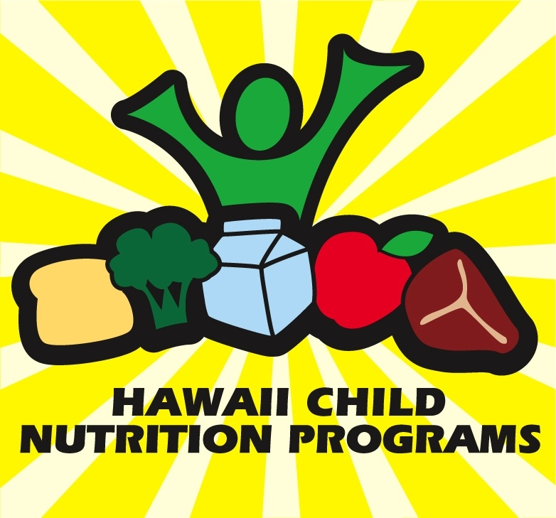 hawaii child nutrition programs 650 Iwilei Road, Suite 270 Honolulu, HI 96817 (808) 587-3600 www.hcnp.hawaii.gov USDA is an equal opportunity provider and employer |  |  | 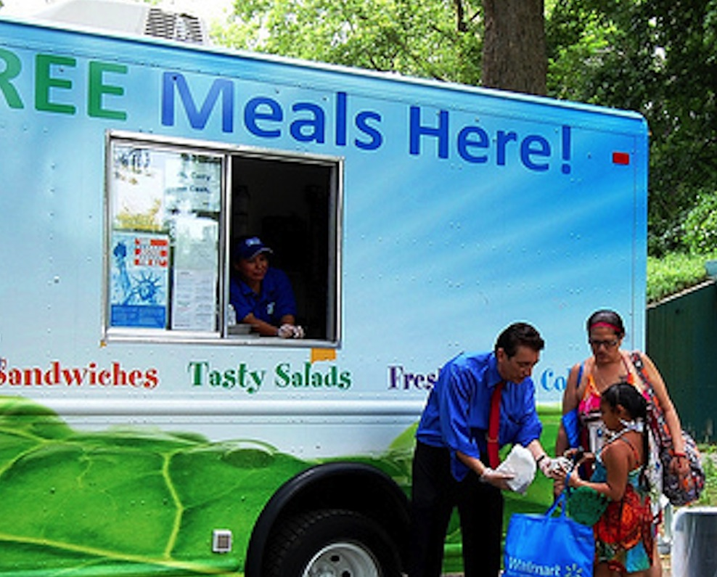  HAWAII CHILD NUTRITION PROGRAMS  - Hawaii School Meals Business Training  March 2014

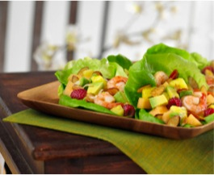  Mission Statement  Our mission is to provide administrative support to eligible food service providers to ensure easy sustained access to USDA nutrition programs.  Vision Statement  Hawaii’s children and adults will have access to healthful meals and nutrition education through USDA programs. |  |  | Are you looking to stabilize your food and beverage income?  Hawaii Child Nutrition Programs can help to set you on a sustainable path with summer food and school food programs. While profits can fluctuate throughout the year, a stable income from a school food service contract can help to ensure your baseline budget stays in the green. Benefits to contracting with schools not only include monetary stability but also community engagement, networking and, ultimately, creating a healthier Hawaii, one child at a time.  The purpose of this workshop is to “fill the nutritional needs of Hawaii’s schools and recreation by providing them with access to trained vendors that deliver nutritious and tasty school meals” -Crystal Bossola, Nutrition Consultant/Trainer  Become a trained vendor to cater to the keiki of Hawaii’s schools!  This workshop will supply vendors with the necessary skills and tools to deliver nutritious and ono foods to the keiki of Hawaii by filling the gap between schools and food producers. |  |  | 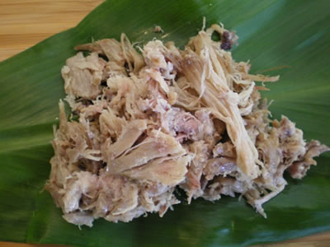  Workshop will cover the following modules:  - National School Lunch Program (NSLP) Introduction  - NSLP Meal Pattern Requirements and Crediting  - Food Safety Training  - How to Analyze a Recipe  - How to Double or Half a Recipe  - How to use the Food Buying Guide  - Record Keeping (Standardized Recipes, Production and Transport Records)  - Offer vs. Serve  - Summer Food Service Program (SFSP) Background  - SFSP Menu Planning and Crediting  - Fresh Fruit and Vegetable Program (FFVP)

