Revised 7/09
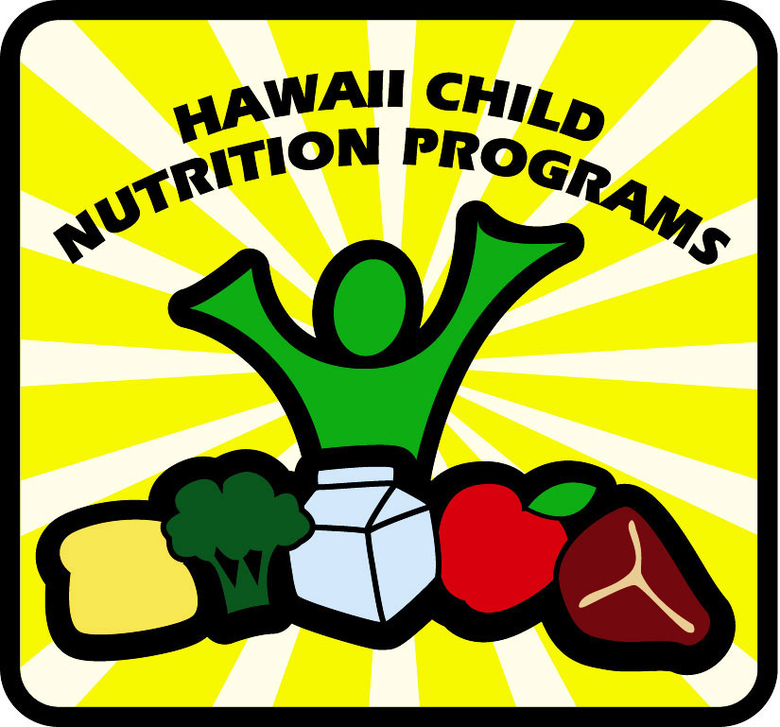 Hawaii Child and Adult Care Food Program
Handy Guide to Creditable Foods

- Creditable foods are used to meet CACFP meal pattern requirements. This list is established by USDA and the HCNP to help assure good nutrition for all participants.

- This is a partial listing of creditable foods for children one year of age and older and adult participants.

- Foods are creditable only if the minimum required quantity of each food component is served. The amount required depends on the age of the participant, the type of meal, the type of food product used and the number served.

- Centers and sponsors of child development homes may make additional restrictions at their discretion. Home providers may contact their sponsor with questions regarding specific foods or quantities.

Milk and Milk Products 

- Milk must be served as a beverage or over cereal. Milk used in cooking may not be credited.

- Milk must be pasteurized fluid milk, fortified with vitamins A and D.

- Participants must be served milk at breakfast and lunch/supper unless an exception statement from a medical authority is on file stating the nature of the problem, listing foods to avoid and alternate foods to be substituted. Serving milk in adult care suppers is optional.

- A separate meal pattern and reimbursable foods list is available and should be followed for infants. CACFP requires that breast milk or iron fortified infant formula be fed until the infant’s first birthday. In Hawaii, current child care center licensing standards require whole milk, formula or breast milk for children under 2 years, unless otherwise directed by a physician. CACFP allows children one month to transition to whole cow’s milk after the first birthday. A diet statement is needed to serve formula at or after 13 months of age.

Non creditable
Cocoa mix made with water
Coffee creamers
Cream
Cream sauce
Cream soup
Custard
Dry milk
Eggnog
Evaporated milk
Half and half
Ice cream
Ice milk
Imitation milk
Pudding
Pudding pops
Raw milk (certified or uncertified)
Reconstituted dry milk
Rice milk
Sherbet or sorbet
Sour cream
Soy milk, beverage or drink
Yogurt – creditable only as a meat alternate

Creditable

Acidified milk (acidophilus)
Buttermilk, cultured milk or kefir
Cow’s milk, flavored or unflavored including chocolate
Skim, non-fat or fat free, reduced fat or low fat (1%, 2%), whole
Cocoa – made from fluid milk
Goat’s milk
Lactose reduced milk
Milkshakes – only the milk portion
UHT milk – ultra high temperature (self stable) cow’s milk

Meat and Meat Alternates 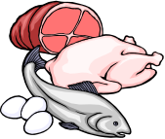

- Meats and meat alternates may include lean meat, poultry, fish, cheese, eggs, nuts, seeds, nut or seed butters, cooked dry beans or peas, and yogurt. Meats must be inspected by the appropriate health authority. This is a partial list only. A combination of two or more meat/meat alternates may be served at the same meal to total the required serving size. In breaded products, only the meat portion is counted.

- Meat and meat alternates must be served in the main dish, or in the main dish and one other item.

- At least ¼ ounce or ½ Tablespoon of meat or meat alternate must be served to count as part of the required serving.

- Cooked dry beans or peas may be used either as a vegetable or as a meat alternate, but not both in the same meal.

- Nuts or seeds may be used for up to ½ of the required serving size of the meat/alternate requirement in lunch and supper.

- The best way to determine the amount of meat alternate in a commercial mixed food such as canned or frozen stew, beef-a-roni, pizza, pot pie, ravioli or breaded meats like chicken nuggets, or fish sticks is to get a Child Nutrition (CN) label, or a product analysis sheet from the manufacturer (not a distributor or sales person). If you cannot determine the meat/alternate content, additional sources may be added to the meal. If an item is homemade, the recipe should show the amount of meat/alternate.

- Shell fish or nuts may produce food intolerances among preschool or adult participants.

Non creditable

Acorns
Bacon-bits, imitation bacon
Bacon – as in BLT sandwiches
Canned cheese sauce
Cheese product or imitation cheese (Velveeta)
Chestnuts
Coconut
Cream cheese - regular, light (Neufchatel cheese) and fat
free
Eggs – raw or undercooked
Fish – home caught
Frozen commercial yogurt products and bars
Game – venison, squirrel, fish etc.
Ham hocks
Home canned meats, home slaughtered meats
Imitation meats and meat alternates (e.g., cheese, crab,
frankfurters, shrimp, etc.)
Luncheon Meats: Spam, Treet, etc.
Oxtails
Pigs’ feet, neck bones, tail bones
Pot pies – commercial
Potted, pressed or deviled canned meat
Powdered cheese – as in boxed macaroni and cheese
Salt pork
Scrapple
Sizzlean
Soup – commercial canned
Spam
Tofu, tempeh, seitan
Yogurt covered fruits, nuts
Yogurt – homemade

  

Creditable

Canadian bacon 
Cheese – natural or processed 
Corndogs - only the hot dog counts as meat 
Cottage cheese, ricotta cheese
¼ c. or 2 oz. = 1 oz. meat alternate
Dried peas, beans, lentils, refried beans, soy beans
(canned or cooked from dry – ¼ c. = 1 oz. meat alternate)
Eggs – cooked, including deviled eggs
Fish and shellfish – cooked, count only meat portion
Fish sticks – must be at least 60% fish
Frankfurters – must be all meat, no cereal or extenders 
Liver, kidney, tripe
Lunch meat  – must be all meat, no cereal or extenders
(includes bologna, ham, liverwurst, pepperoni, turkey ham,
turkey roll)
Peanuts, nuts, seeds¹
Peanut, nut, seed butter – regular or reduced fat¹
Pizza – creditable if CN labeled or homemade and the amount of meat and cheese is documented.
Quiche – only the meat, cheese or egg portion
Sausage, Polish, knockwurst, Vienna sausage
Soups – must be home made with at least ¼ oz. or equivalent
of meat/meat alternate per serving to credit
Spare ribs – only lean meat portion 
Turkey bacon, if CN labeled 
Vegetable protein/meat protein mixtures²
Yogurt – plain, flavored, low fat, unsweetened or sweetened
½ cup or 4 ounces = 1 ounce meat alternate
minimum serving is ¼ c.

 Limit use, since high in salt and/or high in fat.

¹ Choking risk to those under 4 years and the elderly.
² Meat analogs may be up to 100% non-meat protein, and must have a CN label or manufacturer’s statement showing the product meets USDA requirements.
³ Soy cheese may have soy protein and/or casein and must have a CN label or a manufacturer’s statement showing that the product meets USDA requirements.

Fruits and Vegetables 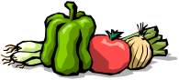
- Most fruits and vegetables are creditable. Serve a variety and use fresh to add texture and nutrition.

- All commercial juices must be pasteurized. Full, 100% full strength juice must be served. Juices labeled “juice”, “full strength juice”, “100% juice”, “single strength juice”, “juice from concentrate” or “reconstituted juice” are full strength. Juices that are naturally high in or fortified with vitamin C are recommended.

- At least ⅛ cup (2 Tablespoons) of fruit or vegetable must be served to each participant in order to count it toward meeting the minimum serving size requirement.

- Juice may count up to ½ of the total fruit/vegetable requirements for lunch or supper.

- Juice may not be served for snack if milk is the only other required food served.

- Two forms of the same food (e.g. apples and apple juice) are not creditable in the same meal.

- Combinations such as fruit cocktail, fruit salad, succotash, mixed vegetables, peas and carrots, stew vegetables and casserole vegetables, count as one fruit/vegetable

Non creditable
Apple butter
Banana chips, commercial
Barbecue sauce
Chili sauce
Coconut
Corn chips
Dry spice mixes
Frozen fruit flavored bars, popsicles
Fruit “drink”
Fruit flavored syrup or powder
Fruit in cookies or grain bars – (e.g., Fig Newtons, grain bars)
Fruit in commercial fruited yogurt
Fruit leather, fruit rollups, fruit shapes
Fruit flavored canned punch (e.g., Hawaiian Punch)
Fruit flavored ice cream
Fruit syrup – from canned fruit
Gummy fruit candy
Home canned fruits and vegetables
Hominy
Honey, syrups, jam, jelly, preserves
Jell-O, gelatin
Juice cocktails (e.g., cranberry, grape, etc.)
Juice drink
Ketchup, condiments and seasonings
Kool-Aid
Lemon pie filling
Lemonade
Nectar (e.g. apricot, peach)
Orangeade
Pizza, commercial2 (amount of sauce is insufficient - unless
more is added)
Pop tart filling
Popsicles – commercial
Posole
Potato chips, potato sticks
Pudding with fruit – commercial
Raw sprouts
Sherbet, sorbet
Tang

¹ Must have a minimum of ⅛ c. fruit or vegetable per
serving. Only the fruit or vegetable portion counts.
² If a commercial product, must have a CN label or
manufacturer’s specification on file or added fruit/vegetable
to supplement the product.

Creditable
Apple cider – must be pasteurized
Baby carrots
Dried peas, beans, lentils, baked beans, refried beans, soy
beans (canned or cooked from dry) count as vegetable or meat/meat alternate, but not both at the same meal.)
Chopped vegetables in home made casserole, stew1
Coleslaw – only fruit/vegetable, not dressing1
Cranberry juice blend – if a blend of full strength juices
Cranberry sauce – made with whole cranberries (not jellied)
Dehydrated vegetables – use when re-hydrated
Dried fruit – apricots, dates, figs, prunes, raisins
Frozen juice bars – must be made with 100% fruit and/or juice
Fruit cobbler, crisp1
Fruit cocktail – counts as one fruit
Fruit or vegetable in gelatin or pudding¹
Fruit pie filling - ½ cup filling = ¼ cup fruit
Fruit sauce – homemade¹
Juice, full strength
Juice blends – if a blend of full strength juices
Juice concentrates
Kiwi fruit
Mixed vegetables – counts as one vegetable
Mushrooms
Pizza sauce or tomato sauce – serve at least 1/8 c. to each
Potatoes
Potato skins
Salsa (all vegetable plus spices)
Soup (tomato or veg) – if commercial,1 c. soup = ¼ c. veg.
Spaghetti sauce – serve at least 1/8 c. to each
Tomato paste – 1 Tbsp. = ¼ c. vegetable
Tomato puree – 2 Tbsp. = ¼ c. vegetable
Tomato sauce – 4 Tbsp. or ¼ c. = ¼ c. vegetable
Vegetable juice blend (e.g., V-8 juice)

 Limit use, since high in salt and/or high in fat.

Grains and Breads 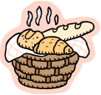

- The grain/bread must be whole grain or enriched or made from whole grain or enriched meal and/or flour, bran or germ. Cereals must be whole grain, enriched or fortified. Enriched means the product conforms to the FDA’s required levels of added iron, thiamin, riboflavin, niacin and folic acid.

- To determine the amount to serve, use the meal pattern chart and the Grains/Breads Serving Size Chart. Do not use the serving size on the label. Do use the product label to determine the weight of the listed serving of the product. Then convert the serving on the label to the amount needed to meet meal pattern requirements (a “cheat sheet” is provided on the back of the Grains/Breads Serving Size Chart and gives common grain/bread serving sizes for the CACFP). Save product labels and keep your own list of amounts of frequently used grains/breads. For CACFP provide ½ serving for ages 1-5 yrs. and 1 serving for 6 yrs. to adult.

- The minimum amount that a food item can contribute to count as a serving is ½ serving.

- Children need nutrient dense foods. Dessert may not be credited as a grains/breads at lunch. Sweet foods should be limited and may not be served more than twice a week at snack.

- To credit homemade grain/bread recipes, divide the total weight (in grams) of all creditable grains in the recipe by 14.75. This is the number of grain/bread servings in the recipe. Then divide this by the number of servings the recipe yields to obtain the number of grains/breads in one serving of the recipe.

Creditable
Bagel
Banana, carrot, pumpkin, zucchini bread
Boston brown bread
Bread pudding¹ – if homemade (HM)
Breading or batter on meats - if CN labeled or amount is known
Bread sticks, hard⁴ or soft
Bread stuffing¹
Cake, cupcakes²
Cereal – dry or cooked, 6 gm. of sugar or less is recommended
Cereal bars^{1, 2}
Chips⁴ – grain based, enriched or whole grain 
Chow mein noodles 
Cinnamon roll³
Coffee cake³
Cookies, brownies or bars ^{2, 5} 
Corn pone, hoe cake
Corn tortillas
Couscous
Crackers⁴
Cream puff shells²
Crepes
Croissants 
Croutons⁴ 
Doughnuts³ 
Dumplings
Egg roll skins, won ton wrappers
English muffins
Fig bars (only the cookie part)
Fruit crisp or cobbler crust^{1, 2, 5}
Fry bread 
Gingerbread
Graham crackers
Grain fruit bars, granola bars^{1, 3}
Grains – barley, cornmeal, farina, millet, oats, quinoa, rice, wheat
Granola cereal^{1, 4}
Grits
Hushpuppies 
Ice cream cones⁵

 Limit use, since may be high in salt and/or high in fat.

Macaroni, noodles, spaghetti and other pasta shapes
Macaroni in boxed or homemade macaroni and cheese
Pie crust or shell⁵  (dessert pies², or in main dish pie)
Pita bread
Pizza crust
Popovers
Pretzels, soft and hard⁴
Pop tarts, toaster pastries (only the crust)^{3, 5}
Puff pastry with main dish 
Quick breads like biscuits, cornbread, muffins, waffles
Rice cakes⁵
Rice pudding^{1, 2}
Saimin(enriched)
Scones
Snack crackers⁴
Sopapillas
Spoon bread
Sweet rolls, buns, pastries³ 
Taco or tortilla shells⁴
Tortillas
Turnover crust³ 
Vanilla wafers (plain cookies)³
Waffles
Wheat germ, bran

Non creditable
Caramel corn
Hominy
Long Rice noodles
Nut or seed flour
Popcorn
Potatoes, potato pancakes
(potatoes are credited as a vegetable, not as a grain)
Potato chips, potato sticks
Ramen noodles (dry)
Tapioca

¹ Only the amount of bread, flour, meal or grain counts.
² may serve for snack.
³ May serve for breakfast and snack.
⁴ Hard, dry foods may cause choking.
⁵ Serving size may not be reasonable for small children.

Grains/Breads^{1, 2} Serving Size Chart
Grain bread products are divided into nine groups according to the serving size needed to provide14.75 grams of flour. When water, fat, sugar, fruit, or nuts are added, then a bigger serving is needed to provide this amount of flour.
Group A  1 serving = 20 gm or 0.7 oz  1/2 serving = 10 gm or 0.4 oz |  | Group D  1 serving = 50 gm or 1.8 oz  1/2 serving = 25 gm or 0.9 oz
• Bread type coating  • Bread sticks (hard)  • Chow mein noodles  • Crackers (saltines or soda crackers and snack  crackers)  • Croutons⁷  • Pretzels (hard) ⁷  • Stuffing (dry) ⁷  Note: weights apply to bread in stuffing. |  | • Doughnuts⁴ (cake and yeast raised, unfrosted)  • Granola bars⁴ (plain)  • Muffins (all, except corn)  • Sweet rolls⁴ (unfrosted)  • Toaster pastries⁴ (unfrosted)
Group E
1 serving = 63 gm or 2.2 oz
1/2 serving = 31 gm or 1.1 oz
• Cookies3 (with nuts, raisins, chocolate pieces
and/or fruit purees)
• Doughnuts⁴ (cake and yeast raised, frosted or
glazed)
• French toast
• Grain fruit bars⁴
• Granola bars⁴ (with nuts, raisins, chocolate
pieces and/or fruit)
• Sweet rolls⁴ (frosted)
• Toaster pastries⁴ (frosted)
Group B
1 serving = 25 gm or 0.9 oz
1/2 serving = 13 gm or 0.5 oz
• Bagels
• Batter type coating, breading
• Biscuits
• Breads (white, wheat, whole wheat, French,
Italian, pumpernickel)
• Buns (hamburger and hot dog)
• Crackers (graham crackers - all shapes,
animal crackers)
• Egg roll skins
• English muffins
• Pita bread (white, wheat, whole wheat)
• Pizza crust
• Pretzels (soft)
• Rolls (white, wheat, whole wheat, potato)
• Tortillas (wheat or corn)
• Tortilla chips (wheat or corn) ⁷
• Taco or tortilla shells⁷
• Wonton wrappers

Group F
1 serving = 75 gm or 2.7 oz
1/2 serving = 38 gm or 1.3 oz
• Cake³ (plain, unfrosted)
• Coffee cake⁴
Group G
1 serving = 115 gm or 4 oz
1/2 serving = 58 gm or 2 oz
• Brownies³ (plain)
• Cake³ (all varieties, frosted)
Group H
1 serving = 1/2 cup cooked (or 25 gm dry)
Group C  1 serving = 31 gm or 1.1 oz  1/2 serving = 16 gm or 0.6 oz |  | • Barley  • Breakfast cereals (cooked)^{5, 6}  • Bulgur, couscous or cracked wheat  • Macaroni (all shapes)  • Noodles (all varieties)  • Pasta (all shapes)  • Ravioli (noodle only)  • Rice (enriched white or brown)
• Cookies3 (plain)
• Cornbread, Johnny cake or hushpuppies
• Corn muffins
• Croissants
• Pancakes or crepes
• Pie crust (dessert pies3, fruit turnovers⁴,
and meat/meat alternate pies)
• Waffles
Group I
1 serving = 3/4 cup or 1 oz, whichever is less
 |  | • Ready to eat breakfast cereal (cold dry) ^{5, 6}
¹ The following foods are whole-grain or enriched or made with enriched or whole-grain meal and/or flour, bran, and/or germ.
² Some of the following foods, or their accompaniments may contain more sugar, salt, and/or fat than others. This should be a consideration when deciding how often to serve them.
³ Allowed only for snacks. ⁴ Allowed for snacks and for breakfasts.⁵ Breakfast cereals are traditionally served as a breakfast menu item but may be served in meals other than breakfast⁶ Cereals may be whole-grain, enriched, or fortified. ⁷ Choking risk.

